Executive summary: [company name] is all about providing excellent service and quality products in a peaceful and relaxed atmosphere. We also offer a friendly work environment, respecting diversity, creativity, and hard work. Our team is guaranteed to provide you with the beautiful results and comfortable treatment you deserve.

[company name] is looking for a website that reflects all of those qualities so that potential customers do not miss out on our great experience.

Approach: By monitoring competitors' websites to know their behavior, we can conclude what strategies they use. In return, we will create our design so that [company name] can keep customers and win (not steal) customers away from competitors.

Overview of Competition:

Cozy Nails and Spa
Madison, WI
https://cozynailsmadison.wixsite.com/mysite
This company went for the hero design trend on its main page. Relatively simple, not much on the main page besides important information: Contact number, navigation tabs, social media icons, hours of operation. They also did an excellent job of adding a gallery that displays their work.

Sky Nails
Fond du Lac, WI
http://www.spadulac.com/
I like the idea of customers having different ways to schedule an appointment. You can schedule an appointment on the website, through Facebook, text, calling, email, walk-ins, etc. Also, just like the other competitors, the website lists all services and prices of those services. The website itself has a basic layout.

Pink Me Salon
La Crosse, WI
https://www.pinkmesalonllc.net/#/
Looking at the website, this nail salon does live up to its name, "Pink'' me. The page uses a few different shades of pink. The main page has an overlay of an image to stay consistent with the aesthetic. To the left of the page is a fixed navigation bar. A great addition that they added was a section about the artist themselves.

Recommendations:
- Follow the hero design trend.
- Gallery section
- Social media icons
- Book online option.
- "Meet the Team" section.
- Stick to a few colors.
Industry Information
According to the information gathered from other nail salons, there is a standard between them all. All offer standard manicures and pedicures with regular nail lacquer or gel polish, and most provide types for nail extension services such as acrylics. It sets them apart if they offer Dip, Builder Gel, or the newly popular Polygel nails. All also, make sure to include a photo gallery of services they have provided.

Grid Overview

https://cozynailsmadison.wixsite.com/mysite
Cozy Nails and Spa
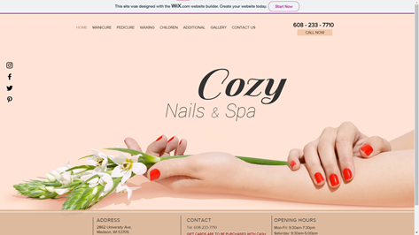
· This Website seems to be the most put together
· Great use of a graphic to keep you interested
· Navigation is easy to follow and understand
· Social Media icons on the side a good touch
· It is mobile friendly
· Not completely responsive
· Services look like the took a picture of a page and uploaded it, could be better in my opinion

http://www.spadulac.com/
Sky Nails
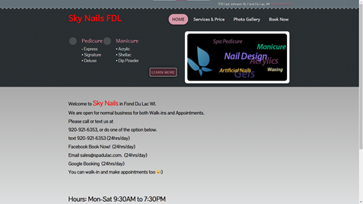
· Design seems very outdated and not cohesive
· The "learn more" looks like a button but it is unusable
· The logo on the side does not seem to represent the company but any nail salon
· Services and prices page is very easy to read and understand.
· Yes mobile friendly
· Not very responsive

https://www.pinkmesalonllc.net/#/
Pink Me Salon
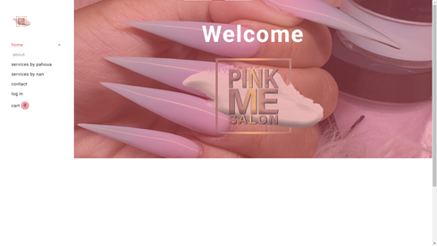
· Fun graphic and minimalist look to the home page
· The "pink me salon" can be clicked and it just pops out the img, seems unnecessary
· The about page as photos with text underneath, the text is hard to read against the background
· Services pages seem well done with slideshow photo sets
· There is a button for "book appointment" that is useful and well done
· Contact page is simple, utilizes google maps and social icons
· There is a log in that does not seem to be useful
· A cart when there are no products to buy online, waste
· Mobile friendly and responsive

Overall Ratings

From websites alone, Cozy Nails and Spas seem to be the best competitor. It looks the most modern and well kept up website. Seems to be the best thought out to catch your attention.

The second contender I would say is Pink Me Salon. They went for a very minimalist design, but they show what they need to show. It seems very modern for the look and feel.

The last contender I would say is Sky Nails. The website's color scheme doesn't go together and the red font for the title is off putting. It also looks like they don't update their photo gallery, at all.

Appendix

Company Name | Cozay Nails and Spa | Sky Nails | Pink Me Salon
URL | https://cozynailsmadison.wixsite.com/mysite | http://www.spadulac.com/ | https://www.pinkmesalonllc.net/#/
Responsive Design | Not Completely | Not Completely | Fast
Logo | No | Yes | Yes
Layout Type | Multi Page | Multi Page | Multi Page
Modern Design | Yes | No | Yes
Fixed Navigation | No | Yes | Yes
Load Times | Fast | Fast | Fast
Company Info | No | No | Yes
Contact Info | Yes | Yes | Yes
Email | No | Yes | Yes
Audio/Video Clips | No | No | No
Photo Gallery | Yes | Yes | Yes
Animation | Yes | No | Yes

