Audience Analysis Report

Prepared for The Nail Hive [Nail Salon]

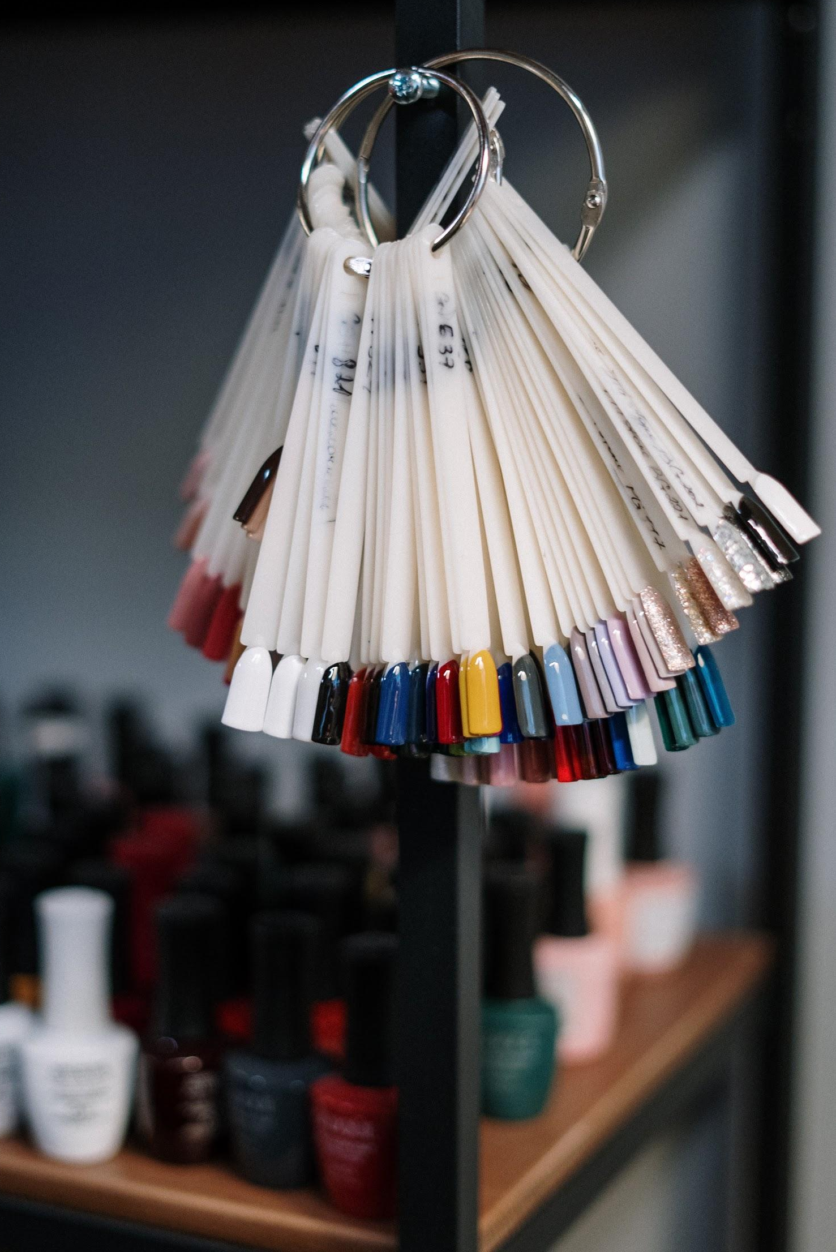

Prepared by:
J.A.R.S Web Design
03/02/2021

[ Table of Contents ]
- Target Demographics - 2
- User Profiles - 3
- User Scenarios - 4

[ Target Demographics ]
 | Primary | Secondary
Gender | Women | Women
Age | 35-54 | 25-34 ; 55+
Income Level | Medium - High | Low - Medium

Target Description :
Women seeking a relaxing, high quality, luxurious nail salon experience at an affordable price from a local establishment.
Located in Fond du Lac, The Nail Hive relies on the surrounding local area for potential clients as traveling long distances for salon service is less ideal. Women are the primary clientele of nail salon service, a majority of which are between the ages 35-54 . According to IBISWorld, women in this age bracket also contribute the most revenue to the salon(hair & nail) industry, 21.4%, stating, “This group tends to demand a larger number of high-value services, including hair coloring and haircuts, as they typically have higher disposable income levels.”

[ User Profiles ]
General Profile :
Customer: Janet Doe
Age: 45-54
Gender: Female
Family Status: Married, 2 Children
Estimated Salary: $64,351
Online Experience: Medium
Online Frequency: 2-6 hours per day
Online Location: From mobile phone
Types of sites visited: Facebook, Amazon, Pinterest
Online purchases per month: 2-4
Average valued purchases: $90.60
Preferred Salon Service: Pedicure

Detailed Profile :
Customer: Jessica Nelson
Age: 28
Gender: Female
Family Status: Engaged
Occupation: Legal Assistant
Salary: $35,523
Online Experience: High
Online Frequency: 4-8 hours per day
Online Location: From Work and Home
Types of sites visited: Instagram, Etsy, Twitter, Chewy
Online purchase per month: 4-6
Jessica Nelson lives in Fond du Lac with her fiancé Nathan Hobb, a middle school teacher at Theisen Middle School, and their two cats. Jessica is recently engaged and works for Fond du Lac County as a Legal Assistant. She enjoys taking care of her collection of house plants and loves to purchase decorated pots for her collection, especially from Etsy. She even grows catnip. An avid internet user, at home or on break at work, she primarily surfs the internet using her cellphone, though she also uses her laptop when needed. Every few weeks, she schedules an appointment at (nail salon) to have her acrylic nails filled and manicured with gel nail polish, as she prefers long lasting patterned and colorful designs. She primarily uses the company website to locate the contact phone number on the contact page to schedule her appointments.

[ User Scenarios ]

Negative :
Samantha Roberts (36), after a previous negative experience at her most recent visit to a different salon, is searching the internet for another local affordable nail salon, via Google. First impressions are important to Samantha. She values an establishment’s overall appearance as an indicator of quality and prefers visual examples to gage what she is looking for. After accessing the salon’s website, she briefly skims over the home page and the navigation. Unable to find the salon’s photo gallery, which is hidden under a “View Our Work” button link, she quickly closes the page and moves on.

Positive :
Felicia Jones (40) has an upcoming vacation she is taking with her family. She is renting a small cabin on lake Michigan through Airbnb and is seeking a manicure and pedicure that will last through her trip and something relaxing to reward herself. She is also seeking to book an appointment for her daughter(15) at the same time for the two of them to enjoy together. She finds the Nail Hive’s website link through their Facebook page, having seen positive reviews and pictures. After glancing over the offered services and prices, she chooses to book a dual appointment through the contact form on the site and fills in all of the required information, her name, her cell phone number, her email, and what times work best for her appointment.

https://nailcenter.us/client-demographics/
https://www.statista.com/statistics/857322/us-hair-nail-salon-share-by-consumer-age/
https://www.sbdcnet.org/small-business-research-reports/beauty-salon

