Color Palettes

Color Palette 1: https://coolors.co/a54657-582630-f7ee7f-fdf4ec-f26157
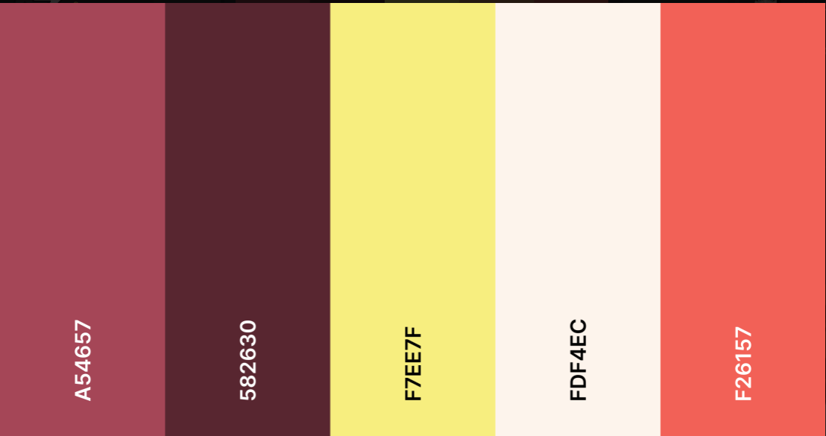
Color Palette 2: https://coolors.co/9258b0-4f2167-f7ee7f-f7d126-ffffff-388697-226b6d
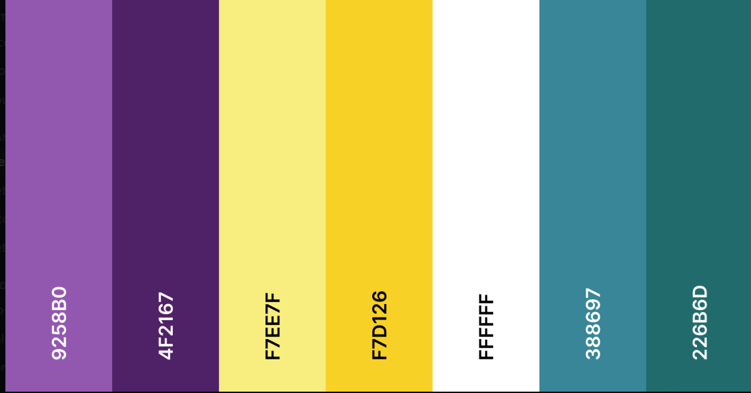

Layouts
Layout 1 in Color Palette 1:
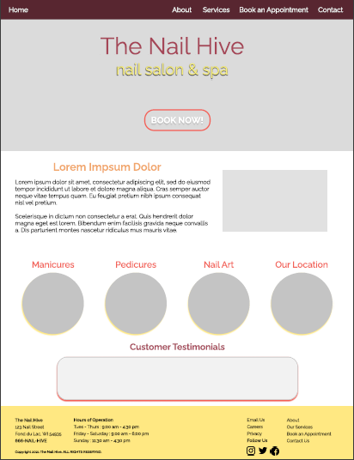
Layout 2 in Color Palette 2:


