Visual Design & Specifications

PREPARED FOR: The Nail Hive

PREPARED BY:
Sabrina Larson | Jeanna Brault |Ashley Griedd |
Riandria Gordon

Contents
Design Style Summary 5
Global Elements 5
Page Dimensions 5
Navigation 5
Footer 5
Colors: 6
HTML Text 6
Graphic Types 7
Font 7
Photo/Image Treatment 7
Icons 7
Page-Specific Elements 8
Home Page: 8
About Page 9
Technical Specifications 10
Introduction 10
Technical Summary 10
Assumptions 10
Global Elements 10
Wireframe 11
Global Elements 12
Global Head 12
Global Navigation 12
Global Footer 13
Page-Specific Elements 14
Home Page 14
Header HTML: 14
Main Content HTML: 15
About Page 16
Services Page 16
Book an Appointment Page 16
Contact Page 16
Naming Conventions 17
File types and extensions 17
Navigation Labels 18
Programming 18
Languages 18
Development Tools 19
Approval 19
Functional Specifications 20
Summary 20
Assumptions 20
Global Elements 20
Page-Specific Elements 21
Home Page 21
About Page 21
Services Page 21
Book an Appointment Page 22
File Structures 23
Project Folder Name: 23
Internal folder structure: 23
Images 24
Rules 24
Client Approval 25

Design Style Summary

https://sabrinalarson.com/jars/the_nail_hive/index.html (temporary) https://sabrinalarson.com/the_nail_hive/index.html (when finished)

Global Elements

Page Dimensions
- Overall layout will be dynamic.
- Media Queries:
  - For Large Screens:
    - min-width: 1400px
  - For Small Screens:
    - max-width: 700px
    - max-width: 799px

Navigation
- Logo: At this time, we have not designed an approved logo for the nail hive. Upon design and approval, the dimensions of the logo will be: 50px by 50px and/or 25px by 25px.
- Background color: #9258b0
- Dimensions: width (360px - 1400px+) by height (65px)
- Navigation contains primary navigation links.
- Navigation bar is globally fixed at the top of the page.

Footer
- Background color: #F7EE7F
- Dimensions: width (360px - 1400px+) by height (181px - 681px)
- Footer contains navigation links, hours of operation, social media links, and contact/legal information.
- Footer is located globally at the bottom of the page.

Colors:
https://coolors.co/9258b0-4f2167-f7ee7f-f7d126-ffffff-388697-226b6d
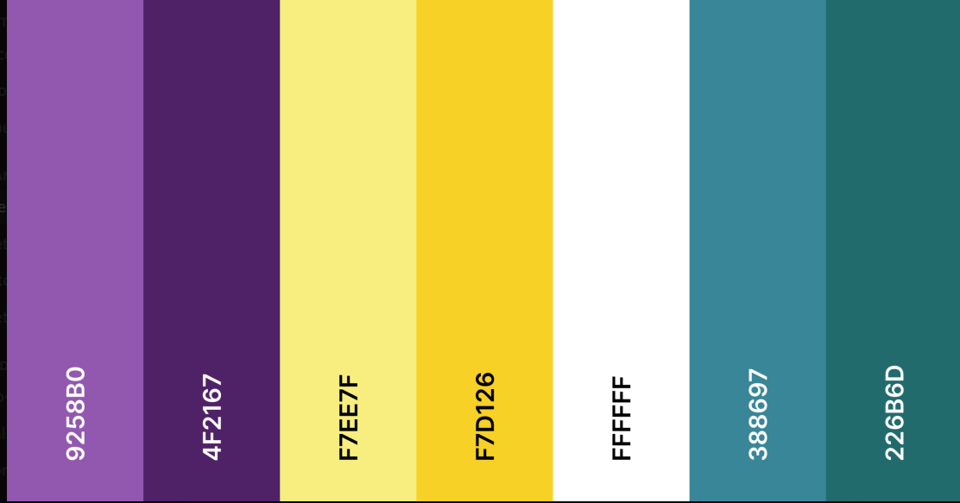
- Background Color: #ffffff White
- Accent Colors: #9258B0 •, #F7EE7F •, #388697 •, #226B6D •
- Secondary Accent Colors: #4F2167 •, #F7D126 •, #B7B7B7, #F2F2F2
- Primary Text Color: #00000 • Black
- Text Box Background: #F2F2F2 •
- Navigation Background: #9258B0 • ; #F7EE7F • (On Hover)
- Navigation Links: #ffffff White ; #000000 Black (On Hover)
- Footer Background: #F7EE7F • ; Footer Text: #000000 Black
- Footer Links: #000000 Black ; #226B6D • (On Hover)
- Standard Links: #388697 • ; #9258B0 • (On Hover)

HTML Text
- H1, H2: varies globally.
- H3: font-size: 2em, color varies globally.
- H4: font-size: 16px ; font-weight: bold ; color: black
- Primary Text Color: #000000 Black ; font-size: 20px
- Navigation Text: font-size: 17px
- Footer Text: font-size: 16px ; no text decoration ; h4 tags will be bold

Graphic Types

Font
- Font Family: Raleway, sans-serif
(Additional fonts may be introduced upon approval from the Nail Hive.)
- Font Weight: Light, Regular, Medium, Semi-Bold, and Bold available

Photo/Image Treatment
- Photograph images will use .jpg. Graphic images will use .png or jpg appropriately.
- Photos/Images will be resized to the necessary design scale to maintain quality.
- Photos/Images will use resolution optimized for the web.
- Photos/Images will use alt text or titles.
- Photos/Images files will be compressed using a free online compressor.

Icons
- Global icons will use the font awesome icon library and consist of:
  - Navigation Icons
    - fa fa-fw fa-home (home)
    - fa fa-info-circle (about)
    - fa fa-cogs (services)
    - fa fa-book (book an appointment)
    - fa fa-fw fa-envelope (contact)
    - fa fa-bars (drop-down menu)
  - Social Media Icons
    - fa fa-Instagram (Instagram)
    - fa fa-twitter (twitter)
    - fa fa-facebook (Facebook)

Page-Specific Elements

Home Page:
- Header:
  - Dimensions: height: 400px - 600px ; width: 100%
  - Contains a background hero image with a center positioning, a size of cover, no repeat, and a scroll attachment.
- H1 styles:
  - color: #F2167
  - font size: 96px
  - text-shadow: 0px 4px 4px #FFF1B0
- H2 styles:
  - color: #226B6D
  - font size: 64px
  - text-shadow: 0px 4px 4px #000000
- Video:
  - Dimensions: width 40%, auto height
- Images:
  - Circle image links:
    - size: 160px - 200px by 160px - 200px
    - border: 2px solid #F7EE7F ; border radius: 50%
    - opacity transition from 0.85 to 1.0 on hover
- Button styles:
  - color: white ; color: #F7EE7F (on hover)
  - border: 6px solid #4499AF ; border: 6px solid #9258B0 (on hover)
  - transition of color and border on hover
  - font size: 2.25 em ; font weight: 600
  - text decoration none
- Testimonial Text Box:
  - background color: #F2F2F2
  - border: 1px solid #B7B7B7
  - box-shadow: 0px 4px 4px #9258B0
  - width: 80% ; height 175px
  - border radius: 40px

About Page
- Images
  - Circle image links:
    - size: 160px - 200px by 160px - 200px
    - border: 2px solid #F7EE7F ; border radius: 50%
    - opacity transition from 0.85 to 1.0 on hover
- Text Box
  - background color: #F2F2F2
  - border: 1px solid #B7B7B7
  - box-shadow: 0px 4px 4px #9258B0
  - width: 80% ; height 175px
  - border radius: 40px
- Button
  - color: #9258B0 ; border color: #388697
  - on hover: #388697 ; border color: #9258B0
- H1 Styles
  - size: 64px
- H2 Styles
  - size: 48px

Technical Specifications

Introduction

Technical Summary
The Nail Hive website will have the capability to connect to the internet to modify and view its content. The website will be a single page, with access to the navigation bar to take the user to other pages. Content on this webpage will consist of text, images, links, and their logo.

Assumptions
The Nail Hive will provide J.A.R.S. Web Design with their preferred text content, images, graphics, and color scheme as outlined in the previous documents. All of the material includes, but is not limited to, summarized in the Technical Summary. Users are responsible for maintaining their computers and systems.

Global Elements
It consists of elements that will be the same throughout their webpage. The Nail Hive will be a single page, with access to the navigation bar to take the user to other pages with particular elements all through their webpage.

Wireframe

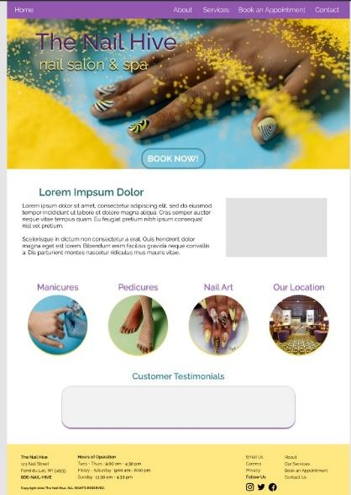

Global Elements

Global Head
HTML
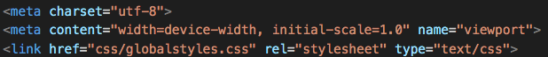
- Additional stylesheets and title tags will be adjusted for every page.

Global Navigation
Image of Navigation
HTML
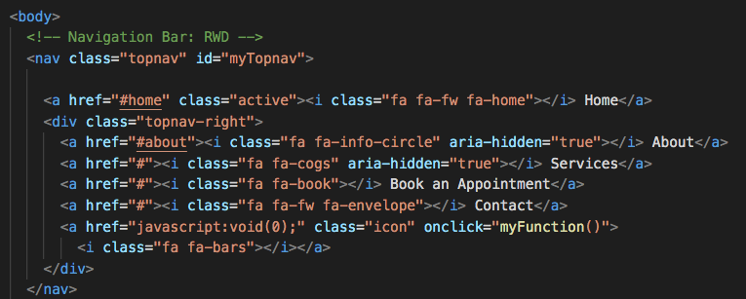

Global Footer
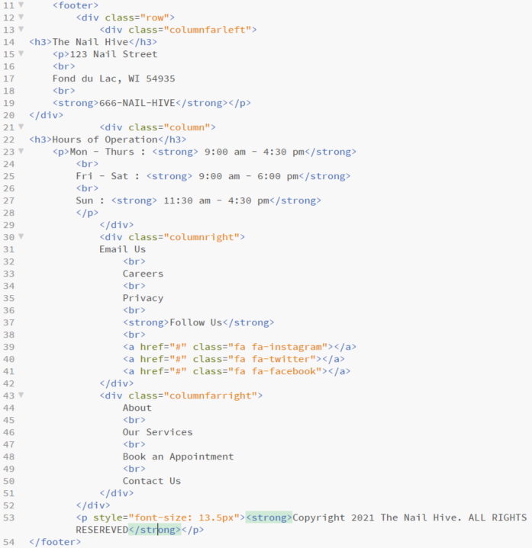
Image of Footer
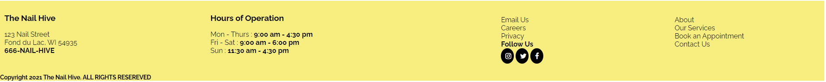

Page-Specific Elements

Home Page

Header HTML:

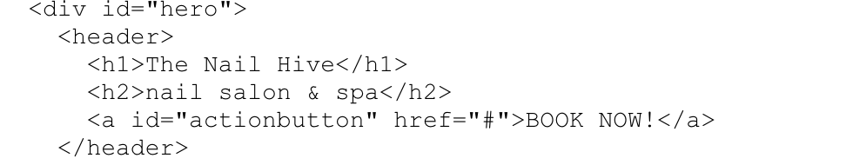

Main Content HTML:
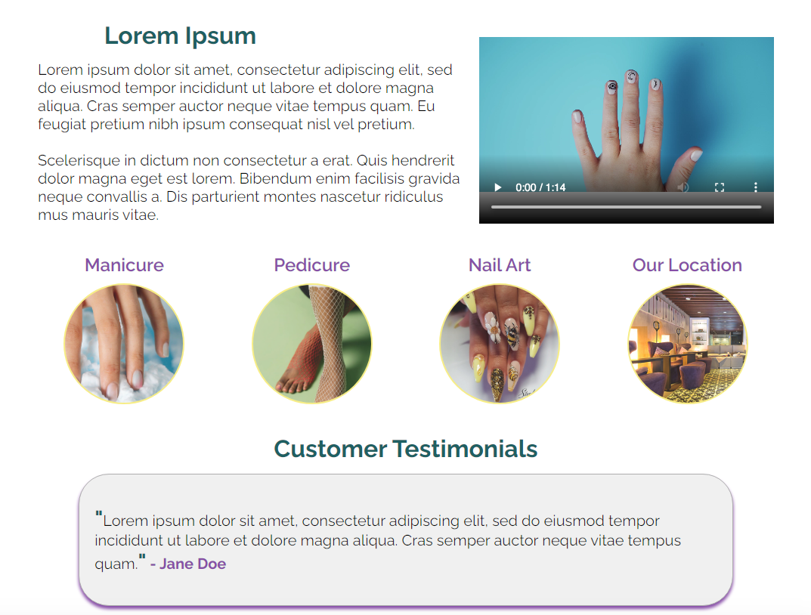
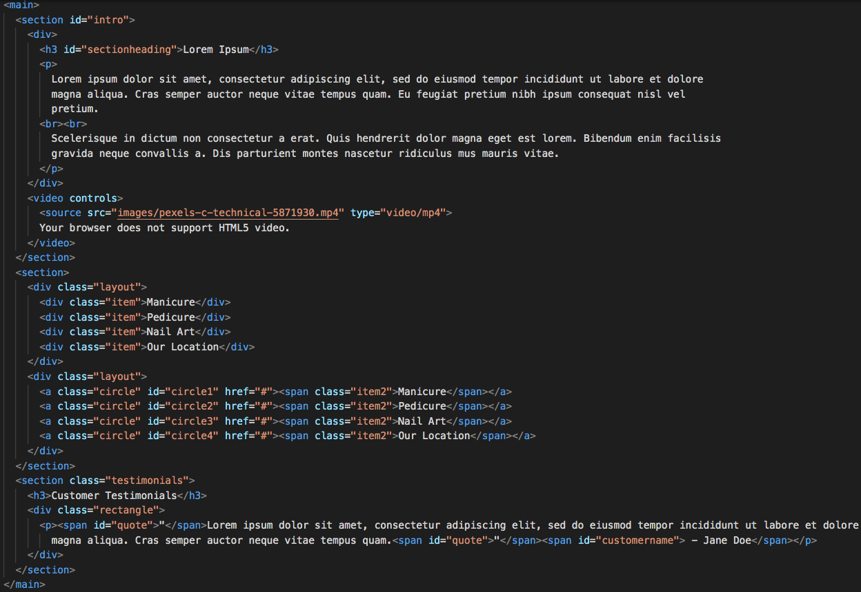

About Page
Coming Soon!

Services Page
Coming Soon!

Book an Appointment Page
Coming Soon!

Contact Page
Coming Soon!

Naming Conventions
- Use names/labels considerations for site users first.
- Titles and descriptions will use clear, simple, descriptive language.
- Aim for SEO (search engine optimization)
- Utilize Keywords
- Avoid abbreviations.
- Avoid special characters and symbols.
- Avoid generic labels.
- Use headings in a proper hierarchy and avoid excessive headings.
- Keywords will be implemented.

File types and extensions
- All the files and folder names will be separated with an underscore “_” and contain no spaces.
- When naming files or folders, it will appear with lowercase letters and numbers (nothing else).
- All file and folder names will be short and straightforward.
- There will be the use of meta tags for keywords and descriptions.
- All images will include the alt tag with keywords that relate to the picture.
- All web files are familiar and recognizable with standard extensions.
File Types | Extensions | Using
Microsoft Word | Editable Documents | .docx, .doc
Portable Document Format (PDF) | Non-Editable Document | .pdf
HTML Documents | Webpage | .html
CSS Documents | Webpage styles | .css
JavaScript Documents | Forms, buttons, etc. | .js
JPG | Pictures/Images | .jpg
PNG | Pictures and Images with a transparent background | .png

Navigation Labels
- The Nail Hive and Logo > index.html
- About > about.html
- Services > services.html
- Book an Appointment > booking.html
- Contact > contact.html

Programming

Document type declaration
<!DOCTYPE HTML>

Languages
- HTML
- CSS
- JavaScript

Development Tools
- Notepad++
- Adobe Dreamweaver
- Brackets
- Microsoft Office
- GoDaddy
- W3C HTML Validation
- W3C CSS Validation
- WAVE Accessibility Tool

Approval

Company | Agency Name ___________The Nail Hive___________
Approved By ___________Rosalind Scott__________
By signing below, the Client agrees that the above description of their consulting project is completed to satisfaction. The Client understands that after approving this phase, any changes relating to the approved portion may require additional development efforts by the Consultant, and additional costs may apply.
Signed:_________Rosalind Scott___________Date: 4/13/2021

Functional Specifications

Summary
This document is the functionality report for The Nail Hive, made by J.A.R.S Web Design. The goal of this website is to be able to navigate the site with ease. It should be user-friendly, modern, and mobile-friendly. The Nail Hive will also be user-friendly and bring new customers and old customers to the new website and the business. There will be diverse web pages on the website to establish and pictures to give good visual attractiveness.

Assumptions
This website will be accessible on any device, tablets, computers, smartphones, etc. Pageable to load in the most used browsers.

Global Elements
Everything will stay consistent on each page: a header, navigation bar, content, and a footer.

Page-Specific Elements

Home Page
Navigation bar- fixed, identical on all pages
Home - About - Services - Book an Appointment - Contact
Hero Image to get immediate attention.
Button - links to our Book an Appointment Page
Small text blub - Quick summary of our salon.
A short video to the right of the blurb
Buttons with links to their respective pages
Customer Testimonials - Quotes from clients about the Nail Hive

About Page
A page about the opening of the Nail Hive and about the team that works there at The Nail Hive.
Images of staff
Brief introductions of themselves

Services Page
A page that lists the services we offer, and the prices of them.
Pictures to show services.
Prices of services
Small Gallery to show tech’s work.

Book an Appointment Page
A page where clients can book an appointment online.
A drop-down menu where clients can pick requested services and available times.

File Structures

Project Folder Name:
- No Spaces, all lower case, simple names

Internal folder structure:
Example
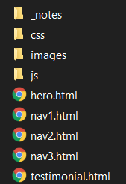
- CSS (different stylesheets)
- Images (png, jpg, etc.)
- Vendor (bootstrap, jQuery)
- Index.html
- About.html
- Service.html
- Booking.html
- Contact.html

Images
Either .jpg or .png files and stored in one file besides the logo, which is in a separate folder
Example
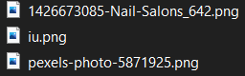

Rules
- Stylesheets go into the CSS folder.
- All images will go into an image folder.
- HTML pages stay in the main folder.
- JavaScript will go into a J.S. folder.

Client Approval

Company | Agency Name ___________The Nail Hive___________
Approved By ___________Rosalind Scott__________
By signing below, the Client agrees that the above description of their consulting project is completed to satisfaction. The Client understands that after approving this phase, any changes relating to the approved portion may require additional development efforts by the Consultant, and additional costs may apply.
Signed:_________Rosalind Scott___________Date: 4/13/2021

