Domain Name Registration
For:
The Nail Hive
Created by J.A.R.S. Web Design

Contents
What to consider in a domain name? 3
Domain Name Recommendation: 5

What to consider in a domain name?
Selecting the right domain name is one of the essential steps in creating your brand or business. Your domain name is frequently one of the primary things somebody sees, and it can impact their thought of your website and your brand. A sensible selected domain name may increase user interest and drive web traffic, while an inaccurately chosen might have the opposite outcome. When feasible, your domain name should also be the name of your business. It should be simple and as short as possible.
With that in mind good criteria for a domain name, we have some suggestions below:
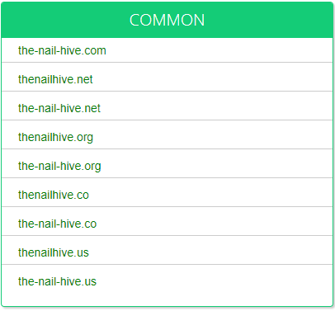
* https://www.namemesh.com/

Domain Name Recommendation:
www.the-nail-hive.com
Websites that end with .com are used the most and easiest to remember; they are also a recognized domain extension. Using your business name for the website with the .com extension will give you the results you want to achieve with both you are the customers searching with search engines.

Domain Name Registrar
Top Domain Name Registration Companies 2021: Comparison

* https://themegrill.com/blog/best-domain-name-registrars/
J.A.R.S. Web Design recommends Namecheap or GoDaddy. Based on the web hosting, we would recommend GoDaddy.com.

Web Hosting and Pricing
The hosting sites below offer many good services and rate as some of the best domain hosting services in 2021. I would suggest going with Bluehost; this is in your price range and has all the features you need for starting a website.


* https://www.hostingadvice.com/how-to/web-hosting-comparison/

By signing this, you agree and understand the terms above:

Signed: 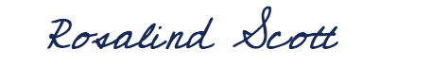 Date: May 4, 2021
Rosalind Scott
Founder and Owner, The Nail Hive

