Hand of Packet

PREPARED BY:

Sabrina Larson | Jeanna Brault |Ashley Griedd | Riandria Gordon

Table of Contents
Contents

Client Survey 7
Creative Brief 9
Statement Overview 9
Mission Statement 9
Goals 9
Target Audience Profile 10
Competitive Positioning 10
Creative Tone 10
Target Message 10
Project Scope 11
Mission Statement: 11
Project Goals: 11
Objective Statements 11
Schedule Overview 12
Budget Overview 12
Project Details 13
Electronic Commerce (eCommerce) 13
Website Information Policy 14
Legal, Taxation, Ethical and International Issues: 17
Website Security Issues and Countermeasures 18
Project Standards 19
Client Responsibility 19
Design and Developer Responsibility 19
Agreement of Terms and Conditions 20
Invoicing TERMS: Please pay by 05/01/2021 20
Maintenance and Rates 21
Web Hosting and Domain 21
Changes 21
Completion Date 21
Payment: 21
Assignment of Project: 21
Copyright and Trademarks 21
Budget Tracking 21
Copyrights of Website 22
Agreement: 22
Detailed Schedule: 23
WBS (Work Breakdown Structure Detailed): 25
Detailed Budget: 27
Internet Marketing Plan 30
Mission Statement 30
Web Presence and Marketing Goals 30
Marketing Objectives 30
Marketing Mix 30
Situation Analysis – Market Trends and Competition 31
Research 31
Competition 32
Target Market Segments 33
Priority Segment 33
Product Analysis 34
Advertising and Marketing Strategies 38
Branding and Pricing Strategies 38
Customer Relations Strategies 40
Online Advertising and Marketing Strategies 41
Offline Advertising and Marketing Strategies 42
Domain Name Strategies 43
Preliminary Internet Marketing Budget 44
Traffic Building Plan 45
Introduction 45
Traffic Building Packages 45
Search Engine Optimization Strategies 46
SEO Strategies 48
Search Engine Positioning Techniques 49
Affiliates & Link Exchange 51
Email & Newsletter Strategies 52
Social Media Strategies 53
Rich Answers 55
Preliminary Traffic Building Budget 56
The Nail Hive Content Outline 57
Home: index.html 57
About: about.html 57
Services: service.html 57
Booking: book.html 57
Gallery: gallery.html 57
Contact Us: contact.html 57
Content Delivery Plan 58
Site Map Visual for The Nail Hive 60
The Nail Hive: Naming Conventions 61
The Nail Hive Wireframe 62
Title 63
The Nail Hive Navigation Structure Plan 64
Navigation Bar 64
The Nail Hive | Logo: 64
About: 64
Services 64
Contact: 64
Book an Appointment: 64
Search Bar 64
Footer 64
Action Button 65
Naming and Labeling Outline 66
Overall Tone 66
Naming Conventions and Guidelines 66
Navigation Labels 66
Enhanced User Profiles 67
Color Design & Choices 69
Color Palettes 69
Layouts 70
Visual Design Final Choice 72
Production Guide 73
Design Style Summary 73
Global Elements 73
Page Dimensions 73
Navigation 73
Footer 73
Colors 74
HTML Text 74
Graphic Types 75
Font 75
Photo/Image Treatment 75
Icons 75
Page-Specific Elements 76
Home Page 76
About Page 77
Services Page 77
Book an Appointment Page 78
Contact Page 78
Technical Specifications 79
Introduction 79
Technical Summary 79
Assumptions 79
Global Elements 79
Wireframe 80
Global Elements 81
Global Head 81
Global Navigation 81
Global Footer 82
Page-Specific Elements 83
Home Page 83
About Page 85
Services Page 86
Book an Appointment Page 87
Contact Page 88
Naming Conventions 89
File types and extensions 89
Navigation Labels 90
Programming 90
Languages 90
Development Tools 90
Approval 90
Functional Specifications 91
Summary 91
Assumptions 91
Global Elements 91
Page-Specific Elements 92
Home Page 92
About Page 93
Services Page 94
Book an Appointment Page 95
Contact Page 96
File Structures 97
Project Folder Name 97
Internal folder structure 97
Images 98
Rules 98
Client Approval 98
Quality Assurance Plan: Introduction: 99
Testing 99
Participants 99
Test Environments 101
Performed Test Cases 102
Additional (Sample) Test Cases 102
Bug Tracking and Fixing Plan 103
Blank Test Case Form 105
Sample Test Cases 106
Responsive (Browser) Test 106
Code Validation Test 106
Web Accessibility 107
Completed Test Cases 109
Test Case Name: Form Functionality 109
Responsive (Mobile) Test 109
Navigation Functionality 110
Images/Video Functionality 111
Blank Bug Report Form 113
Completed Bug Reporting Forms 116
Form 1 116
Form 2 1
Form 3 3
Form 4 3
Form 5 3
Form 6 4
Form 7 2
Domain Name 3
Search Engine Registration Plan 8
Site Announcement Plan 11
Maintenance and Evaluation Plan 13
Program Purpose 16

Client Survey

- Tell us about your business.
  - The Nail Hive! We do all kinds of nails.
  - Who are you, and what do you do?
- What do you want your website to achieve?
  - We have a place for customers to view our nail designs and our products. I would also love for our customers to see the hours and events we showcase.

- Do you have a business logo/icon?
  - No, we have a website banner now, and we are looking into getting a logo.

- What sets your business apart from the current competition?
  - We are open early and late, unlike other nail salons.

- What is your maximum cost?
  - Our budget is between $2000 - $3000 with no maintenance yet.

- What is highly crucial for your new website?
  - A colorful new look feels. Something inviting and friendly.

- Do you have any social media accounts you would like to link to your website?
  - Yes! Facebook, Instagram, etc.

- Do you need a hosting/a domain name?

- How frequently do you plan to update your website?

  - Yes, we have not had the time to create one yet.
  - Would you like to be the one that controls any edits to your website?
  - We will update regularly, but we need your help with the important stuff.

- Is there something you would not like to see on your website?
  - We do not want a lot of clutter on the first page.

- What is your current timeline for the development you would like to achieve?
  - We would like to see your site up and running in about 3 - 5 months.

- What kind of theme, styles, and colors would you like to see on your website?
  - I was thinking something like the colors of beehives nest after all our company is named The Nail Hive!

Creative Brief

Statement Overview
The Nail Hive, located in Wisconsin, is an upscale nail salon focusing on providing professional nail services in an enjoyable and relaxing environment. Our goal is to create a website where customers can be informed and give a glimpse of what The Nail Hive is all about.

Mission Statement
Our mission is to give our customers gorgeous nail spa amenities in a compassionate, extravagant, and specialized atmosphere.
We aim to personalize our customers' wishes to give them the best possible experience with us.
We welcome comments to guarantee luxury and satisfaction and to encourage repeat business. Behind the scenes, we are aware of our customers' health by taking cleanliness very seriously.
We are equipped with high-grade sanitation tools and stringently apply correct sanitation procedures amongst our team. We only use the hand-picked merchandise and creams and offer a tranquil atmosphere with exceptional lighting, music, style, and materials throughout the nail spa.
Our primary goal is to provide our customers with an exceptional and relaxing experience.

Goals
- Drive traffic from Facebook viewers to visit The Nail Hive website in three months.
- Increase 100 unique customer visits in three months.
- Create a modern, mobile-friendly website and have it launched by May 2021.
- Showcase the Nail Hive’s offered services and brand quality.

Target Audience Profile
The Nail Hive’s primary target audience is women between the ages of 35 to 54 seeking a relaxing, high- quality nail salon experience. An average customer in this group is married with exposable income and average to a basic internet/mobile expertise level. Most of the Nail Hive’s customers are within a local driving distance and enjoy the Nail Hive’s pedicure services.

Competitive Positioning
Our three biggest competitors are Cozy Nails and Spa, Sky Nails, and Pink Me Nails. These competitors have a website, multiple services, and many customers. We are ahead of them in offering outstanding customer service and professional service. Still, we are behind when offering a website that includes benefits and a photo gallery.

Creative Tone
We want the website to be inviting and minimalist. The splashes of color here and there accentuate the main attractions. It is easy to read text and layouts to keep it easy to use for all ages. The website will have a friendly tone, making all know that the Nail Hive is a place for all to come and feel pampered! Make room for pictures of our work to give clients a way to see why to visit us.

Target Message
There is nothing wrong with being addicted to nails!


Rosalind Scott
Founder and Owner, The Nail Hive

Project Scope

Mission Statement:
Our mission is to establish a business website that represents the Nail Hive’s salon services/products and displays the Nail Hive’s brand commitment to luxury and relaxation. The site will connect visitors from Facebook and Instagram to expand the Nail Hive’s online presence, traffic, and customer growth. It will provide visitors with a responsive and user-friendly website experience. The website will contain an eCommerce store for customers to purchase Nail Hive brand items and a selection of retail products. These products will be promoted and marketed to increase the Nail Hive’s revenue and brand.

Project Goals:
- Showcase the Nail Hive’s offered services and brand quality.
- Drive traffic from Facebook and Instagram visitors.
- Increase unique customer site visits and website traffic.
- Create a responsive, user-friendly website design.
- Establish an eCommerce storefront for the Nail Hive.

Objective Statements:
- Establish a business website for the Nail Hive consisting of 4-8 pages to be launched in May 2021.
- Implement a photo gallery of service examples featuring nail art and select photos from the Nail Hive’s social media of five to ten web-optimized images.
- Implement a photo gallery of Nail Hive’s business interior pictures, including three to six web- optimized images.
- Present a list of offered services, including cost, provided by the Nail Hive.
- Create a contact page that implements a contact form for site users and clients. The form will contain the user’s name, email, phone number, and a comment section to ask questions or leave comments.
- Implement an online booking form linked via call-to-action buttons to ensure an optimal number of clicks.
- Within the eCommerce storefront page, create high-quality descriptions and images for each of the Nail Hive’s products and retail items to be implemented with the eCommerce store launch.

Schedule Overview:

Phase | Start | End | Work:
Phase 1 | 2/24/21 | 3/30/21 | Discovery & Overview
Phase 2 | 3/31/21 | 4/6/21 | Develop Website Structure
Phase 3 | 4/7/21 | 4/13/21 | Design Visual Interface
Phase 4 | 4/14/21 | 4/27/21 | Development
Phase 5 | 4/28/21 | 5/4/21 | Site Announcement & Final Review
Phase 6 | 11/20/21 | 12/14/21 | ECommerce Site Implementation

Budget Overview:
Budget Phase Overview:
Our hourly wage is $60 an hour per certified professional on the project (4 of us in total). You will be charged for each Hour that each certified professional service on the Design. Each Design incorporates 50 pictures and extra charges made without referring to the customer. No undisclosed fees!
Budget Overview:

Phase: | Work: | Estimated Cost:
Phase 1 | Discovery & Overview | $2600
Phase 2 | Develop Website Structure | $840
Phase 3 | Design Visual Interface | $1080
Phase 4 | Development | $1200
Phase 5 | Site Announcement & Final Review | $600
Phase 6 | eCommerce Storefront Implementation | $1200
 | Additional Costs | $2244
 | Discount | 10%
 | Sales Tax | 5%
Estimated Total Budget: 9226.98

Project Details:

Electronic Commerce (eCommerce):
JARS will implement an eCommerce storefront for the Nail Hive through the shopping cart software OpenCart. Utilizing OpenCart, we will incorporate the following:
- An online storefront design that represents the Nail Hive brand

Payment and transaction processing:
- OpenCart includes and recommends any of the following Payment Gateways
  - Square
  - PayPal Commerce
  - Revolut
  - eWAY Payments
- JARS will assist the Nail Hive in selecting and including one of these options

Shipping/Order Fulfillment
- OpenCart includes an order management system to track and set the status for customer orders and available inventory quantity for each product.
- OpenCart shipping extensions allow for custom shipping settings that can be altered to fit the shipping needs of your business and the customer. JARS recommends using X-Shipping Pro, which is available for a one-time cost of $30. It includes one year of free support and is the highest-rated shipping extension for OpenCart.

Customer Service
- JARS will assist the Nail Hive in creating Customer Service and Relations through the creation of Customer Service strategies.
- OpenCart includes a Product Returns form for customers to fill out to request an RMA (Return Merchandise Authorization) number. This will allow the Nail Hive to manage and resolve requests efficiently.
- JARS will assist in creating a Return Policy for the Nail Hive and a FAQ page for frequently asked customer questions.
Marketing and Promotion
- JARS will develop a Marketing Plan for the Nail Hive. This marketing plan will contain strategies to promote the Nail Hive’s online store and detailed plans to implement marketing for the Nail Hive.

Website Information Policy:
An Information Policy will be created to protect the information of The Nail Hive’s customers; it will include the following content:

This Privacy Policy governs how “The Nail Hive” collects, uses, maintains, and discloses information collected from users (each, a “User”) of the https://sabrinalarson.com/jars/the_nail_hive/index.html website (“Site”). This privacy policy applies to the Site and all products and services offered by The Nail Hive.

Personal identification information

We may collect personal identification information from Users in a variety of ways, including, but not limited to, when Users visit our site, book on the site, place an order, subscribe to the newsletter, fill out a form, and in connection with other activities, services, features or resources we make available on our Site. Users may be asked for, as appropriate, name, email address, mailing address, phone number, and credit card information. Users may, however, visit our Site anonymously. We will collect personal identification information from Users only if they voluntarily submit it to us. Users can always refuse to supply identification information personally, except that it may prevent them from engaging in specific Site related activities.

Non-personal identification information

We may collect non-personal identification information about Users whenever they interact with our Site. Non-personal identification information may include the browser name, the type of computer, and technical information about Users means of connection to our Sites, such as the operating system and the Internet service provider’s utilized and other similar information.

Web browser cookies

Our Site may use “cookies” to enhance the User experience. User’s web browser places cookies on their hard drive for record-keeping purposes and sometimes to track information about them. Users may choose to set their web browser to refuse cookies or alert you when cookies are being sent. If so, note that some parts of the Site may not function properly.

How we use collected information

The Nail Hive may collect and use Users personal information for the following purposes:

- To improve customer service
  - Your information helps us respond to your customer service requests and support needs more efficiently.
- To personalize user experience
  - We may use information in the aggregate to understand how our users use the services and resources provided on our Site.
- To improve our Site
  - We may use the feedback you provide to improve our products and services.
- To process payments
  - We may use users' information when placing an order only to provide service to that order. We do not share this information with outside parties except to the extent necessary to provide the service.
- To run a promotion, contest, survey, or other Site feature
  - To send Users information they agreed to receive about topics we think will interest them.
- To send periodic emails
  - We may use the email address to send User information and updates about their order. It may also be used to respond to their inquiries, questions, and other requests. If User decides to opt- in to our mailing list, they will receive emails that may include company news, updates, related product or service information, etc. If the User would like to unsubscribe from receiving future emails at any time, we include detailed unsubscribe instructions at the bottom of each email.

How we protect your information

We adopt appropriate data collection, storage, and processing practices and security measures to protect against unauthorized access, alteration, disclosure, or destruction of your personal information, username, password, transaction information, and data stored on our Site.

Sensitive and private data exchange between the Site and its Users happens over an SSL secured communication channel and is encrypted and protected with digital signatures.

Sharing your personal information

We do not sell, trade, or rent Users' personal identification information to others. We may share generic aggregated demographic information not linked to any personal identification information regarding visitors and users with our business partners, trusted affiliates, and advertisers for the purposes outlined above.

Compliance with children’s online privacy protection act

Protecting the privacy of the very young is especially important. For that reason, we never collect or maintain information at our Site from those we know are under 13, and no part of our website is structured to attract anyone under 13.

Changes to this privacy policy

The Nail Hive has the discretion to update this privacy policy at any time. When we do, we will post a notification on the main page of our Site, revise the updated date at the bottom of this page. We encourage Users to frequently check this page for any changes to stay informed about how we are helping to protect the personal information we collect. You acknowledge and agree that your responsibility is to review this privacy policy periodically and become aware of modifications.

Your acceptance of these terms

By using this Site, you signify your acceptance of this policy and terms of service. If you do not agree to this policy, please do not use our Site. Your continued use of the Site following the posting of changes to this policy will be deemed your acceptance of those changes.

Contacting us

If you have any questions about this Privacy Policy, the practices of this site, or your dealings with this site, please contact us at:

123 Nail Street

Fond du Lac, WI 54935

666-NAIL-HIVE

contact@the-nail-hive.com

This document was last updated on Dec 7th, 2021

Legal, Taxation, Ethical and International Issues:

Taxation
The Nail Hive should be aware of the nexus, which is the law that states that businesses pay taxes in the area where they reside unless there is an agreement with the other state. This means that if you ship out of your state, there will be no tax collected for those customers. Since The Nail Hive currently only sells and ships within the U.S., exchange rates and tariffs will not be an issue at this time.

Fraud
The Nail Hive will need to keep their security up to date on their E-commerce site to prevent any malicious software from getting into the data and stealing private customer information.

Liability
It is essential to know that if a breach in the system is discovered and customer data is known to have been jeopardized,
J.A.R.S. Web Design does carry Cyberspace Internet Liability Insurance. Although a breach could happen because of a few different reasons, such as an I.S.P. not being secure, please be assured that we will do everything in our power to make sure that such an attack does not happen by working with the security software and using the best practices in web site design. We do secure backups of the system as part of the maintenance agreement.

Privacy
A privacy policy has been written and is available on the website for all to view. This is an essential part of any website and should explain how their data is used.

Copyright
The customer represents J.A.R.S. Web Design completely warranties any constituent of the script, graphics, pictures, designs, trademarks, or other artwork provided to J.A.R.S. Web Design. The customer owns for inclusion in this website, or that the customer has authorization from the legal owner to the user each of these essentials and will hold safe, safeguard, and secure J.A.R.S. Web Design and its subcontractors from any claim or suit from the client's use of such requirements provided.

Copyrights of Website:
Copyright to the website's professional manufactured work generated by J.A.R.S Web Design and is retained by J.A.R.S Web Design. Upon final payment of this agreement, the customer is allocated permissions to use the Design, graphics, and text as a website in the completed manufactured webpages.

Culture
If the Nail Hive decides to take their business internationally in the future, there are a few issues other than payment and shipping to be aware of with the company. Each culture has its characteristics that need to be considered before marketing in that culture. Issues such as language, government, metaphors that don't translate well, and cultural beliefs can make a difference in how you market to that demographic.

Website Security Issues and Countermeasures:

Common Security Threats:
- Spam
  - Email is a powerful medium for higher sales, and it also remains one of the highly used mediums for spamming. Nonetheless, comments on your blog or contact forms are also an open invitation for online spammers where they leave infected links to harm you. They often send them via social media inbox and wait for you to click on such messages. Moreover, spamming not only affects your website’s security but also damages your website speed too.
- Bots
  - You may recognize bots from your good books, such as those that crawl the web and help you rank your website in Search Engine Result Pages. However, exclusive bots were developed to scrape websites for pricing and inventory information. The hackers use such information to change your online store's pricing or garner the best-selling inventory in shopping carts, resulting in a decline in sales and revenue.
- Trojan Horses
  - Admins and customers might have Trojan Horses downloaded on their systems. It is one of the worst security threats where attackers use these programs to swipe sensitive information from their computers with ease.

J.A.R.S Security Countermeasures
- Switch to HTTPS
  - Using outdated HTTP protocols makes you vulnerable to attacks. Therefore J.A.R.S will be switching to HTTPS so that our site is “secured” and will protect the sensitive information users submit and their data as well.
- Secure our Servers and Admin Panels
  - J.A.R.S will use complex password(s) and usernames and change them frequently. We will also make a panel notify us every time an unknown IP attempts to log in.
- Use Antivirus and Anti-Malware
  - J.A.R.S. will use software to flag any malicious transactions or attacks.
- Use Firewalls
  - We will use firewall software and plugins to keep untrusted networks at bay and regulate traffic entering and leaving our site.

Project Standards:
- J.A.R.S is hired to create one website for the Nail Hive.
- Create a website and have it launched by May 2021.
- The website will be compatible with most browsers.

Client Responsibility:
- Must meet all due dates unless notice is given prior.
- Client will provide text content in a Word document in .doc or .docx format.
- The client will provide images and graphics in either .jpg or .png format.
- Change requests form must be submitted before any changes are to be made.

Design and Developer Responsibility:
- Must communicate with the client at least once a week.
- The site will pass through CSS, HTML5, and accessibility validation.
- Responsive Design is used to make site content viewable on mobile and desktop.
- If the J.A.R.S team misses the due date, they must inform the client five to seven days prior.

By signing this, you agree and understand the terms above:
X Customer Print Name
X Rosalind Scott Owner of the Nail Hive 03/30/21

Customer Signature Date

X JARS WEB DESIGN 03/30/21

J.A.R.S. Web Design Signature Date

Agreement of Terms and Conditions:
The Nail Hive (Customer) is hiring J.A.R.S. Web Design for a whole project of developing one website on the customer's web hosting server. As an outcome, the client authorizes J.A.R.S. Web Design to access this hosting account and acknowledges the web hosting service to offer us the customer's web page directory and any other directories or programs that might need to edit this project.

Invoicing TERMS: Please pay by 05/01/2021

Invoice | Description | Hours | Rate/Hour | Amount
INVOICE NUMBER  00001  DATE OF ISSUE  03/30/2021 | Phase 1 | 42 | $60 | $2600
INVOICE NUMBER  00001  DATE OF ISSUE  03/30/2021 | Phase 2 | 14 | $60 | $840
INVOICE NUMBER  00001  DATE OF ISSUE  03/30/2021 | Phase 3 | 18 | $60 | $1080
INVOICE NUMBER  00001  DATE OF ISSUE  03/30/2021 | Phase 4 | 20 | $60 | $1200
INVOICE NUMBER  00001  DATE OF ISSUE  03/30/2021 | Phase 5 | 10 | $60 | $600
INVOICE NUMBER  00001  DATE OF ISSUE  03/30/2021 | Phase 6 |  | $60
INVOICE NUMBER  00001  DATE OF ISSUE  03/30/2021 | Additional Costs |  |  | $2244
 |  |  | SUBTOTAL | $ 8564
 |  |  | DISCOUNT | $ 857
 |  |  | (TAX RATE) | %5
 |  |  | TAX | $385.35
 |  |  | Invoice Total: | $8092.35

Maintenance and Rates:
This contract does not contain post-launch maintenance. The customer will take accountability for the maintenance of the website after the website launches.

Web Hosting and Domain:
The customer apprehends that any Website hosting service obliges a separate contract and is a separate contract with a website hosting service. The customer owns their domain.

Changes:
After the web pages are created, the schedule required to make considerable changes to the client-submitted text will be extra, billed per Hour to be finalized.

Completion Date:
Fees to J.A.R.S. Web Design is owned and accounts payable on the following schedule: 50% is received at the start of the project (the subject of project approval), and 50% must be paid before launching the website.

Payment:
This contract does not contain post-launch maintenance. The customer will take accountability for the care of the website after the website is launched.
J.A.R.S. Web Design retains the right to eliminate web pages from broadcasting on the Internet until final payments are made. If a collection shows vital, the customer agrees to pay all fees incurred by that process.

Assignment of Project:
J.A.R.S. Web Design retains the right to appoint subcontractors to this project to guarantee on-time achievement.

Copyright and Trademarks:
The customer represents J.A.R.S. Web Design completely warranties any constituent of the script, graphics, pictures, designs, trademarks, or other artwork provided to J.A.R.S. Web Design. The customer owns for inclusion in this website, or that the customer has authorization from the legal owner to the user each of these essentials and will hold safe, safeguard, and secure J.A.R.S. Web Design and its subcontractors from any claim or suit from the client's use of such requirements provided.

Budget Tracking:
The period performed on the project is followed through business time logs, and the financial plan budget is then added to a Microsoft Word Document with a comprehensive financial plan.

Copyrights of Website:
Copyright to the website's professional manufactured work generated by J.A.R.S Web Design and is retained by J.A.R.S Web Design. Upon final payment of this agreement, the customer is allocated permissions to use the design, graphics, and text as a website in the completed manufactured webpages.

Agreement:
The contract in this "Terms and Conditions" establishes the sole agreement amongst J.A.R.S Web Design and the customer involving the website. A written alteration order must approve any extra work not stipulated in this contract.
All prices stipulated in this contract will be fulfilled two months after both parties sign this contract. Continuous provisions after that time will oblige a new contract.

By signing this, you agree and understand the terms above:
X Customer Print Name
X_Rosalind Scott, Founder, and Owner of The Nail Hive_ 03/30/2021

Customer Signature Date

X JARS WEB DESIGN 03/30/21

J.A.R.S. Web Design Signature Date

Appendix:

Detailed Schedule:

Detailed Schedule
Phase | Dates | Work:
Phase 1: Discovery & Overview
Part 1 | 2/24/21- 3/2/21 | Discovery  - Audience Analysis Report  - Competitive Analysis Report  - Client Survey-Blank  - Client Survey-Completed
Part 2 | 3/3/21- 3/9/21 | Clarification  - Creative Brief  - Mission Statement  - Project Goals
Part 3 | 3/10/21-  3/30/21 | Project Planning  - Project Scope  - WBS  - Schedule Overview/Detailed  - Budget Overview/Detailed  - Invoice  - Client Approval Forms  - Client Change Forms
Phase 2: Develop Website Structure
Phase 2 | 3/31/21- 4/6/21 | Develop Website Structure  - Site Structure  - Site Map  - Content Outline & Delivery Plan  - Wireframe  - Naming Conventions  - Navigation Structure  - User Scenarios & Paths
Phase 3: Visual Design Interface
Phase 3 | 4/7/21 - 4/13/21 | Design Visual Interface  - Templates and Mockups  - Style Guidelines  - User Experience  - Functionality & Flow Confirmation
Phase 4: Development

Part 1 | 3/14/21 -  4/27/21 | Development  - Develop Website Content  - Content  - Security Features  - Accessibility and Web Standards  - Responsive Web Design  - Search Engine Optimization  - Markup
Phase 5: Site Announcement & Final Review
Part 3 | 5/4/21 | Maintenance and Testing  - Site Announcement Plan  - Site Testing  - Customer Testing  - Quality Assurance Testing  - Client Quality Assurance Plan  - Maintenance and Evaluation Plan
Part 4 | 5/11/21 | Launch  - Hand off Packet  - Client Presentation  - Launch Site

WBS (Work Breakdown Structure Detailed):

Phases: | Work:
Phase 1: | Discovery & Overview:
1.1 | - Audience Analysis Report  - Competitive Analysis Report  - Client Survey-Blank  - Client Survey-Completed
1.2 | - Creative Brief  - Mission Statement  - Project Goals  - Target Audience  - Competitive Position  - Creative Tone/Perception  - Target Message
1.3 | - Project Scope  - Project Objectives  - Schedule Overview/Detailed  - Budget Overview/Detailed  - Invoice  - Details and Assumptions  - Terms and Conditions  - WBS
Phase 2: | Develop Site Structure & Design
2.1 | - Research and Initial Concepts  - Receive Information from Client  - Brainstorming  - Create Basic Structure  - Header Section: Name of Business, Logo, and website links  - Content Section: Home, Menu, Appointments, About, and Contact information.  - Footer Section: Address, Phone number, Email, Social Media Buttons, and Copyright information.  - Information Architecture  - Site Map  - Wireframe  - Naming Conventions  - Navigation Structure  - Content Outline and Delivery Plan  - User Scenarios and Paths
Phase 3: | Design Visual Interface
3.1 | - Templates and Mockups  - Style Guidelines  - Color Scheme  - Logo

- Visual Elements and Artwork
  - Images from Client for Photo Galleries
  - Optimize Images
- Typography
- Functionality and Flow Confirmation
- Cross-Device Compatibility
- User Experience
Phase 4: | Development
- (If Needed) Select Framework and Database
- Develop Website Content
  - Receive details from the Client.
    - Specials/Deals Page
    - Contact Page
    - About Page
    - Services Page
    - Home Page
      - Photo Galleries
      - Online Booking Form
- Markup
- Security Features
  - Secure Booking Form
- Accessibility and Web Standards
- Build RWD and SEO
  - Utilize Meta Tags (Viewport)
  - Utilize Keywords in Title and Alt Tags
Phase 5: | Site Announcement & Final Review
5.1 | - Domain Name Registration  - Search Engine Registration  - Site Announcement Plan  - Testing  - Server Errors  - Debug  - Functionality  - Customer Testing  - Site Performance  - Quality Assurance  - Proofreading  - Client Training  - Client Presentation  - Hand Off Packet  - Deliver Site to Client  - Launch Site  - Maintenance & Evaluation Plan  - Design, Content, and Functionality Updates  - Support and Troubleshooting

Detailed Budget:

 | Task Description | Hours
2/24/21 - 3/2/21 | Phase 1: Part 1: Discovery Documents | ($60/HR)
Jeanna Brault, PM | Audience Analysis | 4:30
Ashley Giedd, CL | Competitive Analysis:  > Industry Info, Grid Overview, Appendix Notes, Overall Rating | 3:00
Riandria Gordon, PR | Competitive Analysis:  > Summary, Approach, Competitive Overview, Recommendations | 3:00
Sabrina Larson, WPS | Client Survey | 4:30
 | Subtotal Work Hours | 15:00
 | Actual Cost | $900
3/3/21 - 3/9/21 | Phase 1: Part 2: Clarification Documents
Jeanna Brault, PM | Creative Brief  > Target Audience, Goals | 1:30
Ashley Giedd, CL | Creative Brief  > Competitive Positioning, Goals, Statement Overview | 1:00
Riandria Gordon, PR | Creative Brief  > Creative Tone | 1:30
Sabrina Larson, WPS | Creative Brief  > Statement Overview, Mission Statement, Goals, Target Message | 1:00
 | Subtotal Work Hours | 5:00
 | Actual Cost | $300
3/10/21 - 3/30/21 | Phase 1: Part 3: Project Planning Documents
 | Project Scope | 5:00
 | Detailed Schedule | 5:00
 | Detailed Budget | 6:00
 | Work Breakdown Structure Document | 6:00
 | Subtotal Work Hours | _
 | Estimated Work Hours | 22:00
 | Additional Fees, Costs, & Materials
 | Contract Fee | $80
 | Estimated Cost | $1400
 | Actual Cost | _

3/31/21 - 4/6/21 | Phase 2: Develop Site Structure
 | Site Map | 3:00
 | Content Outline & Delivery Plan | 3:00
 | Navigation Structure | 3:00
 | User Scenarios and Paths | 3:00
 | Subtotal Work Hours | _
 | Estimated Work Hours | 14:00
 | Estimated Cost | $840
 | Actual Cost | _
4/7/21 - 4/13/21 | Phase 3: Design Virtual Interface
 | Templates and Mockups | 2:00
 | Style Guidelines | 1:00
 | User Experience | 3:00
 | Functionality and Flow Confirmation | 2:00
 | Subtotal Work Hours | _
 | Estimated Work Hours | 18:00
 | Estimated Cost | $1080
 | Actual Cost | _
4/14/21 - 4/27/21 | Phase 4: Development
 | Develop Website Content | 8:00
 | Build Responsive Web Design | 6:00
 | Develop Security Features | 3:00
 | Search Engine Optimization | 2:00
 | Markup (Code) | 1:00
 | Subtotal Work Hours | _
 | Estimated Work Hours | 20:00

 | Estimated Cost: | $1200
 | Actual Cost | _
4/14/21 - 4/27/21 | Phase 5: Site Announcement & Final Steps
 | Site Testing | 4:00
 | Quality Assurance | 3:00
 | Maintenance & Evaluation Plan | 1:00
 | Client Training | 2:00
 | Subtotal Work Hours | _
 | Estimated Work Hours | 10:00
 | Estimated Cost: | $600
 | Actual Cost | _
 | Additional Costs
 | Domain Name Registration | $20/year
 | Search Engine Registration | $1000
 | Server Hosting | $20/month
 | Additional Markup | $1204
 | Additional Upfront Cost | $2244
 | Estimated Total Budget | $8264

Internet Marketing Plan

Mission Statement
Our mission is to develop and enact marketing strategies for the Nail Hive to promote and grow its eCommerce storefront.

Web Presence and Marketing Goals
- Acquire new customers and leads
- Activate current leads and customers
- Expand the Nail Hive’s online brand and identity
- Establish online community
- Increase customer satisfaction and awareness
- Promote the Nail Hive’s brand products

Marketing Objectives
- Leverage digital marketing to grow profits by 20% over two years.
- Implement traffic-building strategies to increase monthly leads by 5%.
- Increase the Nail Hive’s email list by 10% of subscribers within the first month.

Marketing Mix
- Product: The Nail Hive, located in Wisconsin, is an upscale nail salon focusing on providing professional nail services in an enjoyable and relaxing environment. The Nail Hive also offers nail polishes, cosmetics, and a small retail collection of salon products.
- Promotion: Networking and community involvement can also support the Nail Hive’s business advancement. The Nail Hive should make new contacts and reach out to potential customers by participating in personal & beauty care shows, conferences, community activities, and other networking events. Speaking to people about our business can be one of the most effective ways of promoting our service. Social media is another to get the word out about our nail salon. Besides the Facebook page, we would branch out to other social media platforms like Instagram, Pinterest, Tik Tok, etc.
- Price: The Nail Hive's brand products will be priced and marketed at a higher luxury price that accounts for the cost of production and quality. Retail items will be priced based on popularity, brand, and comparable price points. Promotional prices and sales will be carefully selected to ensure profit and promotional success.
- Place: The Nail Hive's products will be available in The Nail Hive's salon and through the Nail Hive's eCommerce website. The website will organize products in a digital catalog with quality marketing and detailed descriptions of each product.

Situation Analysis – Market Trends and Competition
By monitoring competitors' websites to know their behavior, we can conclude what strategies they use. In return, we will create our design so that The Nail Hive can keep customers and win (not steal) customers away from competitors.

Research
- The global nail polish market was estimated at USD 6.89 billion in 2015. The demand is expected to multiply due to growing purchases by the teenage population who prefer designer nails. The rise in the number of people visiting salons and nail art studios is expected to impact the demand positively. (Industry-analysis nail-polish-market, 2017)
Please review the chart below:
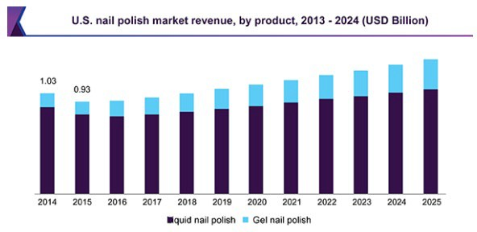

- Gel polish is one of the upcoming products garnering a lot of attention. It is expected to be the fastest- growing segment with a CAGR of 10.5% from 2016 to 2024. The demand is driven by its ability to provide a long-lasting glossy finish. The gel segment is gaining popularity, especially in developed regions such as North America and Europe.
- The affordability and durability of gel nail polishes are expected to be among the key factors driving market growth. However, the product penetration is expected to remain low owing to the high cost.
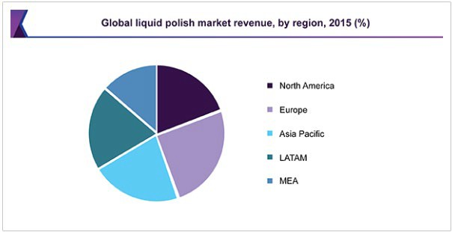
*Cited: https://www.grandviewresearch.com/industry-analysis/nail-polish-market

Competition

Cozy Nails and Spa
  - Madison, WI
  - https://cozynailsmadison.wixsite.com/mysite
  - This company went for the hero design trend on its main page. Relatively simple, not much on the main page besides important information: Contact number, navigation tabs, social media icons, hours of operation. They also did an excellent job of adding a gallery that displays their work.

Sky Nails
  - Fond du Lac, WI
  - http://www.spadulac.com/
  - I like the idea of customers having different ways to schedule an appointment. You can schedule an appointment on the website, through Facebook, text, calling, email, walk-ins, etc. Also, just like the other competitors, the website lists all services and prices of those services. The website itself has a basic layout.

Pink Me Salon
  - La Crosse, WI
  - https://www.pinkmesalonllc.net/#/
  - Looking at the website, this nail salon does live up to its name, "Pink'' me. The page uses a few different shades of pink. The main page has an overlay of an image to stay consistent with the aesthetic. To the left of the page is a fixed navigation bar. A great addition that they added was a section about the artist themselves.

Target Market Segments
- Demographic Segment: The Nail Hive's demographic targets mainly women ages 35-54 with a medium to high-income level, women ages 18-34 with a low to medium income level, and women ages 55+.
- Psychographic Segment: The Nail Hive psychographically targets individuals interested in self beauty and self-care, are willing to pay for luxurious salon services, are eager to treat themselves to a high- quality relaxing experience, and enjoy fashion and trends.

Priority Segment
- The top priority among the targeted market segments is women between 35 to 54. Their demographic part has more disposable income and represents most of the Nail Hive’s current clientele for product purchases.

Product Analysis

Brand Products:

Nail Hive Salon: Nail Files and Buffers
  - Nail Files and Buffer, TsMADDTs Professional Manicure Tools Kit Rectangular Art Care
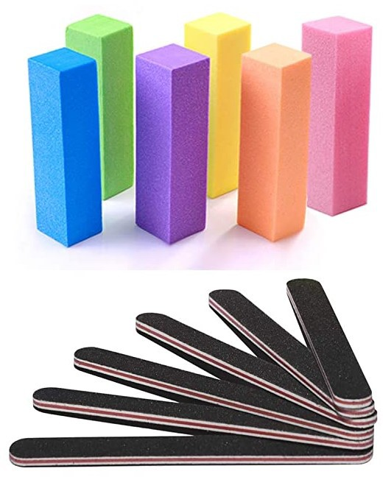
  - About Nail Files (6 pcs Nail Files):
    - Material: Sandpaper + EVA
    - Color: Black
    - Size: 17.8 x 1.9x 0.4cm
    - Quantity: 6 pieces
    - Surface: grit 100/180
  - About Buffers (6 pcs Nail Buffer Block):
    - Material: sand surface sponge
    - Size: 9.6 x 2.5 x 2.5 cm
    - Color: purple, yellow, orange, pink, blue, and green
    - Suitable for: nail salon, nail competition, makeup studio, or home use
    - Quantity: 6 pieces
    - Surface: all four sides are sand surface
  - Description:
    - The tools are suitable for fingernails, toenails, natural nails, acrylic nails, and false nails, fit for all who like nail art.
    - Shape your nails to your desired style with two grits to help you smooth your nails. You should always file the nails in one direction instead of back and forth to help ensure the nails will not split in half.
  - Comparison: to the CGBE Nail Files and Buffer Manicure Tools Kit, which only has a two pc nail buffer block, but seven nail files. Unlike the TsMADDTs Manicure tools kit, this get is made of adhesive tape, which may wear over time with washing the nail files over time. The reviews on the other kit are highly recommended for at-home use or in a Nail Salon, whereas this kit got fewer reviews and is instead coarse on the nails.
- USP: We want to ensure the Nail Hive salon's best quality nail files and buffers. We test our products and find the best reviews of the products we use on you. There are plenty of nail files and buffers out

there, but we want to ensure that you get the best quality that we use in our salon when it comes to our products.

Nail Hive: Gel Nail Polish Set
  - Modelones Gel Nail Polish Sets
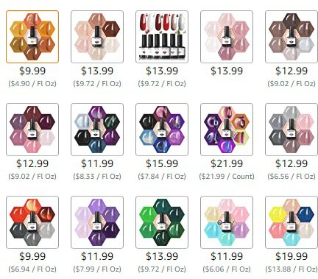
  - Color Variants: Come in a variety of nail colors (see image below):
  - Description: Modelones Gel Nail Polish Sets come in various sets and colors. If you want to change your color before your next appointment, try the Modelones Gel Nail Polish. It comes in multiple colors or even just that one look you have been looking for that particular day. It lasts up to 2 weeks, is chip-resistant, and toxin-free with cruelty-vegan and low smell.
  - Comparison: With the other competitions out, there are a variety of nail polishes out there. Bensel Nail Polish does come in various colors. It does not pond well when applying the nail polish. It is also a product that is not toxin-free with cruelty-vegan and low smell.
- USP: With the Nail Hive salon, we like to provide cruelty-free products that are not tested on animals, are toxin-free, and have a low smell. Ensuring this will be safe not only for all but also for children.

Retail Products:

Cuccio Naturalé Revitalizing Cuticle Oil
Scents: Milk & Honey, Pomegranate & Fig, Vanilla Bean & Sugar
Sizes: 0.5 oz.; 2.5 oz.
Product Description:
Natural and rich oils and Vitamin E nourish and revitalize your cuticles and skin between manicures. Created by salon and spa beauty experts, Cuccio’s Revitalizing Cuticle Oil applies a soothing moisturizer to your cuticles for lasting hydration and cuticle care. Its natural formula is designed to absorb quickly and protect against cracking and dry skin.
Comparison:
This product is comparable to OPI ProSpa Nail & Cuticle Oil and CND SolarOil Nail & Cuticle Conditioner. Unlike these oils, Cuccio cuticle oil comes with mild and refreshing scents, which according to reviews, many customers favor. Cuccio’s cuticle oil also differs in bottle shapes and applicators. Both OPI and CND prefer nail polish-style bottles. Cuccio uses a dropper to apply droplets to the cuticle easily. Cuccio’s has two size variations for this product instead of a single 0.5 bottle.

CND Scentsations Hand and Body Lotion
Scents: Tangerine & Lemongrass, Black Cherry & Nutmeg, Lavender & Jojoba
Sizes: 8.3 oz.; 33 oz.
Product Description:
Hydrate your skin with CND Scentsations Lotions for a luxurious spa experience in your home. Enjoy clean and relaxing fragrances while providing your skin with soothing essential moisture. Its velvety and profoundly hydrating formula is designed and dermatologically tested to soften dry skin quickly. Comparison:
Comparable to Codi's hand and body lotion and similar lotion products, CND Scentsations mainly differs in its combination of fragrances and its bright, colorful, and painted style packaging. Codi lotion has a natural branded appearance with a green bottle and a tan and leafy label. CND lotion is also available in two bottle sizes and is from a professional salon brand, where Codi lotion comes in one bottle size, and its brand varies into other products such as luggage.

- Natural Cosmetics Luxury Hand and Body Soap Gift Box Scents: Kiwi, Strawberry, Pomegranate, Pineapple Weight: 450g per bar
Description: Begin by filling with authentic, all-natural, and organic ingredients. Our triple-milled soaps will leave your face and body feeling cleansed, hydrated, moisturized, and lux. Natural Cosmetics Luxury Hand and Body soap blend the essential oils for a scent that cannot be resisted. Enjoy a selection of 4 irresistible scents that will leave you wanting more. Our soap is vegan, cruelty-free, cold- pressed & made of palm and all-natural ingredients. These sustainable products are paraben-free, sulfate-free, and have natural scents from therapeutic essential oils.

Comparison: Commercial bar soaps are produced on a large scale with harsh chemicals, synthetic ingredients, cheap fragrance oils, and artificial colors, all of which can irritate your skin. Natural Soaps like Natural Cosmetics Luxury Hand and Body Soap is made of natural materials, like pure plant-based oils, oats, honey, and goat milk. These natural ingredients in a bar of soap will work wonderfully for your skin.

- Glamne Nail Care Kit Color: Purple, Gold, Pink Weight: 10.55 Ounces
Description: High-quality, beautifully made manicure and pedicure set with 12pcs helpful nail and toenail tools, multi-functions for hand care, facial care, and foot care. Each tool of the nail kit is manufactured by the careful process of cutting to make sure it can be used more comfortably. The small size of this kit makes it portable and lightweight, which is easy to carry, great for travel and home care!
Comparison: This kit was in comparison with the Redflow 30-in-1 nail kit. Although the Redflow kit had more tools, customers found it too crowded and had difficulty removing and inserting tools back into the kit. Also, customers mentioned having tools that have nothing to do with the upkeep of nail care in their kit. Glamne’s kit only has 12 tools that are essential for nail care.

Unique Selling Proposition
In examining Nail Hive's products, we have developed a few Unique Selling Propositions and approaches to help differentiate Nail Hive’s products from competitors.
- From Our Salon to Your Home
- Many products claim to be salon-level beauty products. Your brand has developed products that you use in your salon.
- A portion of Nail Hive brand products could be donated to support Wisconsin BeeKeepers, such as the Wisconsin Honey Producers.

Advertising and Marketing Strategies

Branding and Pricing Strategies
The critical elements of a branding strategy are differentiation, relevance, and perceived value. Our rationale for each component is a summary of previous discussions and our market study.
Differentiation – Distinguishing “The Nail Hive” from the competition.
The quality of service provided by “The Nail Hive” is core to your mission statement and goals. Your website, blog, and social media presence must convey professionalism. The addition of precise, current, and valuable content will demonstrate this. Your web presence will need regular attention, devotion, and maintenance.
Creating an email newsletter with fresh content distributed on a reliable schedule will reinforce your professional image.
Your slogan “see image below.” conveys your sentiments about the exceptional environment that you offer. Your unique logo also speaks to this and should be used regularly. It needs to be in a file format that can be ‘crisply’ sized to avoid losing any resolution, which will vary depending on where it is used in marketing, advertising, or products.
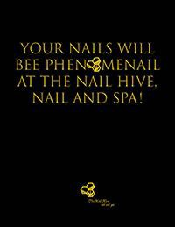
Relevance – Helping to remind clients and interested prospects.
Online store offerings should be helpful and prominently displayed with the logo and key colors. As the products are used, clients will be reminded of your business, which will help to build commitment. Others will see the brand and hopefully become interested and grow familiar with the brand.
Perceived Value – Money spent was well worth it.
The brand should strive to convey good value for the cost of enrollment in services. Web presences and content need to reinforce this to maintain client commitment and attract prospects.

About online products: The products should be relevant and valuable; product appearance should convey your slogan and leverage branding colors; the quality should be very good or excellent to hold up under use so that the value extends.
Cross Promotion Strategy - Create discount coupons and promotions for purchases in the eCommerce store that can apply directly to your salon services and vice versa. This would support customers who visit your salon and encourage them to check out your site. For example, spend $20 in the Nail Hive’s eCommerce store and receive free nail art with your next appointment.

Customer Relations Strategies
- The customer-based marketing strategy will focus on Nail Hive’s customers' ability to find what they need and benefit from shopping online. Customers will find products based on color and the product type they want to choose from when searching the site. The company will focus on the different levels of wants and needs for their nails. When they come to the website to shop, they will find products that best suit their needs when it comes to their nails. That way, people are familiar with the products we sell and use for our nails.

- Relationship Strategy: The Nail Hive will develop a strong relationship with its customers by using its products in the nail salon. At the same time, others learn how to use their products at the nail salon and ask for them at home. When people purchase the products for themselves, there will be little to no learning curve on using the product and visiting the nail salon since they have already been using it. People will relay their happiness with the products to their peers and social media. As an example, a photo captioned, "Look at Sabrina loving her new gift, and what I learned from the nail salon, and I got it at The Nail Hive." There will then be a new segment of customers based on word of mouth.

Customer Service Strategies:

Ask for feedback
    - Follow up a purchase with a recap of the order, but also ask the recipient to send comments or concerns about the delivery of the product or the product itself. Include rating and review tools on product pages. Give people opportunities to communicate with and about your business, and they'll take them.

Send out surveys
    - Create surveys to get a sense of what consumers want. Make it easy for respondents to fill out and submit their answers. It's a helpful method for listening to your customers to understand if they're happy or not with your brand, product, or services.

Online Advertising and Marketing Strategies

Advertising
- Create banner ads
  - Use Java to create attention-grabbing banner ads.
  - Use a non-intrusive but eye-catching ad.
  - Popups are annoying to most customers, and usually, close the window before reading into that.
  - Use either a top banner or a side banner ad.

Email Newsletter
- Create a small newsletter sign-up form in the footer.
- Add functionality to send a “welcome email” when signup is submitted.
- The welcome email outlines what kind of content they can expect from you or offer details of a special offer they might have signed up for to receive it.

Google Business Account
- Create a free google business account to show up on google’s listings.
- Add location, store hours, and contact information.
- Embed listing on the contact page.

Offline Advertising and Marketing Strategies
- Up-sell – Offer every client you see a product or service that goes great with the service you just gave them. If your client has a manicure, offer a mini pedicure or hand lotion.
- Referral Cards – If your client enjoyed their visit with you, let them know you are looking for more great clients and would love to bring a friend who likes to get their nails done.
  - Give your client a referral card that offers % off services to give to their friend to use when they come in.
- Re-book – Before your client leaves, book the next appointment. It is a great way to keep your books filled and keep clients coming in regularly like clockwork.
  - Explain to your client the value of keeping up a schedule.
  - Suggest dates that might be best for the client.
- Call your clients to confirm appointments. Calling ahead of time is probably the best way to reduce no-shows. Sometimes, it allows you to fill that slot if your client can not make it, keeping your cash flow on track.
  - Call AND text 48 hours before the appointment to confirm.
  - Leave detailed voicemails if clients don't answer.

- Customer Loyalty – Keep in contact with clients. Use your Facebook or Twitter Account to "mingle" with them. Give beauty tips and be a great source of information.
  - Give loyal customers a punch card that rewards them each time they visit you for a nail service. After a certain number of appointments, they get a free nail service or a percentage off.

Domain Name Strategies
- Selecting the right domain name is one of the essential steps in creating your brand or business. Your domain name is frequently one of the primary things somebody sees, and it can impact their thought of your website and your brand. A sensible selected domain name may increase user interest and drive web traffic, while an inaccurately chosen might have the opposite outcome. When feasible, your domain name should also be the name of your business. It should be simple and as short as possible.
- With that in mind good criteria for a domain name, we have some suggestions below:
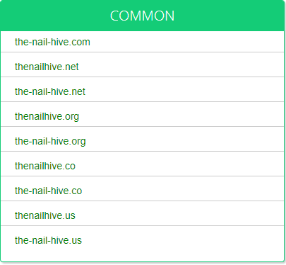
*Resource: https://www.namemesh.com/

Domain Name Recommendation:
- www.the-nail-hive.com
- Websites that end with .com are the easiest to remember; they are also a recognized domain extension. Using your business name for the website with the .com extension will give you the results you want to achieve with both you are the customers searching with search engines.

Preliminary Internet Marketing Budget

This budget contains the price for including initial marketing materials and strategies with your eCommerce website. Additional monthly marketing can be budgeted on request and included with maintenance.

JARS eCommerce Marketing Implementation |  | $60/hr
Branding and Pricing Strategies | Brand Marketing | $180
Branding and Pricing Strategies | Advertisements | $210
Branding and Pricing Strategies | Promotional Materials | $120
Strategy and Marketing Development |  | $190
Customer Relation Strategies | Surveys/Feedback | $60
Customer Relation Strategies | Policy Development | $60
Estimated Total Cost |  | $1000

Traffic Building Plan

Introduction
Below is a plan we have designed to help bring traffic to your site. Traffic building is an essential part of gaining business and customers for your company. The more traffic your site gets, the greater chance someone will buy something. We have three different packages offered, or you can build your package by choosing individual sections. The packages range from a starter, which your site maintenance, to ultimate. Our premium plans help with the latest social media marketing standards and practices. Would you please read through all of the material and choose the plan that best fits your company and its needs?

Traffic Building Packages
Below is the Traffic Building Package we offer. You can also purchase each subsection separately or at a later date.¹

Starter plan (Included with Site)
- SEO Strategies – Site and Content Optimization
- Email & Newsletter Strategies – Monthly Newsletters Starter Package

Advanced plan
- SEO Strategies – Site and Content Optimization, S.E.P. Google Ads Management
- Email & Newsletter Strategies – Monthly Newsletters Starter Package, Social Media Integration, Custom Templates/Graphics
- Social Media Strategies – Facebook & Instagram

Ultimate plan
- SEO Strategies – Site and Content Optimization, S.E.P. Google Ads Management
- Email & Newsletter Strategies – Monthly Newsletters Starter Package, Social Media Integration, Custom Templates/Graphics, Autoresponder Setup, Additional Newsletter Materials
- Social Media Strategies – Facebook, Instagram, LinkedIn, & TikTok
- Affiliate Program Management

¹ External cost from third-party businesses is not included in the pricing of these plans. Each plan is open to negotiation based on client needs and preferences.

Search Engine Optimization Strategies

On-Page SEO Ranking Factors
- Relevant Content: Nothing plays a more significant role in your SEO efforts — and the success of your inbound marketing strategy overall — than the quality of your content. After all, that's why people come to your site in the first place. Providing helpful, engaging, and, most importantly, relevant content is essential if you want to be found in search results.
- Keywords: Keywords are the search terms you want to rank for; this includes them throughout your website and incorporates them strategically into some of the elements described below. However, don't overdo it — the keyword "stuffing" is highly frowned upon and may end up hurting your site's visibility.
- Titles & Title Tags: The title of your site and individual pages have a tremendous impact on your rankings. Try to work core keywords into your titles whenever possible.
- Headings: Search engines place more weight on headers than other text within your site. Be sure you use the appropriate heading tags (H1, H2, H3), and work in keywords here.
- URL Structure: One of the most frequently overlooked — and underutilized — aspects of onsite SEO is URL structuring. How your URLs are structured — and the words they contain — can seriously influence your SEO results. Structure your URLs in a way that makes it easier for search engines to crawl your site and include relevant keywords. Avoid generic URL strings, such as "yourshop.com/page1234343," and instead use "yourshop.com/cnc-machining-services."
- Meta Description: A meta description is the small blurb of information that appears directly below your page's title in search results. You can easily edit this information in WordPress, HubSpot, and other website publishing tools.
- Page Load Speed: Believe it or not, how fast your page takes to load is a significant ranking factor. Ideally, your pages should load in less than three seconds, and if yours is taking longer than that, it could cause frustration for your visitors and hurt your site's performance. A straightforward way to speed things up is to reduce the sizes of your images using free tools like tiny png.
- Alt-Text: Speaking of images, you want to use them as an opportunity to boost your SEO rankings by including keyword-rich and relevant alt text — essentially a text summary of an idea — for every visual on your site.
- SSL Encryption: A relatively new ranking factor, website security is essential to search engines and your visitors. Be sure to convert your website from HTTP to HTTPS.

Off-Page SEO Ranking Factors
- Backlinks/Inbound Links: The core of off-page SEO is linked to your site from other sites. Having a backlink from a high-quality site can help give your site a boost. One of the best ways to acquire backlinks is to produce content that other people want to share. You can also consider submitting guest blogs to trusted industry websites or listed on popular and respected industry sites and platforms.
- Leveraging Video: The second biggest search engine globally isn't Bing or Yahoo — it's YouTube. By establishing a company YouTube channel, publishing engaging videos, and linking back to your site, you can positively impact your SEO.
- Add video tours of your shop floor to your website and Thomasnet.com Company Profile — they have been proven to increase sales. Please look at the example below from a manufacturer who took advantage of our free video advertising services to improve their RFQs.
- Social Media: Promoting your content on your social media accounts won't necessarily help you shoot up the search rankings, but if your content is picked up and shared by the right influencers, that can be huge.
*Resource: https://blog.thomasnet.com/onsite-seo-vs-offsite-seo-whats-the-difference

SEO Strategies
Search Engine Optimization (SEO) affects the visibility of a website in search engine results. Many strategies can be used to gain better SEO. Some of these strategies are done on your site, and others are done by gaining inbound links to your site through various sources.

Meta Tags
  - Using Meta Tags gives search engines more info about the web page and will be found in the
<head> element.
  - Meta Description - Will include a short description of your company. This is the description shown below your site on a search results page.
  - Meta Keywords - This will include a series of keywords that describe your company. This would consist of products and services offered.

Examples
  - Nails, Spa, Nail Salon, Manicure, Pedicure, Nail Art, Nail Polish, Gel Polish, Dipping Powder, Acrylic Nails, Acrylic, etc
- Title Tag - This is the main title of the page.
  - Each page has a title tag that pertains to the content displayed.
  - Example - Contact page will have a title that says: J.A.R.S Web Design - Contact Us
- Title Tag - is used by the following:
  - The title is displayed in the browser toolbar
  - The title is used when a page is added to Favorites.
  - The title is displayed in search results.
- Alt Attribute - Alt attributes are the alternate text to an image, and they are used for accessibility but are also used by search engines.
  - The alt attribute will include a couple of words that describe the picture being displayed.
  - The description is then displayed in some browsers when you hover over the image, and it is also picked up by search engines when they are crawling/indexing your site.
  - All images on your site will include an alt attribute
- Title Attribute - This is formed on a hyperlink tag. It is a short couple-word description of a hyperlink.
  - The description typically includes where the link is going.
    - Example - Contact link could have the following title attribute: 'Contact Information
- Page Structure - This includes appropriately using heading tags.
  - Each page should only have a single h1 tag
  - Each may have multiple h2-h6 tags.
- Web standards - These are a set of highly recommended standards for coding a website. Your site will be coded to these standards, which will be beneficial for SEO.

Search Engine Positioning Techniques
As a subset of SEO, Search Engine Positioning (S.E.P.) techniques and strategies drive website traffic through higher rankings in search results and better search visibility. A majority of these techniques will be implemented as a part of SEO strategies and optimization.

Optimize Content for Voice Search
  - Conversational questions and optimizations for voice search will be added and included with the content. Questions (where fitting) will be retained for headings/titles or in optimal locations throughout the range.

Internal Linking
  - Internal linking adds to existing or new content that connects your content in valuable and informational ways. This linking can drive users to other related pages and blog posts.
  - We will add internal linking between related pages and content across your site using this technique. Blog pages will be linked to related blog content, and product pages will be linked to associated products.

External Linking
  - Including links to authority websites or high-quality content from external sources increases
S.E.P. and increases the value of your content. These links will be added to content where appropriate, and we will not add external links to any direct competitors.

Backlinks / Inbound Linking
- Gaining inbound links to your site will help your website's overall S.E.P. We can increase inbound links to your site through several strategies.

Social Media Backlinks:
  - When included with our social media strategies and tools, social media posts will contain valuable backlinks to website pages, products, and content.

Reciprocity Marketing:
  - By including external links, establishing relationships and reciprocity with other websites increases inbound linking. Our team will aid in this by reaching out and establishing contact with other businesses and websites, including websites that currently link to your site pages.

Google Ads Campaign and Management:
  - Included with our Advanced and Ultimate Traffic Building Plans, we will assist your website in managing and maintaining a Google Ads campaign. We will assist the Nail Hive in creating an Ad budget fitting for your business.

  - Keywords and Positioning: We will curate a list of keywords for your business to target with Google advertising. This type of advertising is for competitive google search results that target keywords.
  - Display and Banner Ads: For your website, we will create and design high-quality, responsive, marketable banner ads for a Google Display Ad Campaign. We typically offer our clients a starting package of 8-10 banner ads by selecting our Google Ads Management tool. These advertisements may vary based on request and amount/size.

Affiliates & Link Exchange

What are Affiliates?
- Systems that pay a percentage of sales revenue to the website refer to a purchaser. These differ from sponsorship programs because payment depends on an actual sale during the guided visit.
- A sales relationship in which an advertiser/website owner pays an affiliate to sell and market and link to their products, usually through posting banners, social media posts, buttons, links, etc.

Affiliate Marketing Tools
- Several well-known companies can provide tools and access to their affiliate networks for e- commerce websites. We recommend any of the following to our clients who are looking for additional reach and services:
  - Rakuten
  - Impact Radius
  - ClickBank
  - Avantlink

Affiliate Program Management: What We Offer
- Included with our ultimate traffic building plan, our digital marketing team helps develop and curate an affiliate program tailored for your website. We will:
  - Create connections with potential affiliates
  - Establish a payout system for affiliates that fit your business:
    - Commissions from direct sales
    - Commissions from sign-ups follow, etc.
    - Pay per click
  - Set program objectives, goals, and key performance indicators.
  - Create incentives for affiliates
  - Our affiliate program management starts at $60 per month.

Email & Newsletter Strategies

Email Accounts:
- Regularly email subscribers using a mailing list software
- Mailing list software gives you greater control
- There are also free services available

Newsletters:
- Email Newsletters are a great cost-effective way to provide information to your clients. It doesn't cost much to set up, and there are minimal costs to create the newsletters.
- You will need to create an account with an Email Campaign company. Below are a few we recommend using:
  - MailChimp
    - Starting Plan (Free)
  - Constant Contact
    - Starting plan ($20/Mo)
- Once you have an account set up, we will create and implement a newsletter sign-up form on your website.
- Email campaigns/newsletters can be created by you using your account. Most email campaign companies provide an array of templates to choose from in the selections.
  - Some companies allow you to post your newsletter directly to your Facebook and Twitter accounts.
- Cost
  - Starter Plan - $90 (Included with the website)
    - Weekly and Monthly Update Newsletters: for new product features or content summaries
    - Seasonal Newsletters: for any changes in seasonal products
  - Advanced plan - $150
    - Social Media Integration
    - Custom High-Quality Graphics
    - Custom Templates
  - Ultimate Plan - $200 per month + $100 set up fee
    - Autoresponder Implementation
(Up to 15 total, may depend on/require newsletter software)
    - Additional Custom Newsletter Materials and Designs

*We estimate a 10% turnover rate on emails sent.

Social Media Strategies
One of the main reasons you should use social media marketing is to increase your website traffic. This is not theoretical, but social media can become a great source of traffic that can help you establish a successful online business.

Facebook
- Set-up
- Page
  - Create a page for the company
  - Upload profile photo
  - Upload cover photo
  - Add company Info
- Cost for set-up
- cost for set-up is $100
- Content
- Create compelling and shareable content
- Add links to content postings
- Schedule content posting
  - Co-Schedule
    - A calendar that helps you see, schedule, and share your content.
    - $29/mo.
- Cost for content management $75

Instagram
- Set-up
- Account
  - Create an account for the company
  - Upload profile photo
  - Add company Info in bio
- Cost for set-up
- cost for set-up is $50
- Content
- Create compelling and shareable content
- Add hashtags to content postings
- Schedule content posting
  - Co-Schedule
    - A calendar that helps you see, schedule, and share your content.
    - $29/mo.
- Cost for content management $75

LinkedIn
- Set-up
- Page
  - Create a page for the company
  - Upload profile photo
  - Add company info in bio
- Cost for set-up
- cost for set-up is $100
- Content
- Publish quick status updates
- Add links to status updates
- Schedule content posting
  - Co-Schedule
  - A calendar that helps you see, schedule, and share your content.
  - $29/mo.
- Cost for content management $75

TikTok
- Set-up
- Account
  - Create an account for the company
  - Upload profile photo
  - Add company info in bio
- Cost for set-up
- cost for set-up is $50
- Content
- Create compelling and shareable content
- Add hashtags to content postings
- Schedule content posting
  - Loomly
    - Loomly is a social media posting and scheduling tool that helps you manage your social media content, including organic posts and ads, from a single platform.
    - $25/mo.
- Cost for content management $75

Rich Answers
Rich answers are the snippets of information usually found in boxes above the typical search results. These rich results are extracted from websites that rank high in search engines, answering a question in what Google thinks is a comprehensive way and using a form of structured data markup that aids Google in displaying them dynamically.

Optimize Site
- Implement Schema Markup (Schema Markup is vital to obtaining a page regarded as a rich answer)
- use Google's structured data markup helper.
- Add microdata to source code.
- Add title and head tags.
- Make a list of common topics your customers ask about
- Use keyword research tools like
- Keywords F.X.
- Keyword Tool
- Google AdWords Keyword Planner to uncover specific phrases and keywords.
- Create content to address/answer questions.
- Total cost to implement rich answers $75

Preliminary Traffic Building Budget

JARS Traffic Building Tools |  | Starter Plan | Advanced Plan | Ultimate Plan
Search Engine Optimization | Content and Website Optimization (SEP included) | $210 | $210 | $210
Search Engine Optimization | Google Ads Management | - | (10%)² | (10%)
Search Engine Optimization | (Initial Setup Cost) | ($120) | ($200) | ($200)
Search Engine Optimization | Total | $210 | $210 | $210
Newsletter Marketing | Monthly Newsletters Package | $90 | $90 | $90
Newsletter Marketing | Custom Graphics/Templates Social Media Integration | - | $60 | $110³
Newsletter Marketing | (Autoresponder Setup) | - | - | ($100)
Newsletter Marketing | Total | $90 | $150 | $200
Social Media Marketing | (Initial Setup Cost) | - | ($150) | ($300)
Social Media Marketing | Content ($75 per platform: Facebook, Instagram, LinkedIn, TikTok) | - | $150 | $300
Social Media Marketing | Maintenance | - | $30 | $60
Social Media Marketing | Total | - | $210 | $360
Affiliate Program Management | Total | - | - | $60
Estimated Total Monthly Cost |  | $300 | $540 | $830
Estimated Total Setup Cost |  | ($120) | ($350) | ($600)

² This percentage cut may vary depending on your determined monthly ad budgeting and a positive ROAS threshold.
³ The Ultimate Tier for Email/Newsletter Marketing includes additional monthly designs and marketing materials customized for your business.

The Nail Hive Content Outline

Home: index.html
- Navigation
- Logo
- Hero Image

About: about.html
- Picture of
- Story of The Nail Hive

Services: service.html
- Natural Nail Prices
- Artificial Nail Prices

Booking: book.html
- Booking Times
- Choose staff you want to book with

Gallery: gallery.html
- Salon Photos
- Nail Design Photos

Contact Us: contact.html
- Name
- Phone Numbers
- Address
- Email
- Social Media Icons
- Map

Content Delivery Plan

Content Description | Notes | Draft Due | Final Due | Assigned | Status
Home: index.html
Meta Tags, keywords, and site descriptions | Will be included on every page
Navigation | Top right, and RWD
Company Logo | Top Left and will be included on every page
Footer | Copyright will be included on every page
Hero Image | Will be on the home page (index.html)
About: about.html
Picture of | jpg
Story of The Nail Hive | Text and p tags
Services: service.html
Natural Nails List Prices | List style of prices
Artificial Nails List Prices | List style of prices
Booking: book.html
List of booking time hours and days | List style of days and hours on the left
Pictures or icons and a list of staff to choose from | The grid layout of staff

Gallery: gallery.html
Images of the Salon | RWD Image Gallery using Flexbox
Images of Nail Designs | RWD Image Gallery using Flexbox
Contact Us: contact.html
Contact Form | H3 tags and p tags  First and Last Name, Country, and Subject
Social Media Icons | Facebook, Instagram. Using font-awesome

Site Map Visual for The Nail Hive:

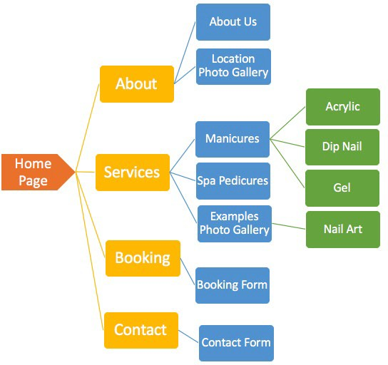
Site Map Key:
- Home Page ▪ Site Pages ▪ Content ▪ Secondary Content

By signing this document, you approve of the site visual structure as detailed above: X
Customer Print Name
X

The Nail Hive: Naming Conventions
- All the files and folder names will be separated with an underscore “_” and contain no spaces.
- When naming files or folders, it will appear with lowercase letters and numbers (nothing else).
- All file and folder names will be short and straightforward.
- There will be the use of meta tags for keywords and descriptions.
- All images will include the alt tag with keywords related to the picture.
- All web files are familiar and recognizable with standard extensions.

File Types | Extensions | Using
Microsoft Word | Editable Documents | .docx, .doc
Portable Document Format (PDF) | Non-Editable Document | .pdf
HTML Documents | Webpage | .html
CSS Documents | Webpage styles | .css
JavaScript Documents | Forms, buttons, etc. | .js
JPG | Pictures/Images | .jpg
PNG | Pictures and Images with a transparent background | .png

The Nail Hive Wireframe
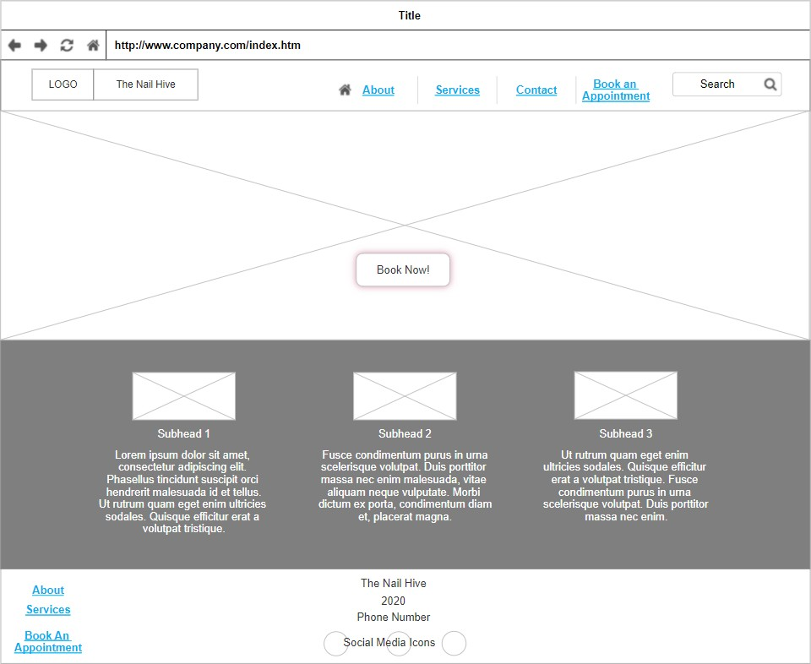

Title
- http://www.company.com/index.htm
- LOGO
- The Nail Hive
- About
- Services
- Contact
- Book an Appointment.
- Search
- Book Now!
- Subhead 1
- Subhead 2
- Subhead 3
- About Services
- The Nail Hive
- 2020 Phone Number
- Book an Appointment.
- Social Media Icons

The Nail Hive Navigation Structure Plan
The Nail Hive’s website's proposed layout will be composed of five content pages and contain zero subpages. To present user-accessible links to these pages, the navigation structure for the Nail Hive’s site will be composed of the navigation bar, the footer, a search bar, and additional directional action button(s)/external links.

Navigation Bar
The navigation bar, across all pages, will be located at the top and contain links to the five content pages.
The logo and the company’s name, “The Nail Hive,” will be located in the upper left of the navigation bar. Clicking the logo and “The Nail Hive” will return or refresh the landing/home page.

The Nail Hive | Logo:
Will link the user to the landing/home page.

About:
Will detail information about the Nail Hive as a company, the staff, and the location venue.

Services:
Will describe the Nail Hive’s offered services, prices, and examples of past work.

Contact:
Will detail ways to contact the Nail Hive, links to the Nail Hive’s social media accounts, the Nail Hive’s address location, hours of service, phone number, and an online contact form for any questions.

Book an Appointment:
This will contain an online booking form for customers to book appointments online.

Search Bar
The location of the navigation bar, a search bar will allow users to search for key terms across the site’s content pages and access pages related to their search.

Footer
The footer, across all pages, will be located at the bottom of the page. It will contain links to the About, Services, and Book an Appointment pages. It will also collect information about the company’s phone number, address, and icon links to the Nail Hive’s social media pages: Facebook, Instagram, and Twitter.

Action Button
A “Book Now!” button will be located in the hero image section of the home page. Clicking this button will take the user to the Book an Appointment page.

Naming and Labeling Outline
This document will define the tone and standards for the labels, names, and headings of the Nail Hive’s website and serve as a guideline during the content development process.

Overall Tone
The Nail Hive’s salon provides customers with a high-quality, luxurious, and relaxing nail salon experience. The Nail Hive’s website content should present a professional, relaxing tone to reflect the Nail Hive’s brand and appeal to the Nail Hive’s target demographic as defined in the Creative Brief. Headings and labels should reflect this with labeling language and provide a clear, simple purpose for site users.

Naming Conventions and Guidelines
- Use names/labels considerations for site users first.
- Titles and descriptions will use clear, simple, descriptive language.
- Aim for SEO:
- Utilize Keywords
- Avoid abbreviations.
- Avoid special characters and symbols.
- Avoid generic labels.
- Use headings in the proper hierarchy and avoid excessive headings.

Navigation Labels
- The Nail Hive and Logo > index.html
- About > about.html
- Services > services.html
- Contact > contact.html
- Book an Appointment > booking.html
- “Book Now!” Call to Action Button > booking.html

Enhanced User Profiles
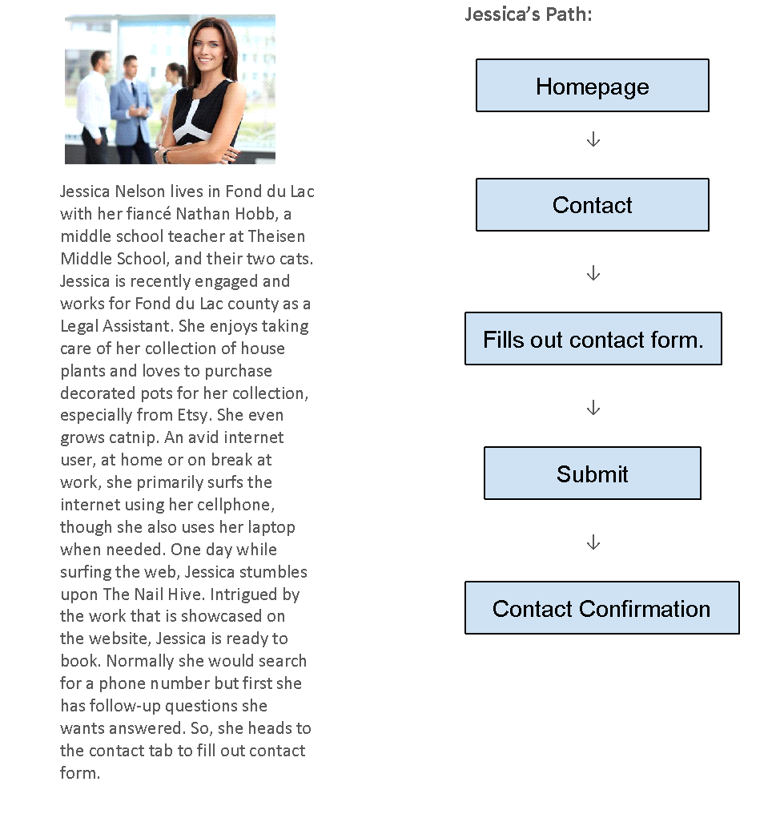

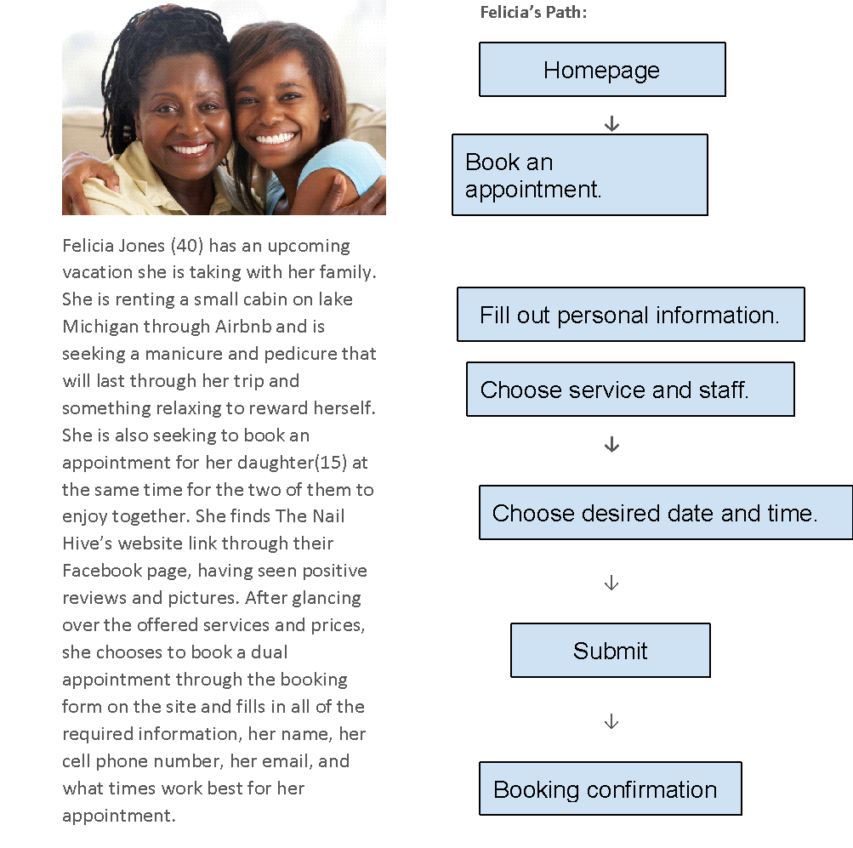

Color Design & Choices

Color Palettes
Color Palette 1: https://coolors.co/a54657-582630-f7ee7f-fdf4ec-f26157
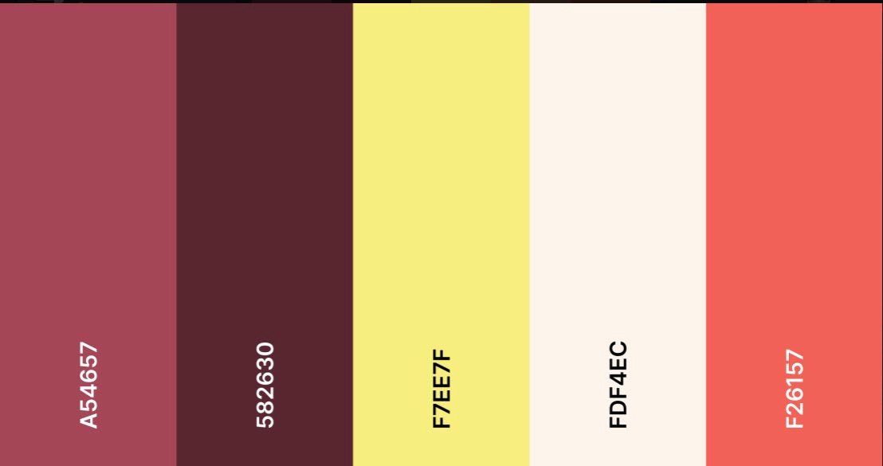

Color Palette 2: https://coolors.co/9258b0-4f2167-f7ee7f-f7d126-ffffff-388697-226b6d
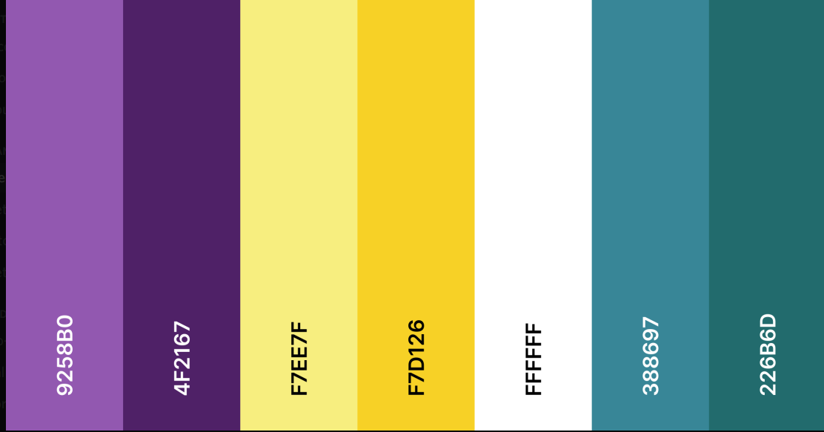

Layouts

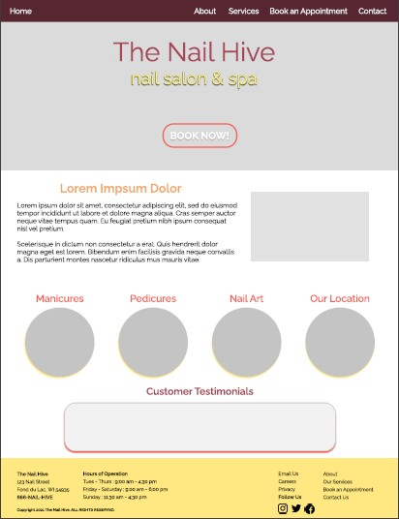
Layout 1 in Color Palette 1:

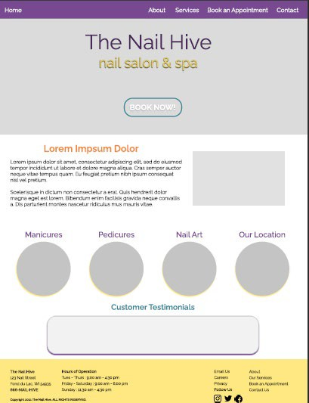
Layout 2 in Color Palette 2:

Visual Design Final Choice
The following color palette and website layout have been chosen by: The Nail Hive

https://coolors.co/9258b0-4f2167-f7ee7f-f7d126-ffffff-388697-226b6d
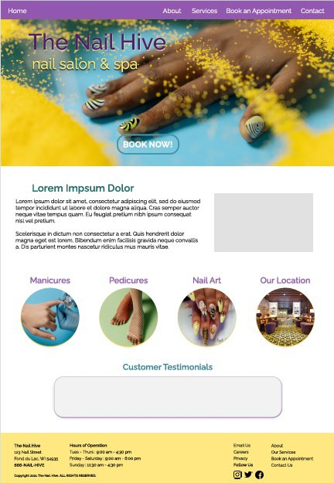

As a client of J.A.R.S Web Design, I have selected the above color palette and design for my website. I understand that further revisions will affect the budget and schedule of the website’s development.

Client signature : Rosalind Scott Date : 4/13/20

Production Guide
https://sabrinalarson.com/jars/the_nail_hive/index.html

Design Style Summary

Global Elements

Page Dimensions
- The overall layout will be dynamic.
- Media Queries:
- For Large Screens:
  - min-width: 1400px
- For Small Screens:
  - max-width: 700px
  - max-width: 799px

Navigation
- Logo: We have not designed an approved logo for the nail hive at this time. Upon design and approval, the dimensions of the logo will be: 50px by 50px and/or 25px by 25px.
- Background color: #9258b0
- Dimensions: width (360px - 1400px+) by height (65px)
- Navigation contains primary navigation links.
- The navigation bar is globally fixed at the top of the page.

Footer
- Background color: #F7EE7F
- Dimensions: width (360px - 1400px+) by height (181px - 681px)
- Footer contains navigation links, hours of operation, social media links, and contact/legal information.
- Footer is located globally at the bottom of the page.

Colors:
https://coolors.co/9258b0-4f2167-f7ee7f-f7d126-ffffff-388697-226b6d
- Background Color: #ffffff White
- Accent Colors: #9258B0 •, #F7EE7F •, #388697 •, #226B6D •
- Secondary Accent Colors: #4F2167 •, #F7D126 •, #B7B7B7, #F2F2F2
- Primary Text Color: #00000 • Black
- Text Box Background: #F2F2F2 •
- Navigation Background: #9258B0 • ; #F7EE7F • (On Hover)
- Navigation Links: #ffffff White ; #000000 Black (On Hover)
- Footer Background: #F7EE7F • ; Footer Text: #000000 Black
- Footer Links: #000000 Black ; #226B6D • (On Hover)
- Standard Links: #388697 • ; #9258B0 • (On Hover)

HTML Text
- H1, H2: varies globally.
- H3: font-size: 2em, color varies globally.
- H4: font-size: 16px ; font-weight: bold ; color: black
- Primary Text Color: #000000 Black ; font-size: 20px
- Navigation Text: font-size: 17px
- Footer Text: font-size: 16px ; no text decoration ; h4 tags will be bold

Graphic Types

Font
- Font Family: Raleway, sans-serif
(Additional fonts may be introduced upon approval from the Nail Hive.)
- Font Weight: Light, Regular, Medium, Semi-Bold, and Bold available

Photo/Image Treatment
- Photograph images will use .jpg. Graphic images will use .png or jpg appropriately.
- Photos/Images will be resized to the necessary design scale to maintain quality.
- Photos/Images will use resolution optimized for the web.
- Photos/Images will use alt text or titles.
- Photos/Images files will be compressed using a free online compressor.

Icons
- Global icons will use the font awesome icon library and consist of:
- Navigation Icons
  - fa fa-fw fa-home (home)
  - fa fa-info-circle (about)
  - fa fa-cogs (services)
  - fa fa-book (book an appointment)
  - fa fa-fw fa-envelope (contact)
  - fa fa-bars (drop-down menu)
- Social Media Icons
  - fa fa-Instagram (Instagram)
  - fa fa-twitter (twitter)
  - fa fa-facebook (Facebook)

Page-Specific Elements

Home Page:
- Header:
  - Dimensions: height: 400px - 600px ; width: 100%
  - It will contain a background hero image with a center positioning, a size of the cover, no- repeat, and a scroll attachment.
- H1 styles:
  - color: #00000
  - font size: 96px
  - text-shadow: 0px 4px 4px #F7EE7F
- H2 styles:
  - color: #226B6D
  - font size: 64px
  - text-shadow: 0px 4px 4px #000000
- Video:
  - Dimensions: width 40%, auto height
- Images:
  - Circle image links:
    - size: 160px - 200px by 160px - 200px
    - border: 2px solid #F7EE7F ; border radius: 50%
    - opacity transition from 0.85 to 1.0 on hover
- Button styles:
  - color: white ; color: #F7EE7F (on hover)
  - border: 6px solid #4499AF ; border: 6px solid #9258B0 (on hover)
  - transition of color and border on hover
  - font size: 2.25 em ; font weight: 600
  - text decoration none
- Testimonial Text Box:
  - background color: #F2F2F2
  - border: 1px solid #B7B7B7
  - box-shadow: 0px 4px 4px #9258B0
  - width: 80% ; height 175px
  - border radius: 40px

About Page
- Images
- Circle image links:
  - size: 160px - 200px by 160px - 200px
  - border: 2px solid #F7EE7F ; border radius: 50%
  - opacity transition from 0.85 to 1.0 on hover
- Text Box
- background color: #F2F2F2
- border: 1px solid #B7B7B7
- box-shadow: 0px 4px 4px #9258B0
- width: 80% ; height 175px
- border radius: 40px
- Button
- color: #9258B0 ; border color: #388697
- on hover: #388697 ; border color: #9258B0
- H1 Styles
- size: 64px
- H2 Styles
- size: 48px

Services Page
- Header:
  - Dimensions: height: 451px - 316px ; width: 100%
- H2 styles:
o color: #000000
  - font size: 52px
- Slideshow:
  - Dimensions: max width 1000px, auto height
- Images
o size: 1440 x 810

Book an Appointment Page
- H2 styles:
  - font-weight: 600
  - font-size: 52px
- H3 styles:
  - margin-top: 40px
  - padding-bottom: 15px
- Booking Form:
  - dimensions: 596 x 802
  - padding-bottom: 15px
  - color: #f7ee7f; color: #fff; color: #4f2167
  - font-size: 20px
  - box-shadow: 10px 15px 20px

- Button
  - color: #fff; background color: #000000

Contact Page
- H2 styles:
  - font-weight: 600
  - font-size: 52px
- Contact Form:
  - dimensions: 1023 x 867
  - color: #f2f2f2
  - font-size: 20px
  - box-shadow: 10px 15px 20px
- Button
  - color: #226b6d; on hover: #f7d126
- Input Text Boxes
  - width: 100%
  - border: 1px solid #226b6d

Technical Specifications

Introduction Technical Summary
The Nail Hive website will have the capability to connect to the internet to modify and view its content. The website will be a single page, with access to the navigation bar to take users to other pages. This web page will consist of text, images, links, and a logo.

Assumptions
The Nail Hive will provide J.A.R.S. Web Design with their preferred text content, images, graphics, and color scheme outlined in the previous documents. All of the material includes, but is not limited to, summarized in the Technical Summary. Users are responsible for maintaining their computers and systems.

Global Elements
It consists of elements that will be the same throughout their webpage. The Nail Hive will be a single page with access to the navigation bar to take the user to other pages with particular elements all through their webpage.

Wireframe

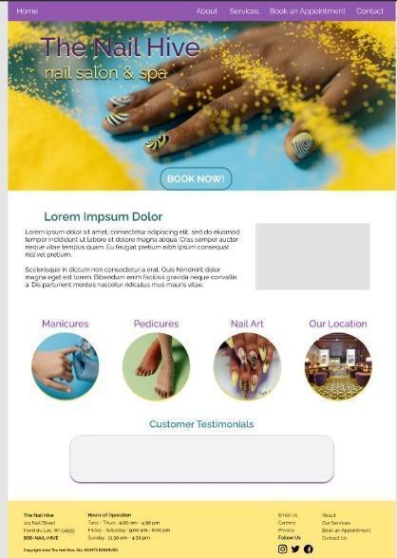

Global Elements

Global Head
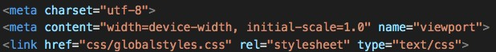HTML
- Additional stylesheets and title tags will be adjusted for every page.

Global Navigation
Image of Footer
HTML
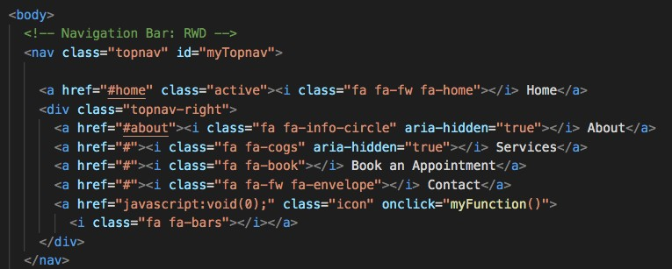

Global Footer
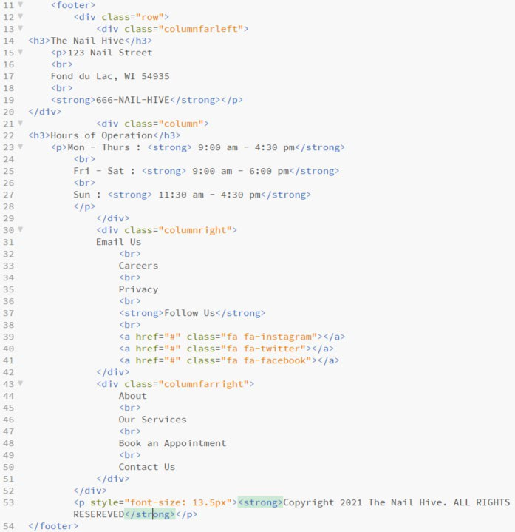
Image of Footer
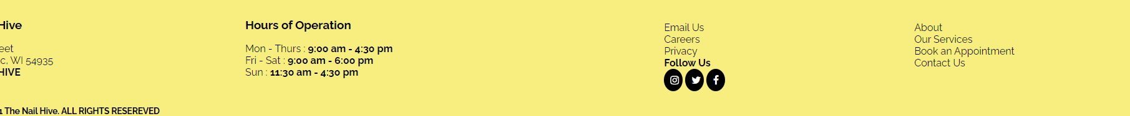

Page-Specific Elements

Home Page


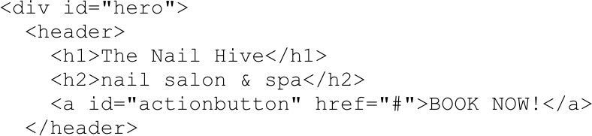
Header HTML:

Main Content HTML:
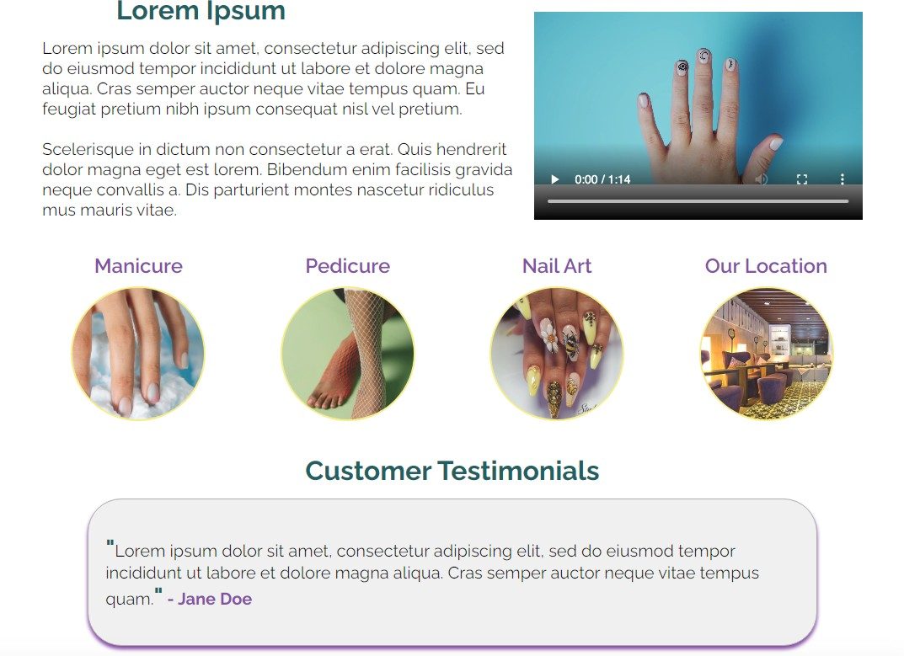
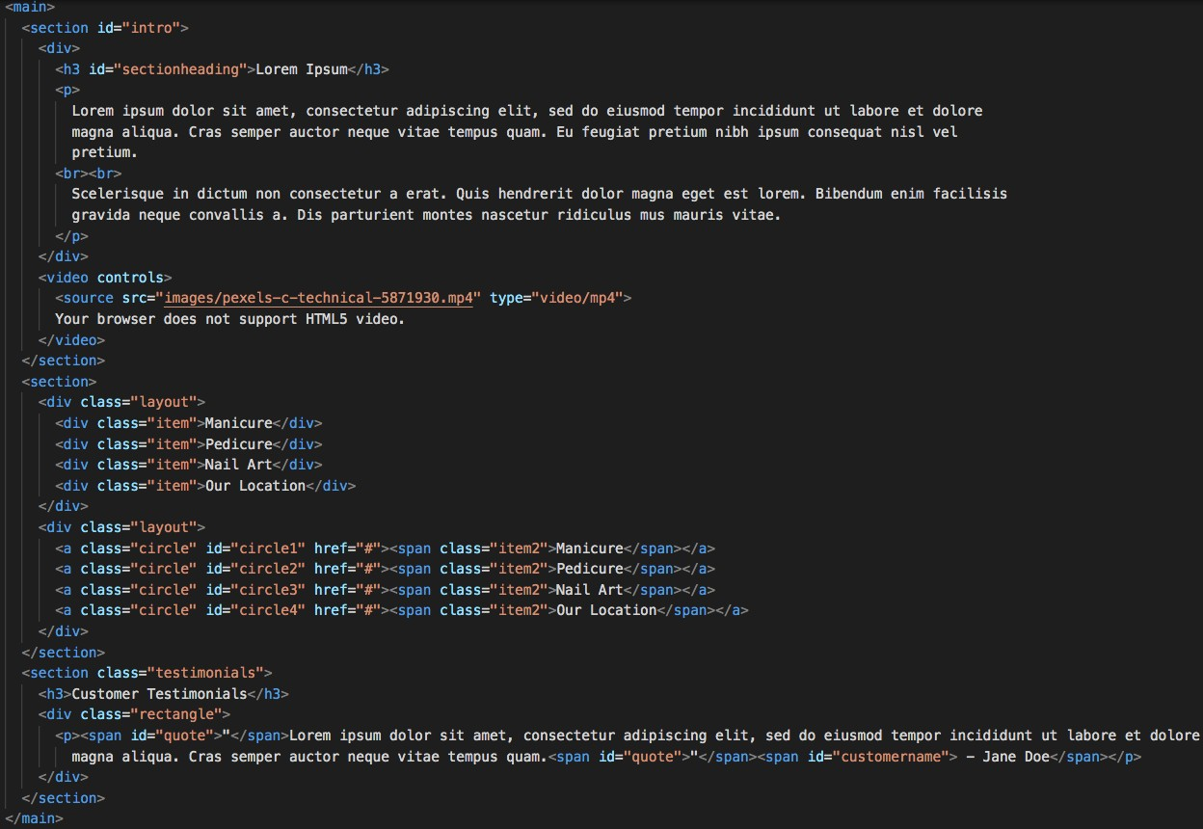

About Page
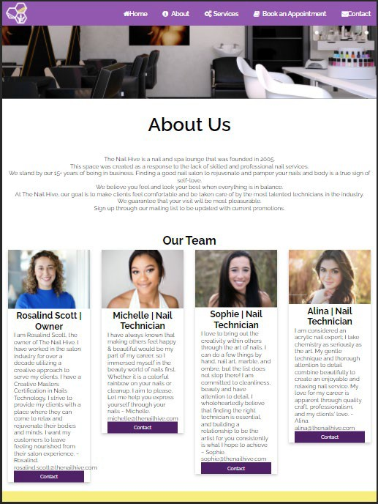
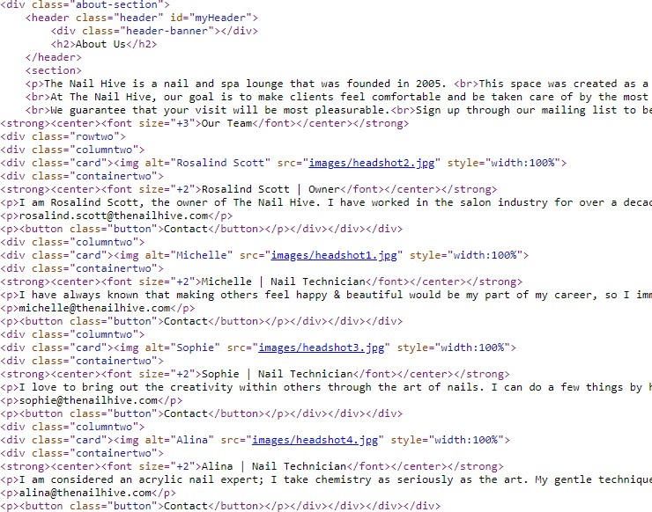

Services Page
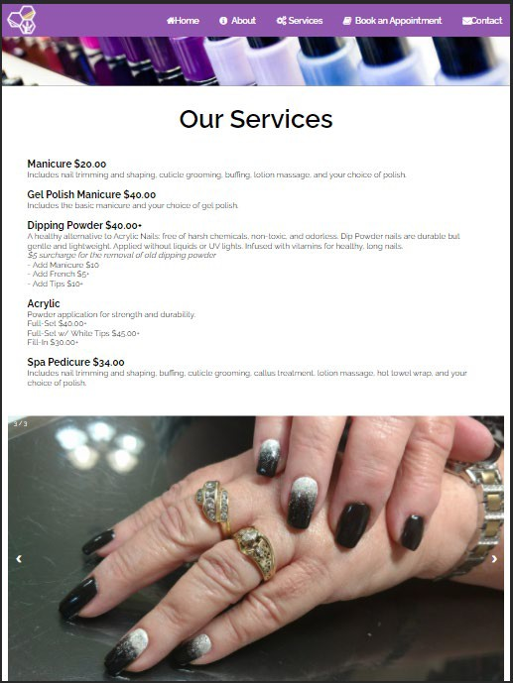
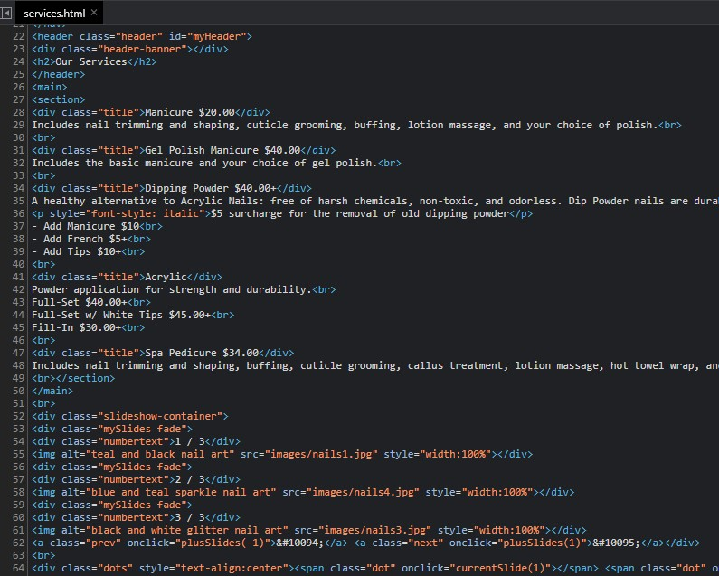

Book an Appointment Page
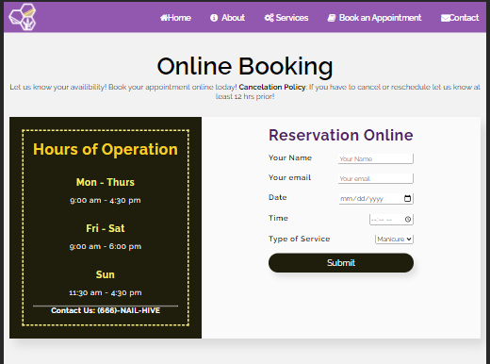
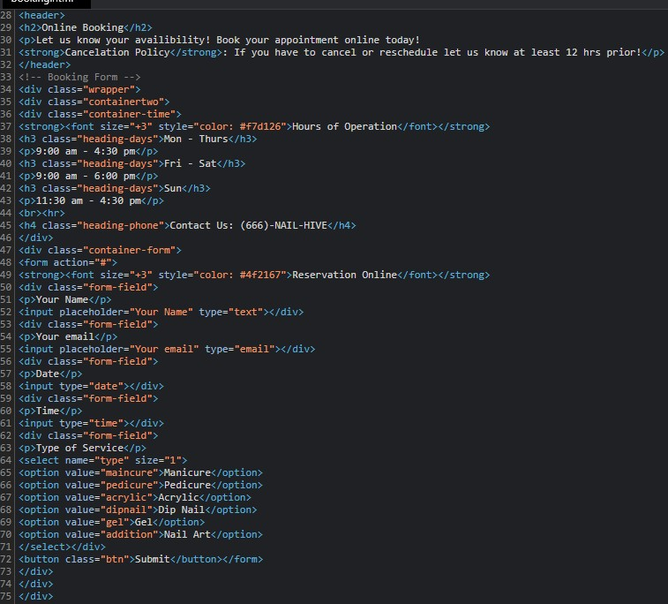

Contact Page
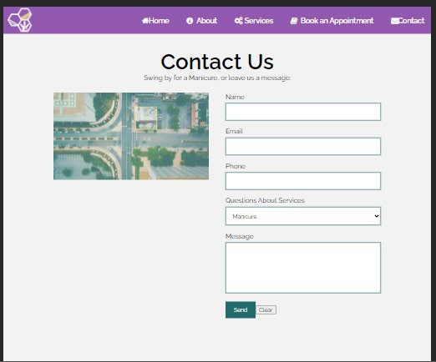
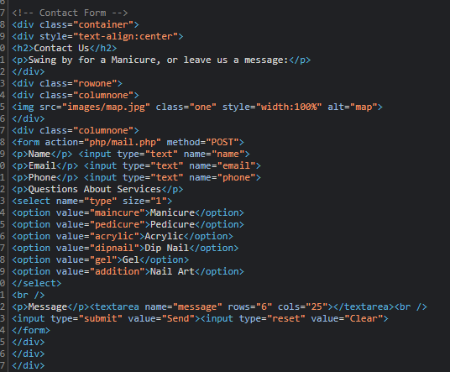

Naming Conventions
- Use names/labels considerations for site users first.
- Titles and descriptions will use clear, simple, descriptive language.
- Aim for SEO (search engine optimization)
- Utilize Keywords
- Avoid abbreviations.
- Avoid special characters and symbols.
- Avoid generic labels.
- Use headings in a proper hierarchy and avoid excessive headings.
- Keywords will be implemented.

File types and extensions
- All the files and folder names will be separated with an underscore “_” and contain no spaces.
- When naming files or folders, it will appear with lowercase letters and numbers (nothing else).
- All file and folder names will be short and straightforward.
- There will be the use of meta tags for keywords and descriptions.
- All images will include the alt tag with keywords related to the picture.
- All web files are familiar and recognizable with standard extensions.

File Types | Extensions | Using
Microsoft Word | Editable Documents | .docx, .doc
Portable Document Format (PDF) | Non-Editable Document | .pdf
HTML Documents | Webpage | .html
CSS Documents | Webpage styles | .css
JavaScript Documents | Forms, buttons, etc. | .js
JPG | Pictures/Images | .jpg
PNG | Pictures and Images with a transparent background | .png

Navigation Labels
  - The Nail Hive and Logo > index.html
  - About > about.html
  - Services > services.html
  - Book an Appointment > booking.html
  - Contact > contact.html

Programming
Document type declaration
<!DOCTYPE HTML>

Languages
- HTML
- CSS
- JavaScript

Development Tools
- Notepad++
- Adobe Dreamweaver
- Brackets
- Microsoft Office
- GoDaddy
- W3C HTML Validation
- W3C CSS Validation
- WAVE Accessibility Tool

Approval

Company | Agency Name The Nail Hive Approved By Rosalind Scott
By signing below, the Client agrees that the above description of their consulting project is completed to satisfaction. The Client understands that after approving this phase, any changes relating to the approved portion may require additional development efforts by the Consultant, and additional costs may apply.
Signed: Rosalind Scott Date: 4/13/2021

Functional Specifications

Summary
This document is the functionality report for The Nail Hive, made by J.A.R.S Web Design. The goal of this website is to be able to navigate the site with ease. It should be user-friendly, modern, and mobile-friendly. The Nail Hive will also be user-friendly and bring new and old customers to the new website and the business. There will be diverse web pages to establish and pictures to give good visual attractiveness.

Assumptions
This website will be accessible on tablets, computers, smartphones, etc. Pageable to load in the most used browsers.

Global Elements
The Navigation Bar and the Footer are global elements that will remain consistent across all site pages.
The Navigation Bar contains links to other top-level, main priority site pages.
It contains links to the following: Home - About - Services - Book an Appointment - Contact
The Footer contains contact information, hours of operation information, and an additional navigational section for users to access secondary site pages and social media links. This footer section is an essential aid to site users to access specific and vital site information and links.
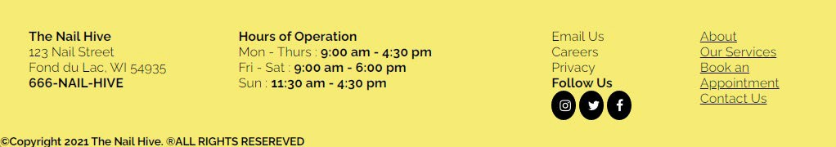
A consistent header will be applied for every page other than the home/landing page to allow a visual consistency for site users.


Page-Specific Elements

Home Page
Contains a hero image and header to visually catch site visitors’ attention with significant overlaid text reading “The Nail Hive; nail salon & spa.” It also has an outlined action button, “Book Now!”, which will link users to the Book an Appointment page.

An introduction blurb will allow site users to at a glance learn more about the Nail Hive as a business and the overall goals/atmosphere. This section includes a short promotional video example of the Nail Hive's nail stamping technique.
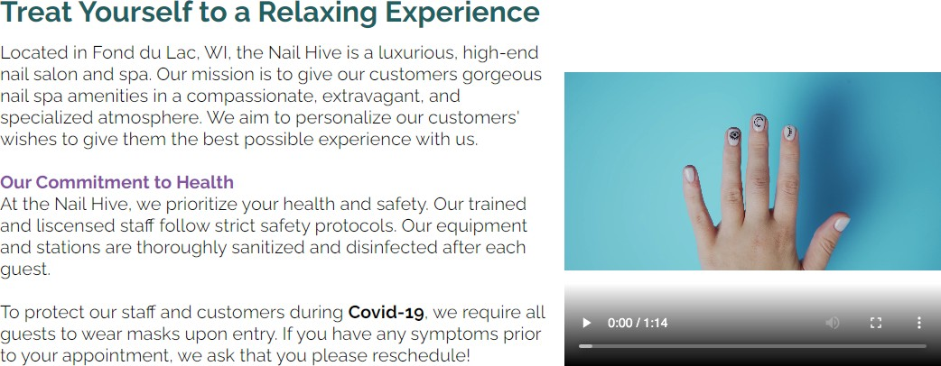

Circle image buttons act as visual navigation and representation of the Nail Hive’s services to site visitors.


Review of the Month: A chosen quoted review about the Nail Hive to promote business and give potential new customers an idea of what customers have enjoyed about the Nail Hive’s services.
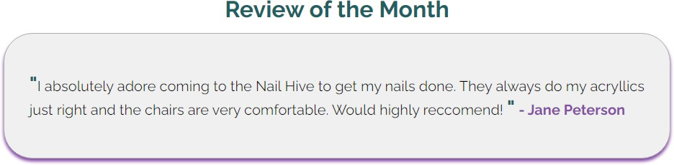

About Page
A short introduction paragraph includes general information about the Nail Hive as a business. This provides site users with a friendly and professional understanding.
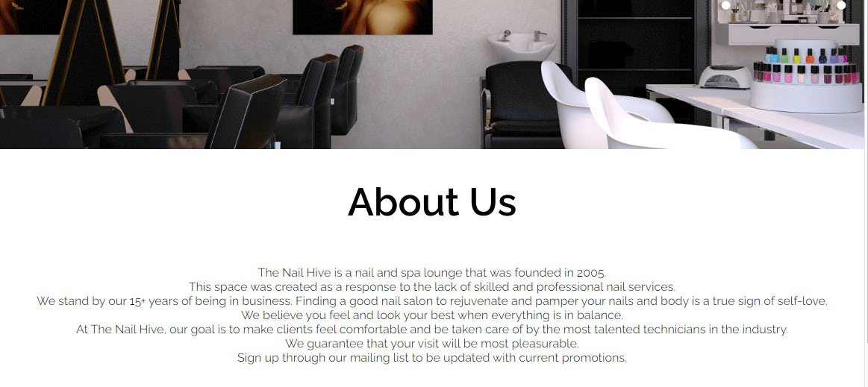
Our team allows potential customers to connect to and be introduced to our staff and highlight any skills or specifications. Contact links allow clients to email our staff any questions or inquiries.
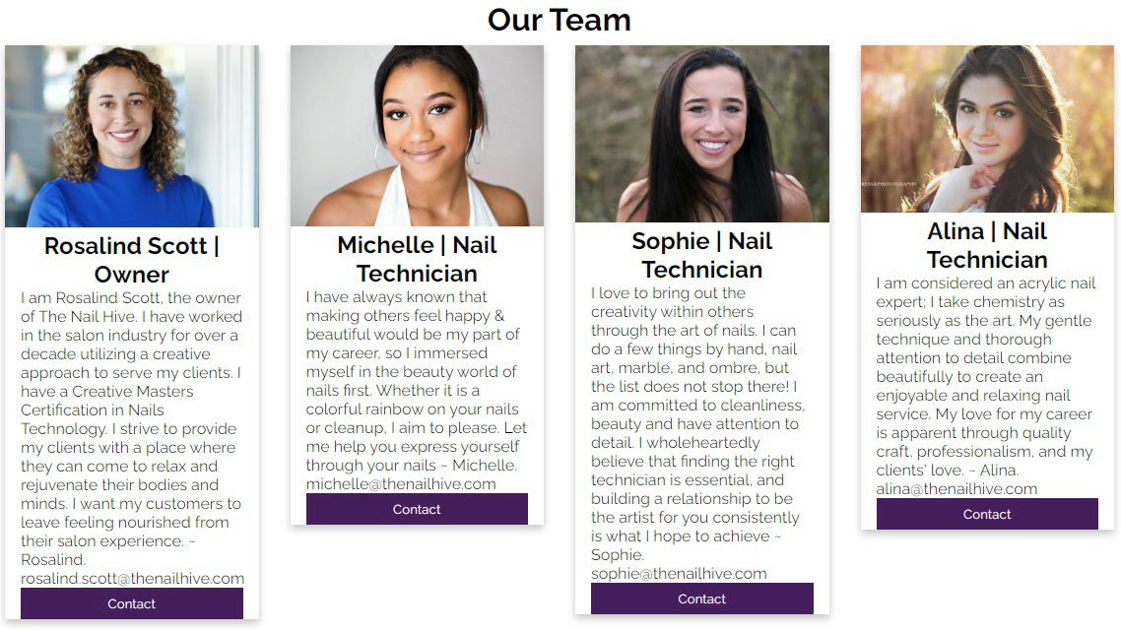

Services Page
Our Services lists and gives detailed descriptions of the Nail Hive's services, including price information. Prices are easy to locate for user ease.
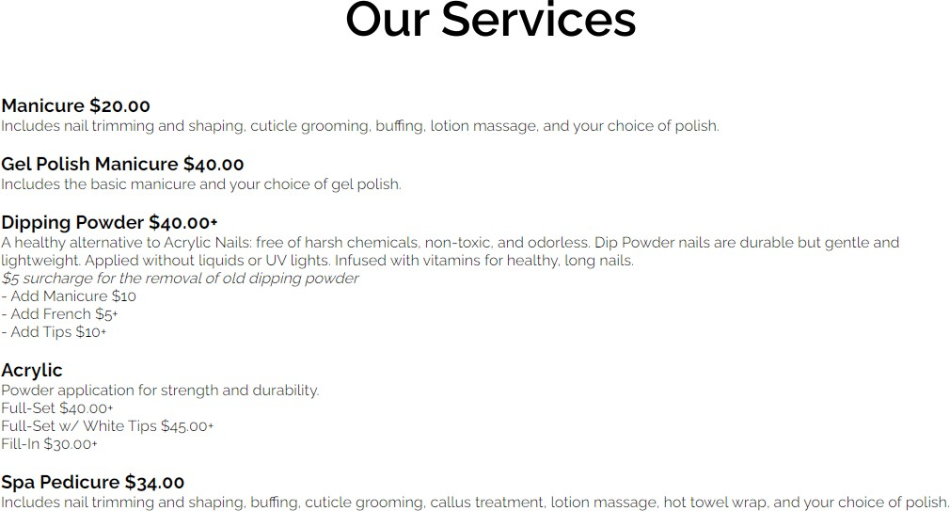

A small gallery of example work highlights the skills and services offered. In the top corner it lists the number of images and the circles at the bottom highlight to show which image is selected from the list. The gallery arrows allow users to flick through photos manually.
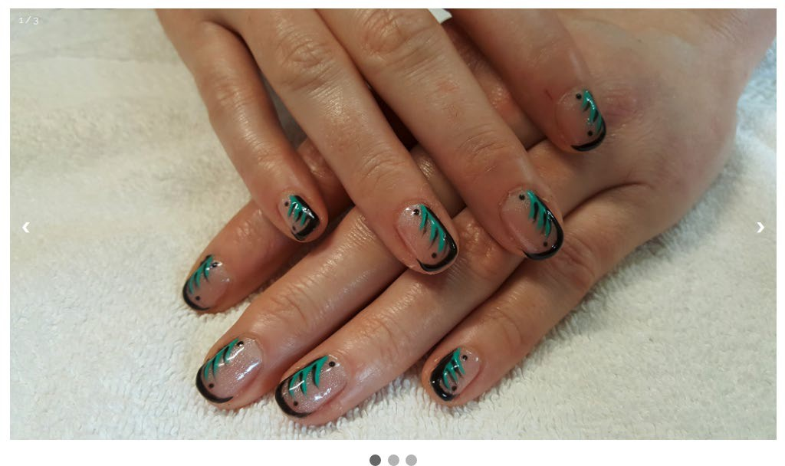

Book an Appointment Page
This page functions as an online form where clients can book an appointment online. It contains form fields for name, email, date, time, and type of service. There is a submit button to submit the form. There is also a side informational panel containing information about the Nail Hive’s hours of operation and a contact number.
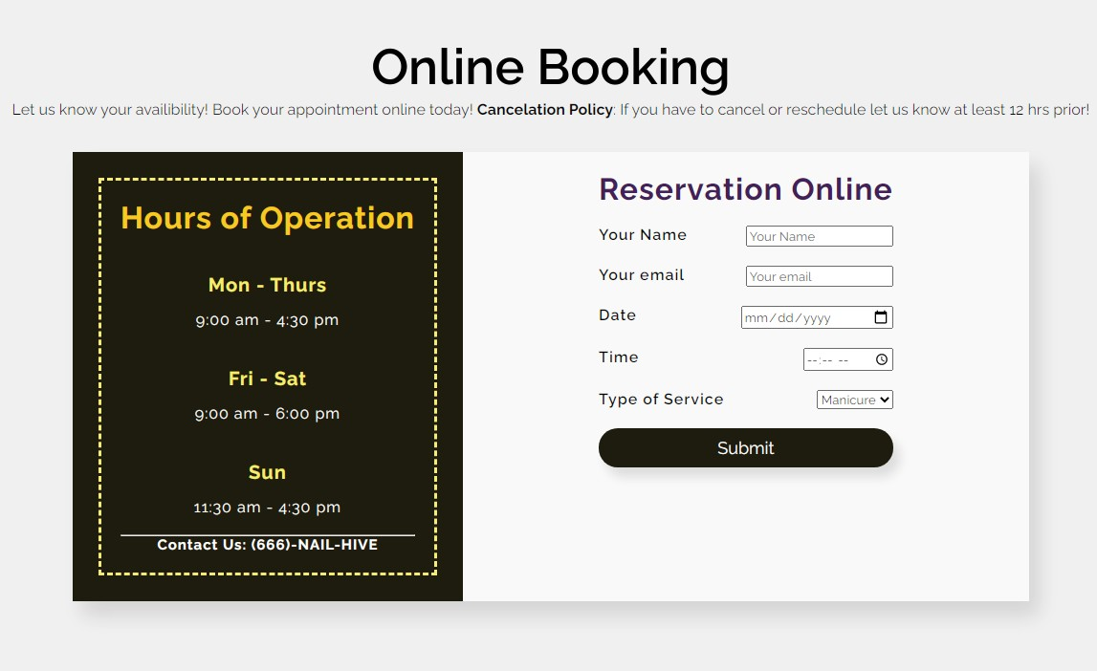
The Date section includes a drop-down monthly calendar to allow users to easily select the date/day of the week with one click. It also starts at the current date.
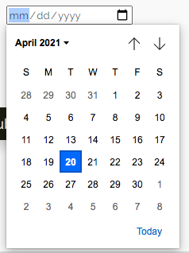
The Time Section includes a scroll-through menu to select the hour, minute quickly, and am/pm options with only a few clicks. It starts at the current time.
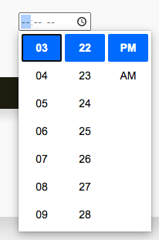
The Type of Service includes a drop-down menu to select from a range of service choices: Manicure, Pedicure, Acrylic, Dip Nail, Gel, and Nail Art.

Contact Page
The Contact page functions as a contact form for site visitors to send other questions or messages to the Nail Hive. It includes form fields for name, email, phone, message, and a drop-down menu to inquire about a specific service. There is a Send button to send the message and a clear button that allows users to reset/clear the form.
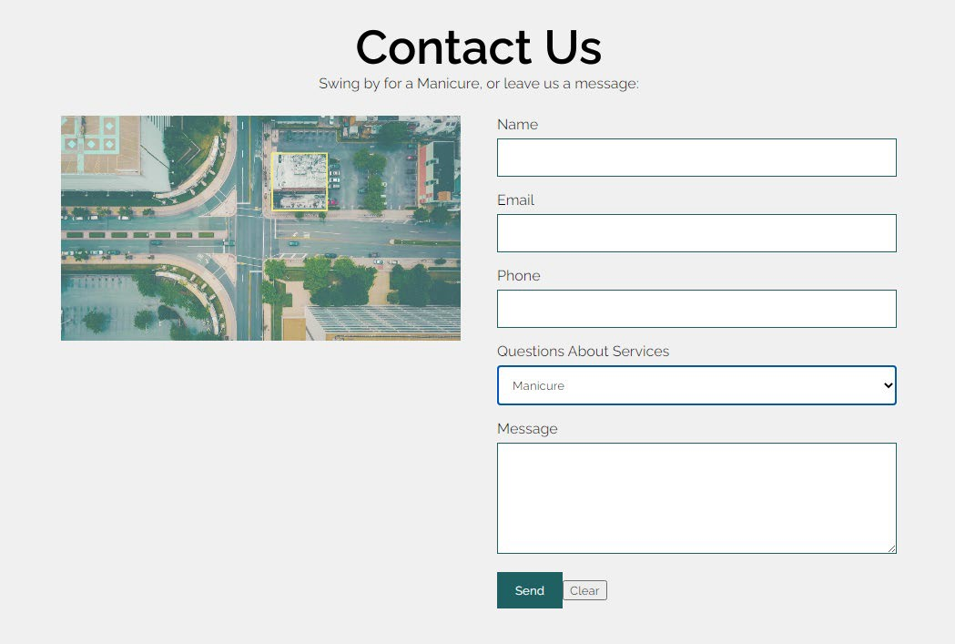

File Structures

Project Folder Name:
- No Spaces, all lower case, simple names

Internal folder structure:
Example
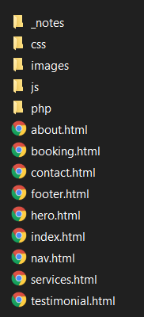
- CSS (different stylesheets)
- Images (png, jpg, etc.)
- Vendor (bootstrap, jQuery)
- Php (php files)
- Js (JavaScript Files)

- Index.html
- About.html
- Service.html
- Booking.html
- Contact.html

Images
Either .jpg or .png files and stored in one file besides the logo, which is in a separate folder.
Example
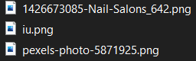

Rules
- Stylesheets go into the CSS folder.
- All images will go into an image folder.
- HTML pages stay in the main folder.
- JavaScript will go into a J.S. folder.

- PHP will go into a PHP folder.

Client Approval

Company | Agency Name The Nail Hive Approved By Rosalind Scott
By signing below, the Client agrees that the above description of their consulting project is completed to satisfaction. The Client understands that after approving this phase, any changes relating to the approved portion may require additional development efforts by the Consultant, and additional costs may apply.
Signed: Rosalind Scott Date: 4/20/2021

Quality Assurance Plan: Introduction:
J.A.R.S Web Design has designed a Quality Assurance Plan for The Nail Hive website (https://sabrinalarson.com/jars/the_nail_hive/ ). The plan outlines the process that J.A.R.S Web Design will be complete making sure the website & accessibility standards have functioning links & images, is mobile- friendly, and has a functioning form. There will be testing completed in various formats.

Testing
The test will be light and informal.

Participants
Quality Assurance Lead / Public Relations Specialist
- Works with Client to finalize major fixes/bugs
- Responsible for overseeing and evaluating bugs.
- Client questions are directed to the QA Lead.
Project Manager
- Will oversee internal and external test cases.
- Also, has final approval with the client over the bugs and their fixes.
Creative Lead
- Assists in bug testing and test cases.
- Approves any bug fixes that require design changes.
- Fix reported bugs and assist the QA Lead.
Web Production Specialist
- Assists in bug testing and test cases.
- Plans attack on high-risk bugs.
- Revises code to fix bugs.
Client
- Test the final site for bugs before launch.
- Report to the whole team with updates.
- Informs the QA Lead with any questions.
- Signs Final plan idea.

By signing this document, you agree to the Quality Assurance phase outlined above.

Rosalind Scott 5/27/21

Signature Date

Test Environments

Test | 1 (Sabrina) | 2 (Ria) | 3 (Ashley) | 4 (Jeanna)
Platform | Windows 10/Samsung 20+ Phone | macOS/ iPhone 11 | Linux/Pixel XL 2 Phone | macOS / iPad / iPhone 6s
O.S. | Windows 10/Samsung 20+ Phone | Catalina 10.15.3/iOS | Ubuntu 18.04.4/Android 11 | macOs High Sierra 10.13.6  /
Hardware Type | Laptop/ Samsung 20+ Phone | Macbook Pro/ iPhone 11 | Dell G5 15 SE 5505 laptop/Pixel  2 XL Android  version 11 | iMac / iPad / iPhone 6s
Browser | Firefox/Opera/Edge/Chrome/Chrome on Samsung 20 + Phone | Safari/Google Chrome 90.0.4430.85 | Firefox version 88.0/Chrome android version 28.0.1500 | Safari version 11.1.2  (desktop)/ Chrome version 99.04430.85  (desktop)
Resolution  / Screen Size | 15-inch (1920 x 1080)/Samsung 20+  size 6.7” (1,600 x 720) | 13.3-inch (2560  x 1600)/ iPhone (1792 x 628)  size 6.1” | Linux res 1920x1018 size 15.6” / Android res 2880x1440 size 6” | 1920 x 1080 /  11”  1194 x834 /  750 x 1334

Performed Test Cases
- Responsive (Mobile Functionality) across all pages
- Images/Videos across all pages
- Navigation across all pages
- Form Functionality across all pages

Additional (Sample) Test Cases
- Code Validation Testing
- Web Accessibility
- Responsive (Browser Functionality)

Bug Tracking and Fixing Plan

Assumptions
It can be understood that all issues have been fixed by J.A.R.S Web Design and Development before the client’s launch date. J.A.R.S Web Design will be responsible for fixing any problems that may occur in the first six months of the client’s website launch date.

Risk
The tests completed on the client’s website were performed on commonly used and updated browsers. The website may function and look different on older browsers.

Bug Reporting Tracking Plan
Testers complete the Bug Tracking Form to record any issues/bugs found on the client’s website. Testers then share the information found to the Quality Assurance Lead, who then determines the severity of the problem and works with the Project Manager to establish the priority level for resolving the issue.

Bug Severity Levels
- Low – Basic improvements
- Medium – Easy to resolve problems (typos, grammatical errors)
- High – Minor loss of website function.
- Critical – Major loss of website function
- Catastrophic – Website crashes

Bug Fix Priority Levels
- Priority 1 – Fix bug as soon as possible (highest priority)
- Priority 2 – Fix bug before subsequent testing
- Priority 3 – Fix bug before the final launch date
- Priority 4 – Bugs can be fixed after the launch of the website.

Bugs Not fixed Before Launch Date
If the client’s website contains low, medium, or high bug severity bug levels, the website will still launch on schedule. If there is a critical or catastrophic bug, all issues must be fixed within one week of the launch date.

By signing below, you signify that you understand and agree with the J.A.R.S Web Design Website & Development’s Bug Tracking and Fixing Plan.

Rosalind Scott _ 5/27/21

Signature Date

Blank Test Case Form

The Nail Hive Test Case
Test Case Name:
URL:
Testing
Environment:
Tester Name:
Test Date:
Action | Expected Result | Result | Comments

Sample Test Cases
To be completed and filled out by testers.

The Nail Hive Test Case
Test Case Name: |  |  |  | Responsive (Browser) Test
URL: |  |  |  | https://www.sabrinalarson.com/jars  /the_nail_hive/
Testing Environment:
Tester Name:
Test Date:
Action |  |  |  | Expected  Result | Result | Comments
Page Responsive in intervals up to 400px |  |  |  | The main aspects of all pages resize accordingly
 |  |  |  | Text realigns and resizes accordingly
 | The Nail Hive Test Case |  |  | Text realigns and resizes accordingly
 | Test Case  Name: | Code Validation Test
 | URL: | https://www.sabrinalarson.com/jars  /the_nail_hive/

Testing Environ
ment:
Tester
Name:
Test
Date:
 | Action | Expected  Result | Result | Comments
 | HTML  Validation | Code validates across all pages with  zero errors
 | CSS  Validation | Code validates across all pages with zero errors
Text resizes in intervals up to 400px
Images/videos resized in intervals up to 400px |  |  |  |  |  | Images/vide os resize and are clear

The Nail Hive Test Case
Test Case Name: | Web Accessibility
URL: | https://www.sabrinalarson.com/jars/the_nail_hive/
Testing
Environment:

Tester Name:
Test Date:
Action | Expected Result | Result | Comments
Images | All images are visible and contain a descriptive alt attribute
Color Contrast | All text, icon, and input elements meet WCAG  2.0 Level AA contrast  standards
Headings | The site has one h1 per page; each page uses h tags in sequence without  skipping levels.
Links | All links are descriptive and recognizable. Links that open in a new tab are identified.
Language/Text | All language text used is easy to understand.
WCAG 2.0 Check | The site passes a WCAG  2.0 tool test without any errors or warnings.

Completed Test Cases

The Nail Hive Test Case
Test Case Name: Form Functionality
URL: https://www.sabrinalarson.com/jars/the_nail_hive/
Testing Environment: (Windows 10); Firefox/Opera/Edge/Chrome ; Samsung Galaxy 20+
Tester Name: Sabrina Larson
Test Date: 4/26/21
Action | Expected Result | Result | Comments
Booking Form | Working Book Form | Form does do the date and time but is not functional | The booking form works but does not send anything
Contact Form | Working Contact Form | The form does send an email to me with all the info from the recipient. | Send an email to the user and the reply.
Test Environments | Firefox/Opera/Edge/Chrome ; Samsung Galaxy 20+

The Nail Hive Test Case
Test Case Name: | Responsive (Mobile) Test
URL: | https://www.sabrinalarson.com/jars/the_nail_hive/
Testing Environment: | Platform- Pixel 2 XL  Operation System- Android 11  Browser-Chrome
Tester Name: | Ashley Giedd
Test Date: | 04/26/2021

Action | Expected Result | Result | Comments
Responsive to 400px on all pages | Images/Text resize appropriately | All pages except Booking are appropriately responsive | Check the @media screen attribute in its CSS
Text is responsive to 400px on all pages | Text is easy to read at its size and aligned correctly | All pages except Booking are easy to read and aligned | Known issue, please see above
Images/Videos are responsive at 400px | Images/videos resize correctly, easy to see | All pages except Booking are resized and correct | Known issue, please see above

The Nail Hive Test Case
Test Case Name: | Navigation Functionality
URL: | https://www.sabrinalarson.com/jars/the_nail_hive/
Testing Environment: | iMac / iPad 11” Pro / iPhone 6s Browsers: Safari, Chrome  (see test environment 4 (Jeanna) for additional information)
Tester Name: | Jeanna Brault
Test Date: | 4/26/21
Action | Expected Result | Result | Comments
Navigation Bar (Primary Links) | All links function across all site pages | N | The “Home” link opens in a new tab
Footer Links | All links function across site pages | Y* | *(Social media pages have not been linked yet. Privacy and Careers Pages have not been developed.)
Logo | Returns to the home/landing page | N | Refreshes the current page
Button | Links to “Book an Appointment” | Y | n/a

The Nail Hive Test Case
Test Case Name: | Images/Video Functionality
URL: | https://sabrinalarson.com/jars/the_nail_hive/ (index.html, about.html, services.html, contact.html)
Testing Environment: | Macbook Pro; Safari; Catalina 10.15.3
Tester Name: | Riandria Gordon
Test Date: | 04/25/21
Action | Expected Result | Result | Comments
Image/Video Quality | Images/videos are high- quality | Y
Image/Video Optimization | Images or Video load quickly  Images/video is  optimized for the web | N | Video on the index.html page buffers or doesn't load at all.
Responsive Images/Video | Images/video mobile- friendly  Images/Video have alt  text | Y Y
Image/Video Display | Images/video follow CSS rules | Y

The Nail Hive Test Case
Test Case Name: | Images/Video Mobile
URL: | https://sabrinalarson.com/jars/the_nail_hive/ (index.html, about.html, services.html, contact.html)
Testing  Environment: | iPhone 11; iOS; Safari
Tester Name: | Riandria Gordon
Test Date: | 04-25-21
Action | Expected Result | Result | Comments
Images/Video Quality | Images/videos are high- quality | Y
Image/Video Optimization | Images or Video loads quickly  Images/videos are  optimized for the web | N | Video on the index.html page buffers or doesn't load at all.
Responsive Images/Video | Images/video mobile- friendly  Images/Video have alt  text | Y  Y
Image/Video Display | Images/video follow CSS rules | Y

Blank Bug Report Form

Bug Reporting Form
Log # |  | Priority
Tester Name |  | Severity
Test Date |  | Date Started
Browser |  | Date Completed
Error Type
URL of Page with Bug
1
2
3
Description of Bug

Screenshot of Error
Severity of Bug
Low – Basic improvements
Medium – Easy to resolve problems (typos, grammatical errors)
High – Minor loss of website function
Critical – Major loss of website function
Catastrophic – Website crashes
Bug Priority Levels
Priority 1 – Fix bug as soon as possible (highest priority)
Priority 2 – Fix bug before subsequent testing
Priority 3 – Fix bug before the final launch date
Priority 4 – Bug can be fixed after the launch of the website
Budget Impact
Description | Hours | Due Date

Was Bug Fixed?
- Completed 100%
- Fixed, but still needs work.
- Unresolved
Approval
Client Signature
Project Manager Signature

Completed Bug Reporting Forms

Form 1

Bug Reporting Form
Log # | Video on homepage | Priority | 2
Tester Name | Riandria Gordon | Severity | High
Test Date | 04/25/21 | Date Started | 04/25/21
Browser | Safari | Date Completed | in progress
Error Type
Video is buffering on the homepage or does not load at all.
URL of Page with Bug
One https://sabrinalarson.com/jars/the_nail_hive/index.html
2
3
Description of Bug
Video needs to be compressed to a reasonably-media file without losing quality.

Screenshot of Error
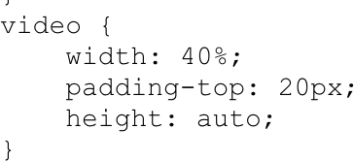

Severity of Bug
Low – Basic improvements
Medium – Easy to resolve problems (typos, grammatical errors)
High – Minor loss of website function
Critical – Major loss of website function
Catastrophic – Website crashes
Bug Priority Levels
Priority 1 – Fix bug as soon as possible (highest priority)
Priority 2 – Fix bug before subsequent testing
Priority 3 – Fix bug before the final launch date
Priority 4 – Bug can be fixed after the launch of the website
Budget Impact
Description | Hours | Due Date
identifying/fixing the issue | 1 | 04/25

Was Bug Fixed?
- Completed 100%
- Fixed, but still needs work.
- Unresolved
Approval
Client Signature
Project Manager Signature
Jeanna Brault 4/27/21

Form 2

Bug Reporting Form
Log # | Accessibility Issues | Priority | 2
Tester Name | Sabrina Larson | Severity | High
Test Date | 4/25/21 | Date Started | 4/25/21
Browser | Microsoft Edge  90.0.0818.46 (64 bit) | Date Completed | In progress
Error Type
Links must have discernible text: Element has no title attribute
URL of Page with Bug
One https://www.sabrinalarson.com/jars/the_nail_hive/
2
3
Description of Bug
Compliance Data & Impact
- Ensure that all link names are accessible. It may be possible that the inner link text is not visible to a screen reader, duplicate link labels, or the link is not focusable.

- Ensure all links can receive programmatic focus; for example, avoid device-specific events (for example, onmouseover)

- https://dequeuniversity.com/rules/axe/4.1/link-name?application=axeAPI

1 | Page

Screenshot of Error
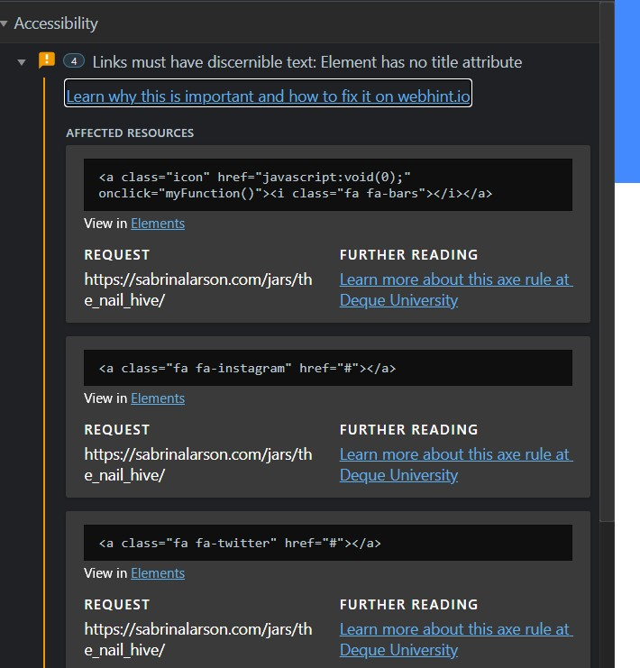
Severity of Bug
Low – Basic improvements
Medium – Easy to resolve problems (typos, grammatical errors)
High – Minor loss of website function

Critical – Major loss of website function
Catastrophic – Website crashes
Bug Priority Levels
Priority 1 – Fix bug as soon as possible (highest priority)
Priority 2 – Fix bug before subsequent testing
Priority 3 – Fix bug before the final launch date
Priority 4 – Bug can be fixed after the launch of the website
Budget Impact
Description | Hours | Due Date
identifying/fixing the issue | 1

Was Bug Fixed?
- Completed 100%
- Fixed, but still needs work.
- Unresolved
Approval
Client Signature
Project Manager Signature
Jeanna Brault 4/27/21

Form 3

Bug Reporting Form
Log # | Runtime Errors/ Type  Error | Priority | 3
Tester Name | Sabrina Larson | Severity | High
Test Date | 4/25/21 | Date Started | 4/25/21
Browser | Opera Browser | Date Completed
Error Type
Unchecked runtime.lastError: Invalid color name.
Error handling response:TypeError: Cannot destructure property ‘h” of ‘undefine’ as it is undefined
URL of Page with Bug
One https://www.sabrinalarson.com/jars/the_nail_hive/
2
3
Description of Bug
Invalid Color Name and JavaScript Error

Screenshot of Error
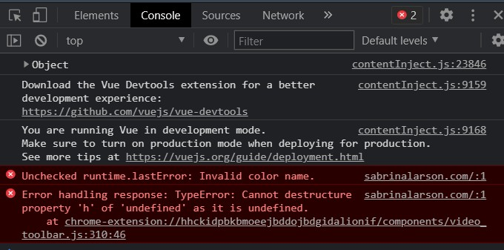
Severity of Bug
Low – Basic improvements
Medium – Easy to resolve problems (typos, grammatical errors)
High – Minor loss of website function
Critical – Major loss of website function
Catastrophic – Website crashes
Bug Priority Levels
Priority 1 – Fix bug as soon as possible (highest priority)
Priority 2 – Fix bug before subsequent testing
Priority 3 – Fix bug before the final launch date
Priority 4 – Bug can be fixed after the launch of the website

Budget Impact
Description | Hours | Due Date
identifying/fixing the issue | 1

Was Bug Fixed?
- Completed 100%
- Fixed, but still needs work.
- Unresolved
Approval
Client Signature
Project Manager Signature

Form 4

Bug Reporting Form
Log # | Layout Forced/Parsing  Value Error | Priority | 3
Tester Name | Sabrina Larson | Severity | High
Test Date | 4/25/21 | Date Started | 4/25/21
Browser | Firefox (Ver. 88, 64-bit0 | Date Completed | 4/27/21
Error Type
Layout Forced
Parsing Error with homestyle.css
URL of Page with Bug
1 https://sabrinalarson.com/jars/the_nail_hive/
2
3
Description of Bug
The layout is being forced before the page is fully loaded. This causes the stylesheets not to load and may cause a flash of unstyled content. There is also a parsing error for the background origin. Is it in the homestyles.css?

Screenshot of Error
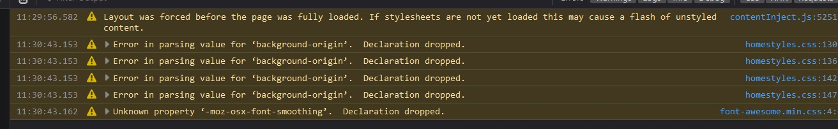
Severity of Bug
Low – Basic improvements
Medium – Easy to resolve problems (typos, grammatical errors)
High – Minor loss of website function
Critical – Major loss of website function
Catastrophic – Website crashes
Bug Priority Levels
Priority 1 – Fix bug as soon as possible (highest priority)
Priority 2 – Fix bug before subsequent testing
Priority 3 – Fix bug before the final launch date
Priority 4 – Bug can be fixed after the launch of the website
Budget Impact
Description | Hours | Due Date

identifying/fixing the issue | 1

Was Bug Fixed?
- Completed 100%
- Fixed, but still needs work.
- Unresolved
Approval
Client Signature
Project Manager Signature

Form 5

Bug Reporting Form
Log # | NU HTML Checker | Priority | Medium
Tester Name | Sabrina Larson | Severity | 3
Test Date | 4/25/21 | Date Started | 4/25/21
Browser | Chrome | Date Completed | 4/25/21
Error Type
No Space between attributes The end tag Header is seen.
Unclosed element
Stray end tag
URL of Page with Bug
One https://www.sabrinalarson.com/jars/the_nail_hive/
2
3
Description of Bug
Error No space between attributes.
Error End tag header saw, but there were open elements. Error Unclosed element <div>
Error Stray end tag <div>

Screenshot of Error
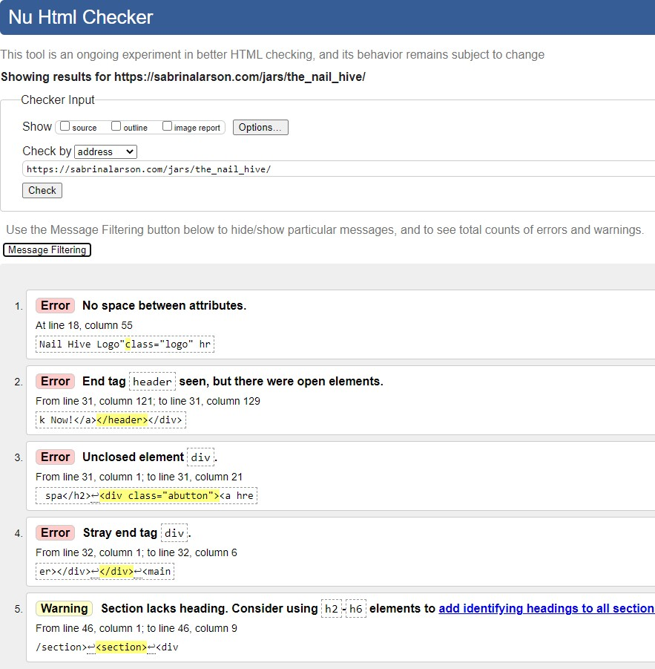
Severity of Bug
Low – Basic improvements

Medium – Easy to resolve problems (typos, grammatical errors)
High – Minor loss of website function
Critical – Major loss of website function
Catastrophic – Website crashes
Bug Priority Levels
Priority 1 – Fix bug as soon as possible (highest priority)
Priority 2 – Fix bug before subsequent testing
Priority 3 – Fix bug before the final launch date
Priority 4 – Bug can be fixed after the launch of the website
Budget Impact
Description | Hours | Due Date
identifying/fixing the issue | 1

Was Bug Fixed?
- Completed 100%
- Fixed, but still needs work.
- Unresolved
Approval
Client Signature

Project Manager Signature

Form 6

Bug Reporting Form
Log # | W3C CSS Validator | Priority | Medium
Tester Name | Sabrina Larson | Severity | 3
Test Date | 4/25/21 | Date Started | 4/25/21
Browser | Chrome | Date Completed
Error Type
Center is not a background-origin
URL of Page with Bug
One https://www.sabrinalarson.com/jars/the_nail_hive/
2
3
Description of Bug
Center is not a background-origin value center. #circle1 - #circle4

Screenshot of Error
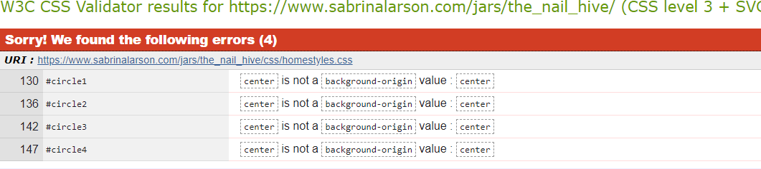
Severity of Bug
Low – Basic improvements
Medium – Easy to resolve problems (typos, grammatical errors)
High – Minor loss of website function
Critical – Major loss of website function
Catastrophic – Website crashes
Bug Priority Levels
Priority 1 – Fix bug as soon as possible (highest priority)
Priority 2 – Fix bug before subsequent testing
Priority 3 – Fix bug before the final launch date
Priority 4 – Bug can be fixed after the launch of the website
Budget Impact
Description | Hours | Due Date

identifying/fixing the issue | 1

Was Bug Fixed?
- Completed 100%
- Fixed, but still needs work.
- Unresolved
Approval
Client Signature
Project Manager Signature

Form 7

Bug Reporting Form
Log # | W3C Link Checker | Priority | High
Tester Name | Sabrina Larson | Severity | 3
Test Date | 4/25/21 | Date Started | 4/25/21
Browser | Chrome | Date Completed
Error Type
Broken URI fragments JavaScript Void

URL of Page with Bug
One https://www.sabrinalarson.com/jars/the_nail_hive/
2
3
Description of Bug
Some of the links to this resource point to broken URI fragments (such as index.html#fragment).
You should change this link: people using a browser without JavaScript support will not follow this link.

Screenshot of Error
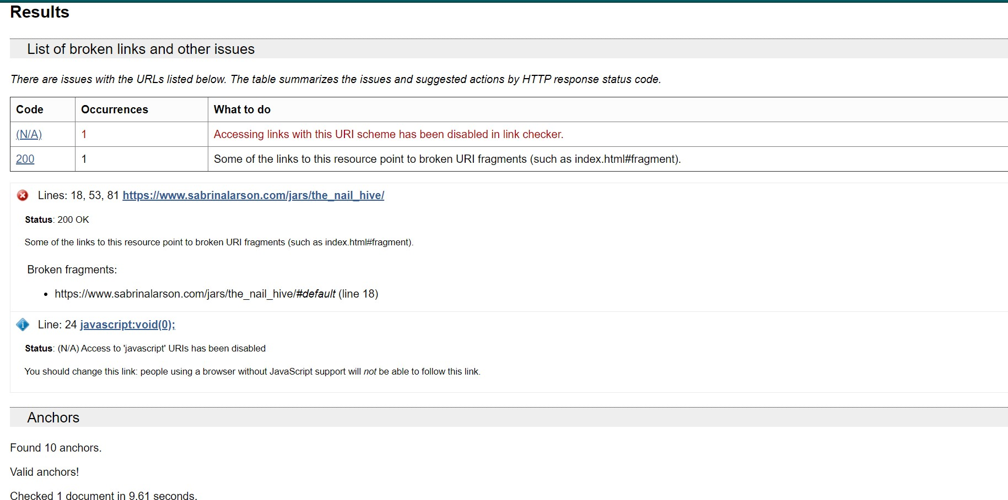
Severity of Bug
Low – Basic improvements
Medium – Easy to resolve problems (typos, grammatical errors)
High – Minor loss of website function
Critical – Major loss of website function
Catastrophic – Website crashes
Bug Priority Levels
Priority 1 – Fix bug as soon as possible (highest priority)
Priority 2 – Fix bug before subsequent testing
Priority 3 – Fix bug before the final launch date
Priority 4 – Bug can be fixed after the launch of the website

Budget Impact
Description | Hours | Due Date
identifying/fixing the issue | 1

Was Bug Fixed?
- Completed 100%
- Fixed, but still needs work.
- Unresolved
Approval
Client Signature
Project Manager Signature

Domain Name

What to consider in a domain name?
Selecting the right domain name is one of the essential steps in creating your brand or business. Your domain name is frequently one of the primary things somebody sees, and it can impact their thought of your website and your brand. A sensible selected domain name may increase user interest and drive web traffic, while an inaccurately chosen might have the opposite outcome. When feasible, your domain name should also be the name of your business. It should be simple and as short as possible.
With that in mind good criteria for a domain name, we have some suggestions below:
* https://www.namemesh.com/

Domain Name Recommendation:
www.the-nail-hive.com
Websites that end with .com are the most and easiest to remember; they are also a recognized domain extension. Using your business name for the website with the .com extension will give you the results you want to achieve with both you are the customers searching with search engines.

Domain Name Registrar
Top Domain Name Registration Companies 2021: Comparison
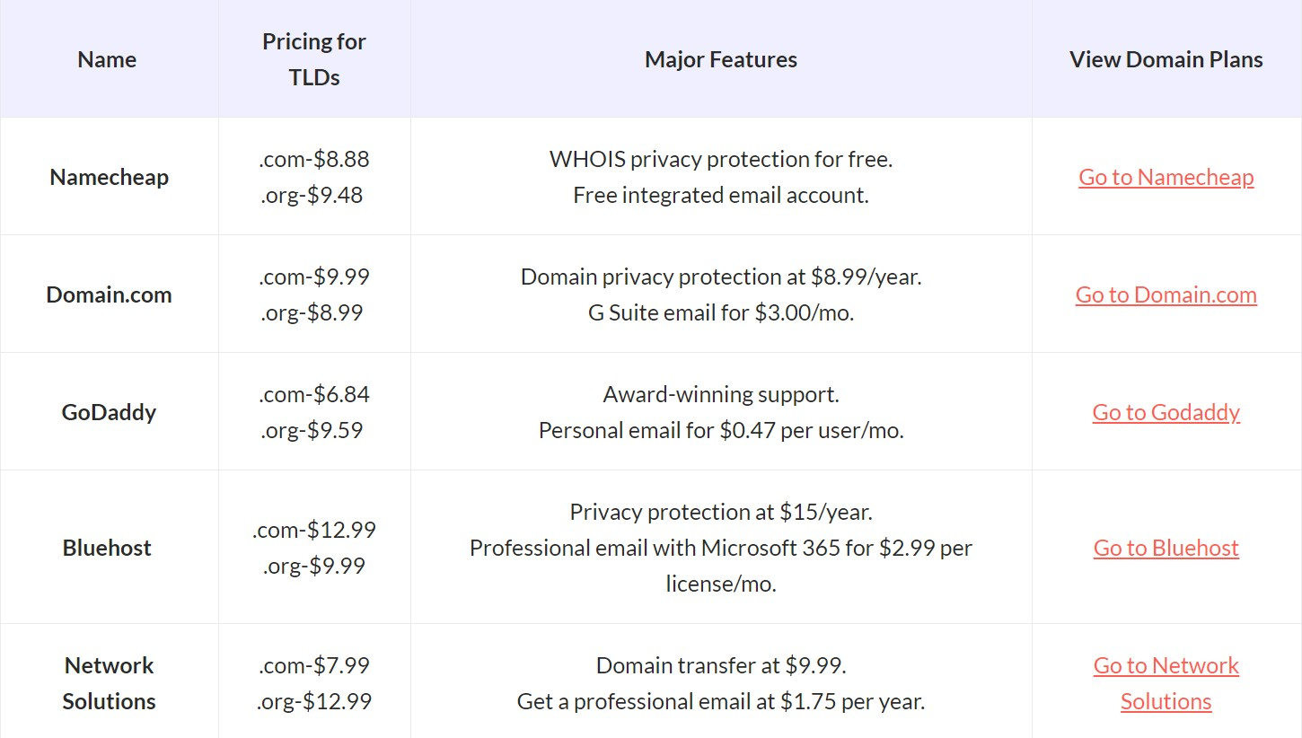
- https://themegrill.com/blog/best-domain-name-registrars/
J.A.R.S. Web Design recommends Namecheap or GoDaddy. Based on the web hosting, we would recommend GoDaddy.com.

Web Hosting and Pricing
The hosting sites below offer many good services and rates as the best domain hosting services in 2021. I would suggest going with Bluehost; this is in your price range and has all the features you need for starting a website.
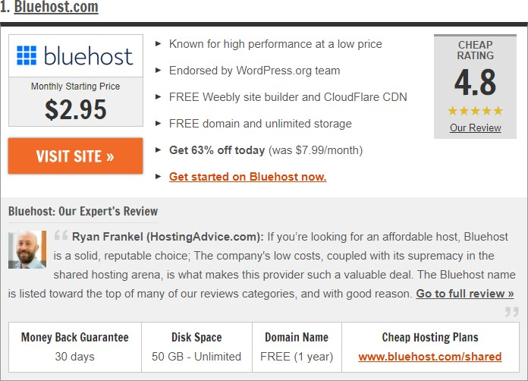

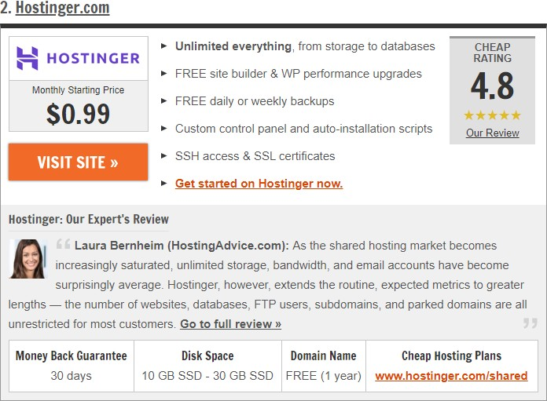

- https://www.hostingadvice.com/how-to/web-hosting-comparison/

By signing this, you agree and understand the terms above:

Signed: Date: May 4, 2021
Rosalind Scott
Founder and Owner, The Nail Hive

Search Engine Registration Plan
Popular Search Engines
  - Google
  - Bing
  - Yahoo
  - Baidu
  - Yandex

SEO Best Practices
  - Write compelling title tags
  - Meta Description tags
  - Optimize your images alt text
  - Keywords in URL

Search Engine Registration Tool
- Ahrefs (https://ahrefs.com/)
- Semrush(https://www.semrush.com/)

Ahrefs

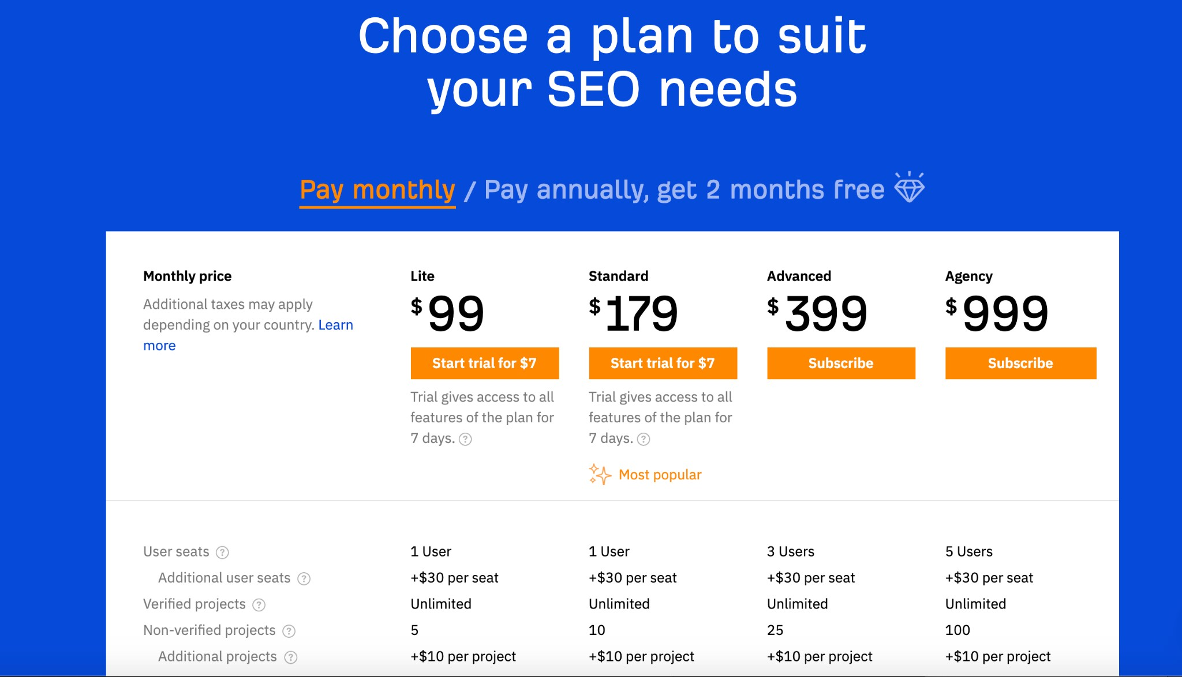

Ahref - Plans include site auditing, rank tracker, site explorer, content explorer, keyword explorer, and other extra tools. For this, I would recommend the “Lite” version for The Nail Hive, given the small size of the business.

Semrush
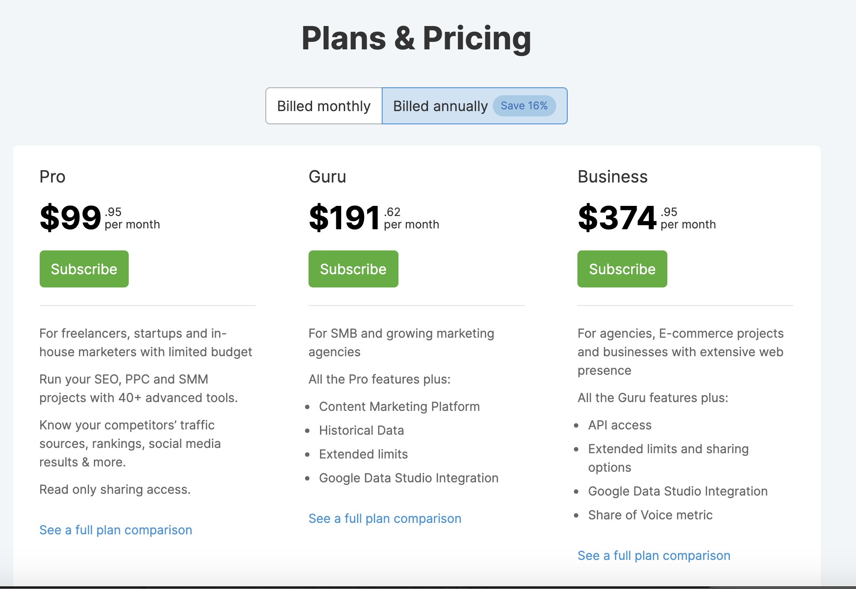
Semrush - Plans include domain and keyword analytics, reporting, and content marketing platform. It is recommended to purchase the “pro” plan for this plan because it is the best for smaller businesses.
Final Recommendations: After in-depth research of search engine registration plans, J.A.R.S suggests going with the Ahrefs “Lite” package. Ahrefs provides many tools, whereas Semrush requires additional charges for their tools. Choosing Ahrefs will give all of the tools necessary to make The Nail Hive website SEO friendly, such as site auditing, rank tracking, and site exploring. If the client chooses to use the Ahrefs “Lite” Package, they will need to purchase the package, and an additional cost will be added for
J.A.R.S implementing the software. Please sign and date it below if you want to add this to the existing plan.

Client signature: Rosalind Scott

Date: 05/03/21

Site Announcement Plan

Pre-Launch Activities
- The Nail Hive will be notified two weeks before the website release. It will be a soft launch date, June 1st, 2020.

- The Nail Hive will be responsible for advertising the release of the website to their clientele. The expected full launch date is June 8th, 2020.

- Include an announcement on their old site that a new site is coming.

Launch Activities
- The Nail Hive will send a notice about the website to all clientele who have given their emails.

- The Nail Hive will advertise on their social media platforms.

- The Nail Hive employees will have the option to print new business cards with the website on them.

Post Launch Activities
- The Nail Hive will be responsible for advertising their new website on their respective social media platforms.

- The Nail Hive has agreed to give clients who book through their website 10% off their service.

Off-Site Activities
- The Nail Hive will be printing new business cards for their staff.

- The Nail Hive will be advertising on their social media platforms, through emails, and advertising at the salon.

Cost Summary
The Nail Hive will be responsible for the branding and its cost. This includes but is not limited to; printing or design of the business cards, and work with social media platforms, and any advertisement.

Client signature: Rosalind Scott

Date: 05/03/21

Maintenance and Evaluation Plan

Maintenance Schedule

Scheduled Monthly Maintenance
- Perform Functionality Testing
  - Test and report any found bugs/errors
  - All of the following displays and functions as designed
    - Images/Video
    - Navigation Links
    - Forms
- Code Validation: Check that all updated code validates without errors
- Site Analytics Report
- eCommerce Analytics Report
- Site Backup

First Month After Launch
- User Testing
  - Test and evaluate
    - User Experience and Pathing
    - Form Usability
    - eCommerce Store Pathing and Checkout
- Client Feedback Form
- Update Client Testimonials (Home Page)
  - Add additional client testimonials

Requested or Urgent Maintenance
- Site content and eCommerce store changes can be updated by client request
- Bug Fixing: (Discovered two weeks after site launch)
  - Major or higher-level bug fixes will be fixed upon discovery/report
  - Medium level bug fixes will be fixed within one week from discovery
  - Will be included in monthly billing

Quarterly Maintenance
- User Testing
  - Run user tests for:
    - User Experience and Pathing
    - Form Usability
    - eCommerce Experience

    - Product Mapping
- Functionality Testing
  - Test and report any found bugs/errors
    - Mobile/Responsive on different devices
    - Site Accessibility
- Scheduled Bug Fixing
  - Fix found bugs on a Trivial or Minor level.
- Evaluate and Schedule Site Changes
  - Content Updates
    - Booking Form
    - Update Services Content
      - Any price and service changes
      - Add updated/new photos to service gallery
      - Add any specials/sales/promotional content
  - Review and Update SEO
  - Review Traffic Building
  - UI Enhancements
  - eCommerce Updates and Evaluations
    - Product Updates
    - Storefront Updates
    - Evaluate Marketing

Yearly Maintenance
- Content Review: Ensure all site content is current and up to date
- Yearly Evaluation Report
  - Determine and schedule any significant updates to site design

Evaluation Plan

Client Site Feedback Form
After launch, a Google form will be distributed to the Nail Hive’s clients via email(after successful completion of site forms as a part of the client response), upon request, and through social media posts(one for Facebook and one for Instagram on the Nail Hive’s official pages). JARS will create and manage this form and distribute it by the Nail Hive. Its purpose will be to receive feedback about the usability and content of the site from clients. It will also serve as promotional and incentivized marketing. Successful completion of the form will give clients a 20% off coupon to be used at the Nail Hive. This form will remain an active promotion for the first month of site release. JARS will provide results after the duration and evaluate with the client on any needed site changes or content updates.
One year after site release, this form will be redistributed and promoted to determine additional changes.

Site Analytics Report
JARS will prepare a monthly Site Analytics Report for the Nail Hive using Google Analytics. It will evaluate the following:
- Audience Analytics: User demographics and device information
- Acquisition Behavior: Site traffic information
This information will be used to evaluate overall site performance, traffic from social media, and unique site visits.

Yearly Site Evaluation Report
JARS will compile documentation to create a Yearly Site Evaluation Report for the Nail Hive. This report will use gathered information to help determine quality updates to the site. It will discuss any design and content change recommendations.

By signing this, you agree and understand the terms above:

Signed: Date: May 4, 2021
Rosalind Scott
Founder and Owner, The Nail Hive

Program Purpose
The intention of this training plan is so that The Nail Hive can perform essential updates on their website in the means and time they choose outside of any work that J.A.R.S. Web Design is already providing for The Nail Hive.

Program Background
J.A.R.S. Web Design has generated this training program to deliver our clients basic information. It is to help the client understand how to use their new websites and do the basic steps necessary to operate their website.

Program Scope/Exclusions
- Help with changing out images if needed.
- Help update client reviews if needed.
- Update services page if needed.
- Update contact form
- Update links to social media
- JARS may be contacted if there is an issue with the site.
- JARS is NOT responsible for making changes to the page's overall design.

ORGANIZATIONAL UNITS INVOLVED

J.A.R.S. Web Design
- Jeanna Brault
  - Production Manager
- Sabrina Larson
  - Web Production Specialist
- Ashley Giedd
  - Creative Lead
- Riandria Gordon
  - Public Relations Specialist

The Nail Hive
- Rosalind Scott
  - Owner
- The Nail Hive Staff

Goals and Objectives
- Teach how to upload to GoDaddy account.
- Teach how to update images and video.
- Teach how to edit services.
- Teach how to update social media icons.
- Teach how to organize booking reservations.
- Present the entire site to the client highlighting its content and functionality.

Expected Benefits
- The client will be able to navigate the whole site confidently.
- The client will be able to update services, prices, and images without guidance.
- The client will train future users on all aspects of the site.

Issues and Constraints
- The client will have minimal/no knowledge of code.
- Additional training might be needed if updates occur.

Critical Success Factor
- , The client knows how to update their website effectively.
- The client knows the significance of updating the website and uses a regular maintenance schedule.
- The client has the assurance that they can do the needed tasks.

Program Risk
- Customers may find it challenging to comprehend the site update process through training.
- Conceivably the person receiving the training will not be put in charge of updating the website.
- The client may need additional time outside this training session.

PROGRAM APPROACH & DELIVERABLES
- Video training presentation;
- Hands-on training opportunities;
- Written training packet;

Program Platform
JARS will be happy to provide a 2-hour training program over Zoom to explain how the client may update and maintain their website. This will include; a website walkthrough, uploading and updating on GoDaddy, changing images/videos on the website, and how to edit the services page on their own.

Management Approach
JARS Web Design is a small, experienced web design and development team. The JARS Project Manager oversees all training. JARS Public Relations Specialist will manage and provide the training presentation and deliver training materials/packets upon presentation. Additional training videos will be produced by members of the team determined through team members’ areas of specialty.

Budget
JARS Web Design works at a rate of $60/hr.
The design team created all training materials and videos produced by JARS Web Design to train the client and may not be redistributed or sold by the client.
Additional training may be contracted via client request.

Training Budget Summary

Training Plan Budget | Estimated Cost
Training Presentation (2hr) | $120
Training Materials and Packet | $60
Training Videos | $120
Estimated Training Cost | $300

Client Signature of Approval
By signing this, you agree to the outlined training plan above:

Signed: Date: May 18, 2021
Rosalind Scott
Founder and Owner, The Nail Hive

