Adding and Editing Services
Client Training Handout

Prepared for: The Nail Hive
by JARS Web Design
5/11/21

How to Add/Edit Services
- Open website file
- Open services.html in a text editing program such as:
Visual Studio Code
Atom
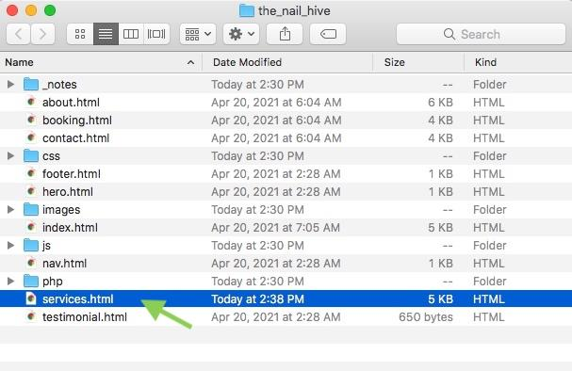
Notepad++

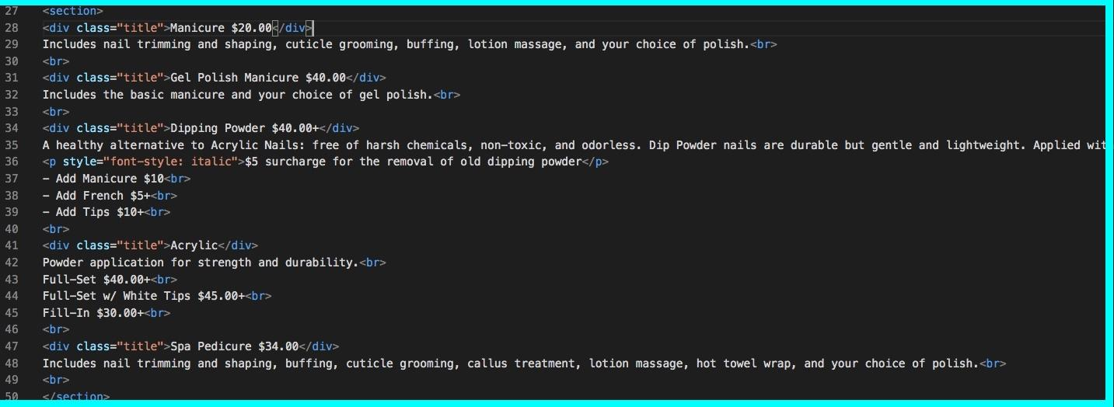
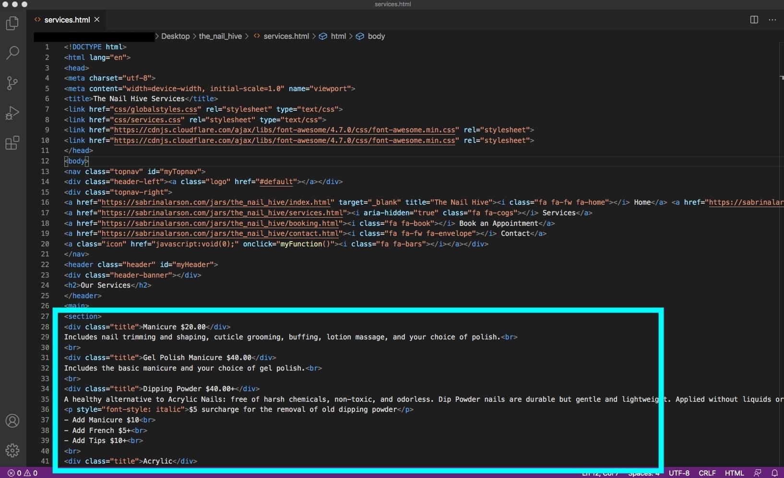
- Scroll to locate the list of services in the file. Located around lines 27 - 50

Editing a Service:
  - Locate the service you would like to edit.
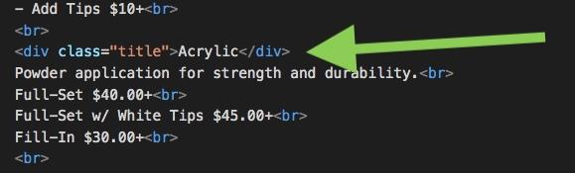
  - Replace the listed price with any price changes.
Green indicates any additions/changes. Red indicates any removals.
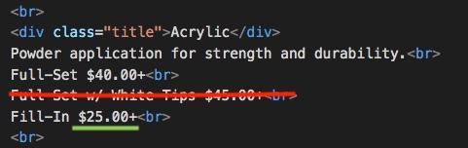
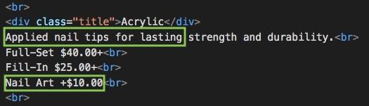
  - Apply any changes to service description.
  - Use <br> to add line breaks
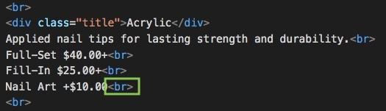
  - Save the file. Go to file > save
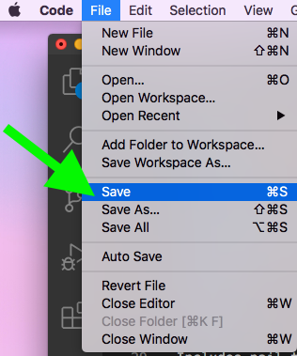
  - Preview edits in browser. Right click the services.html file, go to Open With > and select your browser of choice. Evaluate changes to match the overall appearance of the site.

Preview After Edits:
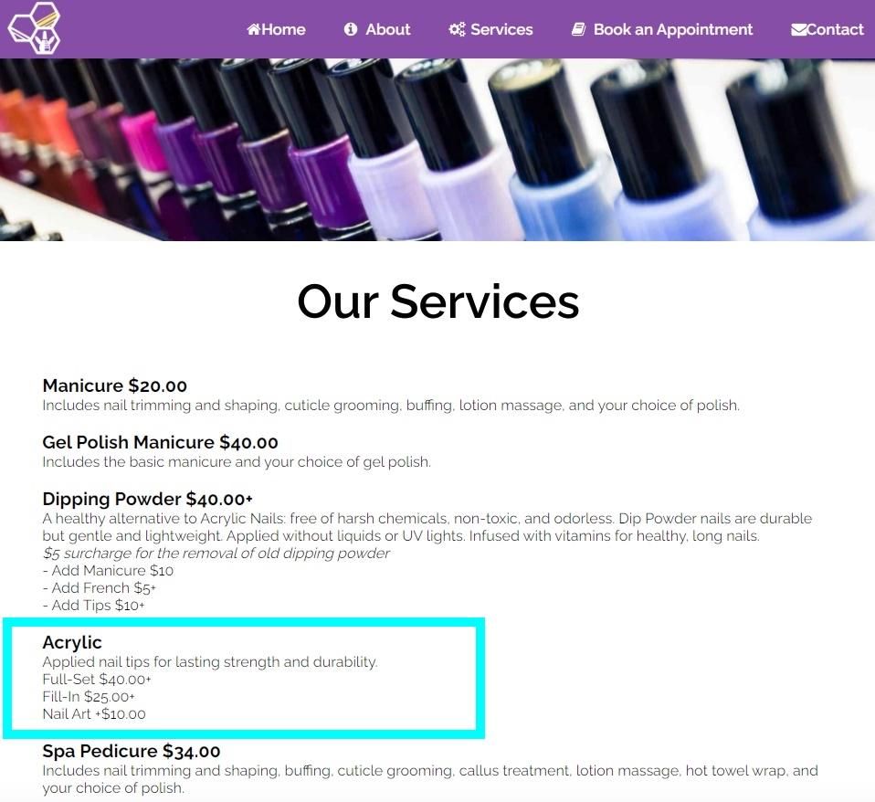

Adding a New Service:
  - Select where in the list of services you would like to add the new service. In this example we'll be adding a “Mani Pedi” service after Spa Pedicure. Make sure to add services before the closing </section> tag.
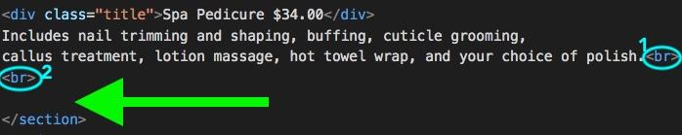
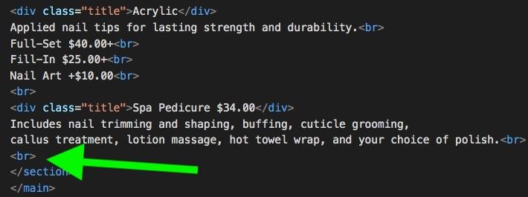
  - Press return to create a new empty line after the second <br> tag of the previous service’s description.
  - Type <div class=”title”>NewServiceTitleHere *Price</div>
example: <div class=”title”>Mani Pedi $50.00</div>
The price is optional if you plan to include multiple prices in the description.
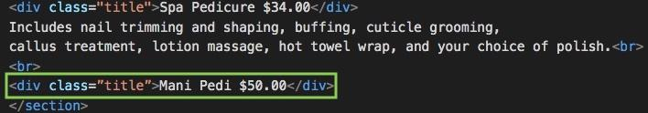
  - Press return and add a short description of the new service.
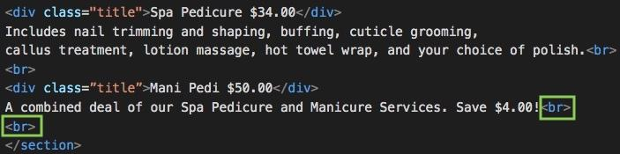
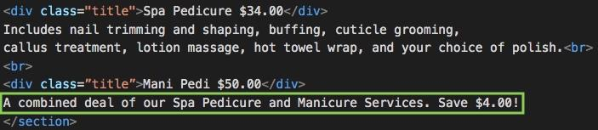
  - Include a <br> tag for any needed line breaks. Add one at the end of every description line and one at the end of the description.
  - Save the file. Go to file > save

  - Preview your changes in a browser. Right click the services.html file, go to Open With > and select your browser of choice. Evaluate changes to match the overall appearance of the site.
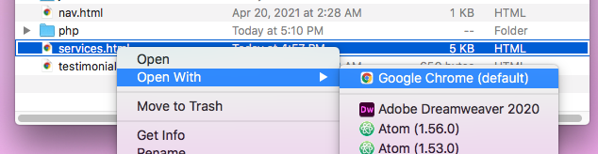
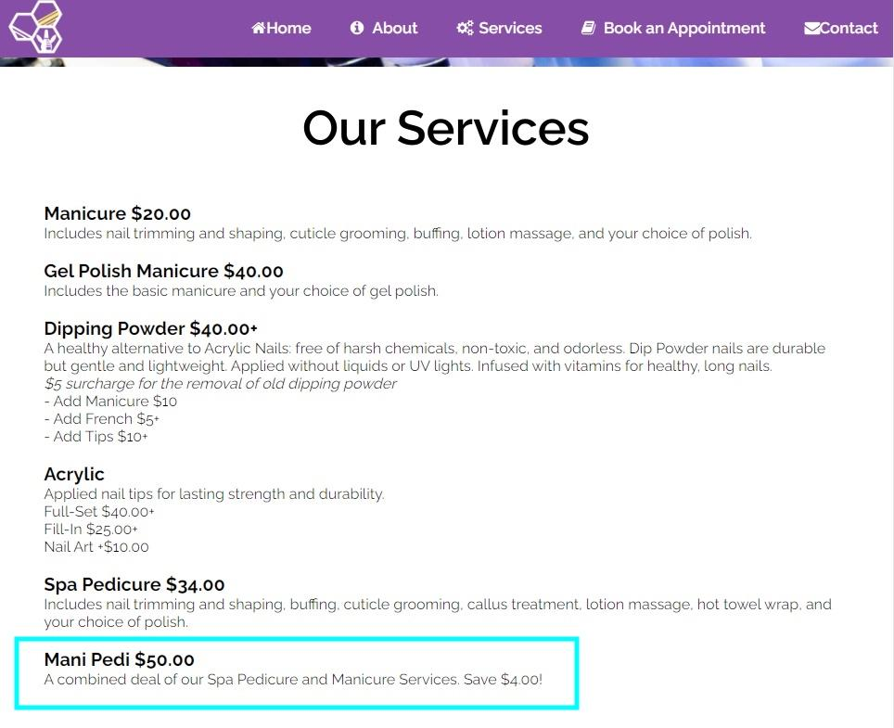

Edit the Booking Form to Include New Services
  - Open the booking.html file in a text editing program.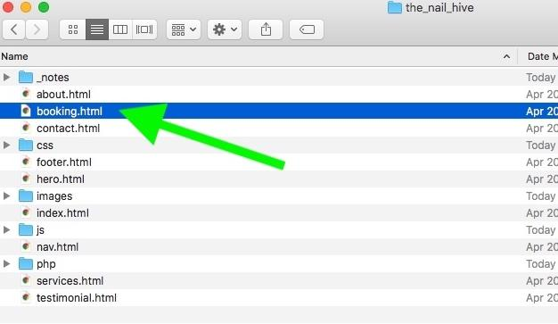
  - Scroll until you find <p>Type of Service</p> for the list of service options. Located around line 63.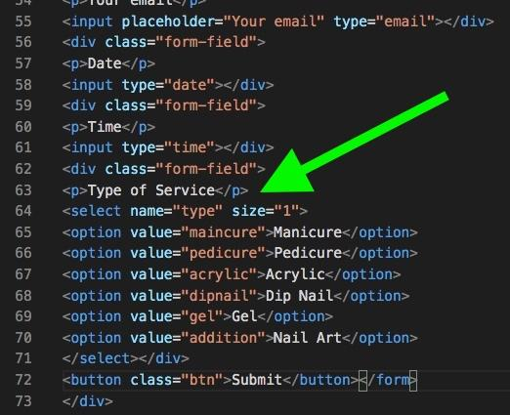
  - To add a new service, select where you would like to include the service in the list. Click after the closing </option> tag and press return to create a new line.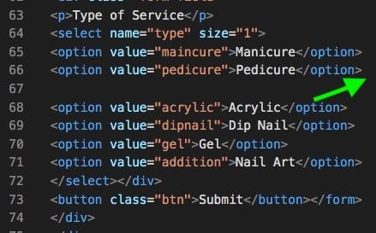
  - Type <option value=”servicetitlehere”>ServiceHere</option> to add the new service option.
example: <option value=”manipedi”>Mani Pedi</option>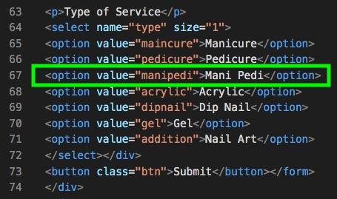
  - Save the file. Go to file > save
  - Preview any changes in a browser. Right click the booking.html file, go to Open With > and select your browser of choice. 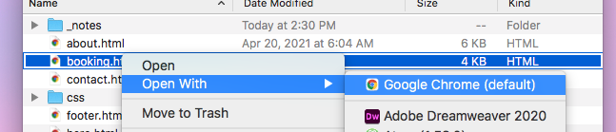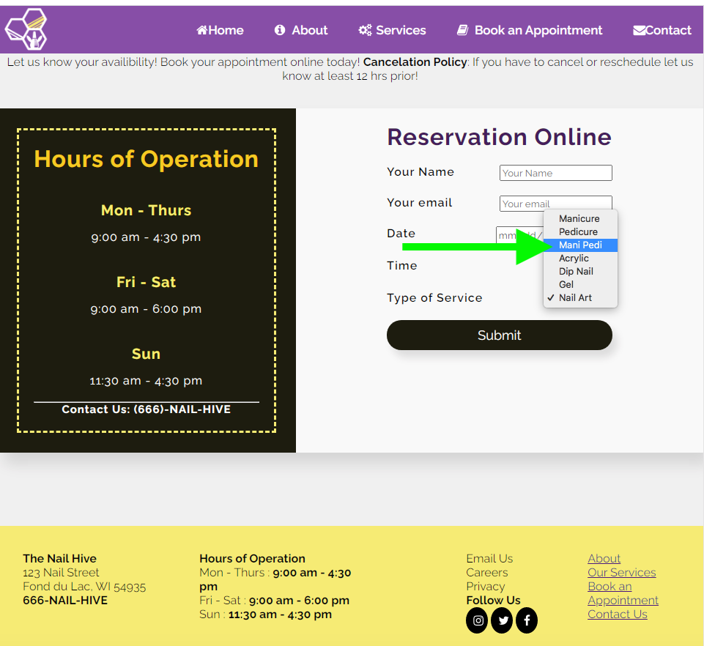

Upload/Update Files to Server.
  - Follow instructions from the Upload to GoDaddy video to update site files for both the booking.html and services.html files.
Video located here: https://www.sabrinalarson.com/jars/jars_docs/client_docs/GoDaddy_Upload_Site.mp4

