Production Guide

PREPARED FOR: The Nail Hive

PREPARED BY:
Sabrina Larson | Jeanna Brault |Ashley Griedd |
Riandria Gordon

Contents
Design Style Summary 5
Global Elements 5
Page Dimensions 5
Navigation 5
Footer 5
Colors: 5
HTML Text 6
Graphic Types 7
Font 7
Photo/Image Treatment 7
Icons 7
Page-Specific Elements 8
Home Page: 8
About Page 9
Technical Specifications 10
Introduction 10
Technical Summary 10
Assumptions 10
Global Elements 10
Wireframe 11
Global Elements 12
Global Head 12
Global Navigation 12
Global Footer 13
Page-Specific Elements 14
Home Page 14
Header HTML: 14
Main Content HTML: 15
About Page 16
Services Page 18
Book an Appointment Page 20
Contact Page 22
Naming Conventions 24
File types and extensions 24
Navigation Labels 25
Programming 25
Languages 25
Development Tools 26
Approval 26
Functional Specifications 27
Summary 27
Assumptions 27
Global Elements 27
Page-Specific Elements 28
Home Page 28
About Page 28
Services Page 28
Book an Appointment Page 29
File Structures 30
Project Folder Name: 30
Internal folder structure: 30
Images 31
Rules 31
Client Approval 32

Design Style Summary

https://sabrinalarson.com/jars/the_nail_hive/index.html

Global Elements

Page Dimensions
- Overall layout will be dynamic.
- Media Queries:
  - For Large Screens:
    - min-width: 1400px
  - For Small Screens:
    - max-width: 700px
    - max-width: 799px

Navigation
- Logo: At this time, we have not designed an approved logo for the nail hive. Upon design and approval, the dimensions of the logo will be: 50px by 50px and/or 25px by 25px.
- Background color: #9258b0
- Dimensions: width (360px - 1400px+) by height (65px)
- Navigation contains primary navigation links.
- Navigation bar is globally fixed at the top of the page.

Footer
- Background color: #F7EE7F
- Dimensions: width (360px - 1400px+) by height (181px - 681px)
- Footer contains navigation links, hours of operation, social media links, and contact/legal information.
- Footer is located globally at the bottom of the page.

Colors:
https://coolors.co/9258b0-4f2167-f7ee7f-f7d126-ffffff-388697-226b6d
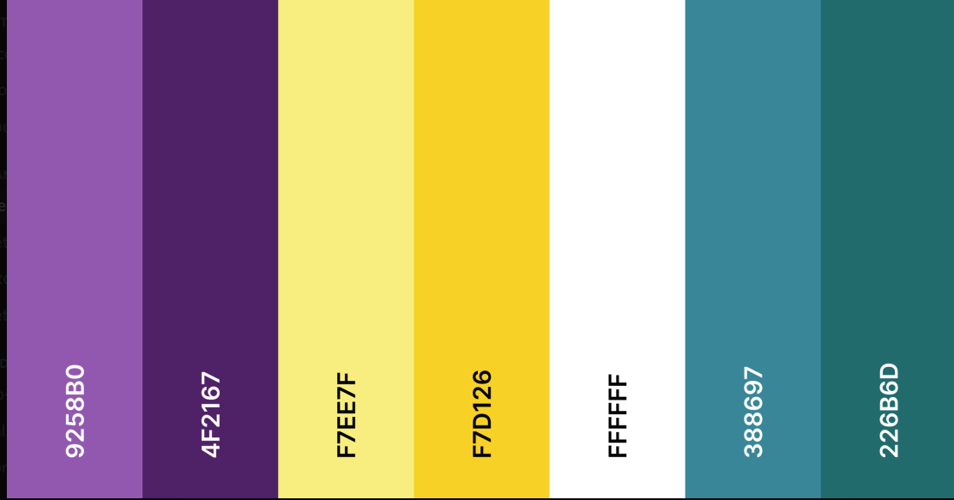
- Background Color: #ffffff White
- Accent Colors: #9258B0 •, #F7EE7F •, #388697 •, #226B6D •
- Secondary Accent Colors: #4F2167 •, #F7D126 •, #B7B7B7, #F2F2F2
- Primary Text Color: #00000 • Black
- Text Box Background: #F2F2F2 •
- Navigation Background: #9258B0 • ; #F7EE7F • (On Hover)
- Navigation Links: #ffffff White ; #000000 Black (On Hover)
- Footer Background: #F7EE7F • ; Footer Text: #000000 Black
- Footer Links: #000000 Black ; #226B6D • (On Hover)
- Standard Links: #388697 • ; #9258B0 • (On Hover)

HTML Text
- H1, H2: varies globally.
- H3: font-size: 2em, color varies globally.
- H4: font-size: 16px ; font-weight: bold ; color: black
- Primary Text Color: #000000 Black ; font-size: 20px
- Navigation Text: font-size: 17px
- Footer Text: font-size: 16px ; no text decoration ; h4 tags will be bold

Graphic Types

Font
- Font Family: Raleway, sans-serif
(Additional fonts may be introduced upon approval from the Nail Hive.)
- Font Weight: Light, Regular, Medium, Semi-Bold, and Bold available

Photo/Image Treatment
- Photograph images will use .jpg. Graphic images will use .png or jpg appropriately.
- Photos/Images will be resized to the necessary design scale to maintain quality.
- Photos/Images will use resolution optimized for the web.
- Photos/Images will use alt text or titles.
- Photos/Images files will be compressed using a free online compressor.

Icons
- Global icons will use the font awesome icon library and consist of:
  - Navigation Icons
    - fa fa-fw fa-home (home)
    - fa fa-info-circle (about)
    - fa fa-cogs (services)
    - fa fa-book (book an appointment)
    - fa fa-fw fa-envelope (contact)
    - fa fa-bars (drop-down menu)
  - Social Media Icons
    - fa fa-Instagram (Instagram)
    - fa fa-twitter (twitter)
    - fa fa-facebook (Facebook)

Page-Specific Elements

Home Page:
- Header:
  - Dimensions: height: 400px - 600px ; width: 100%
  - Contains a background hero image with a center positioning, a size of cover, no repeat, and a scroll attachment.
- H1 styles:
  - color: #00000
  - font size: 96px
  - text-shadow: 0px 4px 4px #F7EE7F
- H2 styles:
  - color: #226B6D
  - font size: 64px
  - text-shadow: 0px 4px 4px #000000
- Video:
  - Dimensions: width 40%, auto height
- Images:
  - Circle image links:
    - size: 160px - 200px by 160px - 200px
    - border: 2px solid #F7EE7F ; border radius: 50%
    - opacity transition from 0.85 to 1.0 on hover
- Button styles:
  - color: white ; color: #F7EE7F (on hover)
  - border: 6px solid #4499AF ; border: 6px solid #9258B0 (on hover)
  - transition of color and border on hover
  - font size: 2.25 em ; font weight: 600
  - text decoration none
- Testimonial Text Box:
  - background color: #F2F2F2
  - border: 1px solid #B7B7B7
  - box-shadow: 0px 4px 4px #9258B0
  - width: 80% ; height 175px
  - border radius: 40px

About Page
- Images
  - Circle image links:
    - size: 160px - 200px by 160px - 200px
    - border: 2px solid #F7EE7F ; border radius: 50%
    - opacity transition from 0.85 to 1.0 on hover
- Text Box
  - background color: #F2F2F2
  - border: 1px solid #B7B7B7
  - box-shadow: 0px 4px 4px #9258B0
  - width: 80% ; height 175px
  - border radius: 40px
- Button
  - color: #9258B0 ; border color: #388697
  - on hover: #388697 ; border color: #9258B0
- H1 Styles
  - size: 64px
- H2 Styles
  - size: 48px

Services Page
- Header:
  - Dimensions: height: 451px - 316px ; width: 100%
- H2 styles:
  - color: #000000
  - font size: 52px
- Slideshow:
  - Dimensions: max width 1000px, auto height
- Images
  - size: 1440 x 810

Book an Appointment Page
- H2 styles:
  - font-weight: 600
  - font-size: 52px
- H3 styles:
  - margin-top: 40px
  - padding-bottom: 15px
- Booking Form:
  - dimensions: 596 x 802
  - padding-bottom: 15px
  - color: #f7ee7f; color: #fff; color: #4f2167
  - font-size: 20px
  - box-shadow: 10px 15px 20px

- Button
  - color: #fff; background color: #000000

Contact Page
- H2 styles:
  - font-weight: 600
  - font-size: 52px
- Contact Form:
  - dimensions: 1023 x 867
  - color: #f2f2f2
  - font-size: 20px
  - box-shadow: 10px 15px 20px
- Button
  - color: #226b6d; on hover: #f7d126
- Input Text Boxes
  - width: 100%
  - border: 1px solid #226b6d

Technical Specifications

Introduction

Technical Summary
The Nail Hive website will have the capability to connect to the internet to modify and view its content. The website will be a single page, with access to the navigation bar to take the user to other pages. Content on this webpage will consist of text, images, links, and their logo.

Assumptions
The Nail Hive will provide J.A.R.S. Web Design with their preferred text content, images, graphics, and color scheme as outlined in the previous documents. All of the material includes, but is not limited to, summarized in the Technical Summary. Users are responsible for maintaining their computers and systems.

Global Elements
It consists of elements that will be the same throughout their webpage. The Nail Hive will be a single page, with access to the navigation bar to take the user to other pages with particular elements all through their webpage.

Wireframe

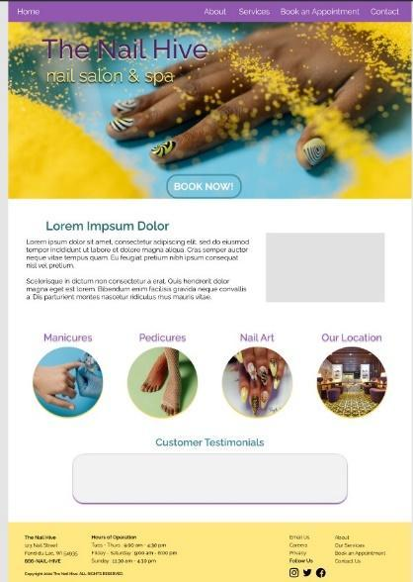

Global Elements

Global Head
HTML
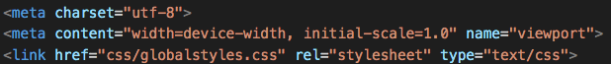
- Additional stylesheets and title tags will be adjusted for every page.

Global Navigation
Image of Footer
HTML
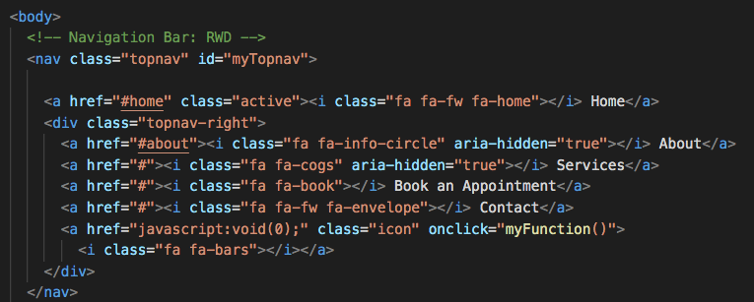

Global Footer
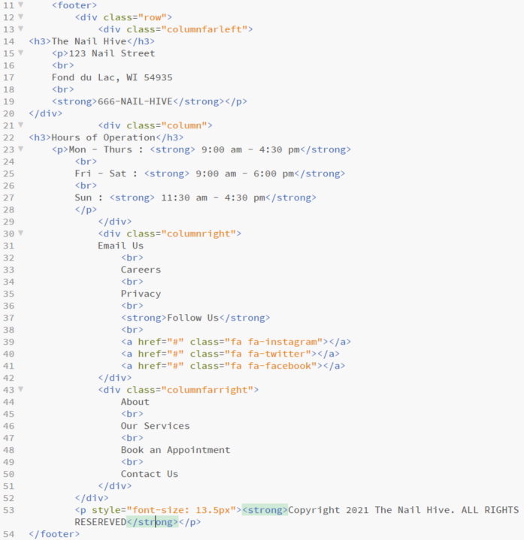
Image of Footer
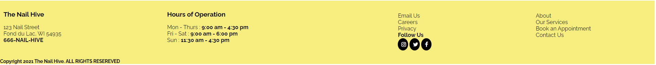

Page-Specific Elements

Home Page

Header HTML:

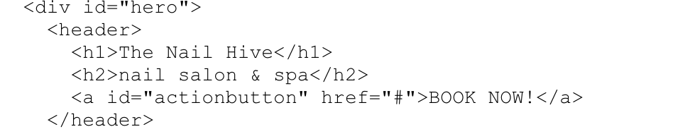

Main Content HTML:
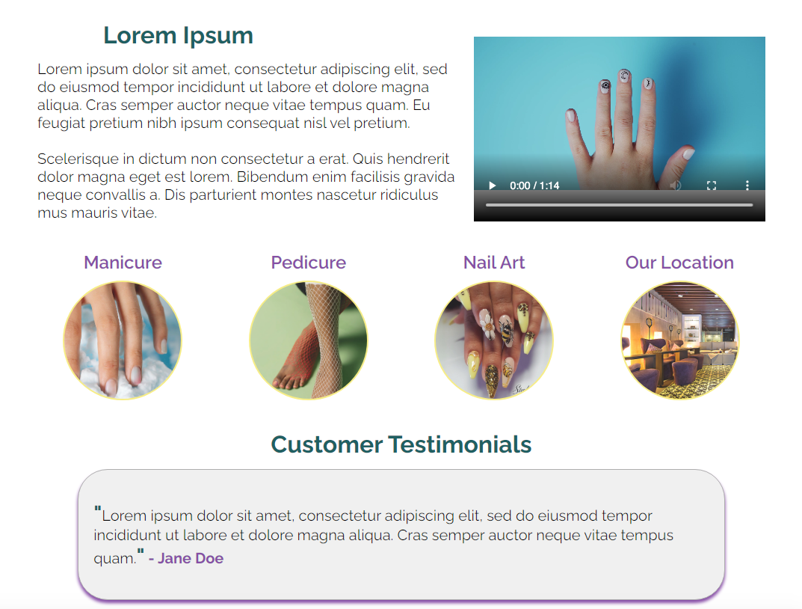
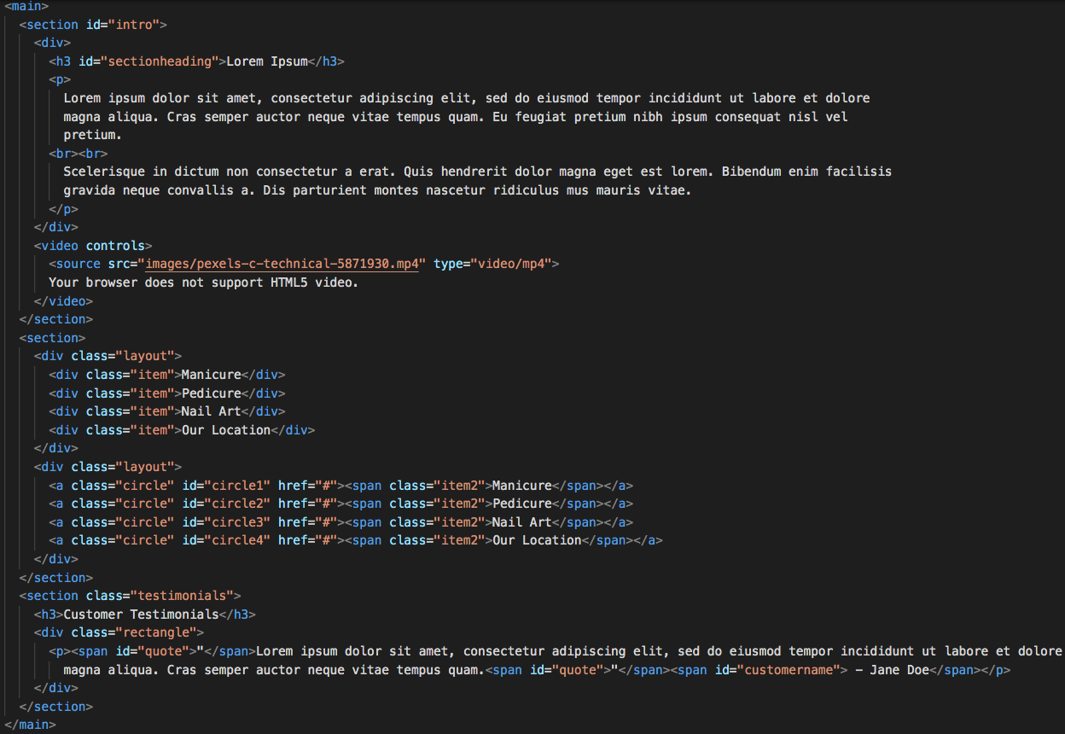

About Page
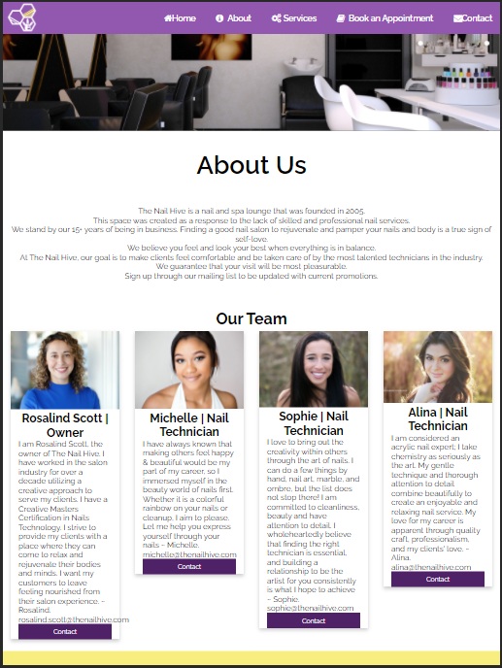
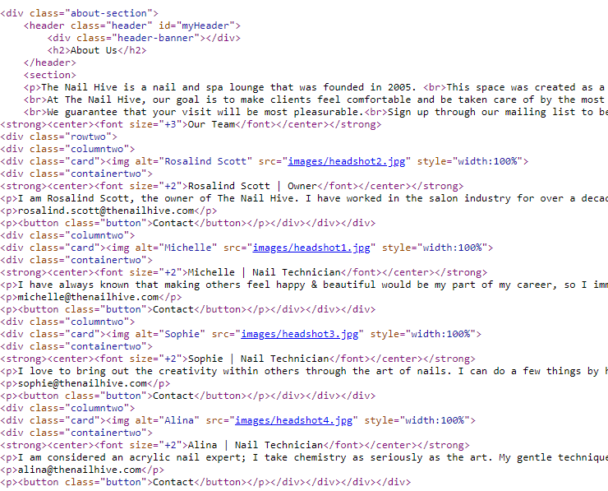

Services Page

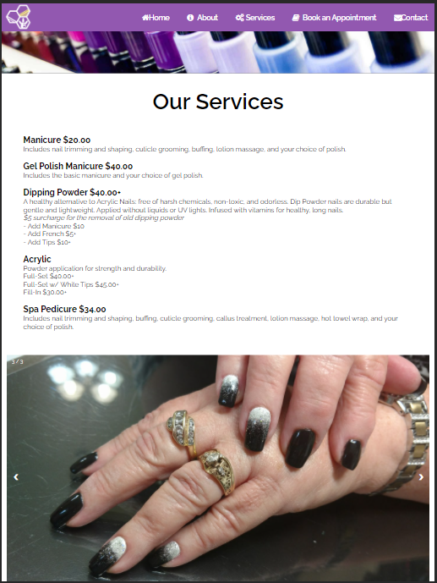
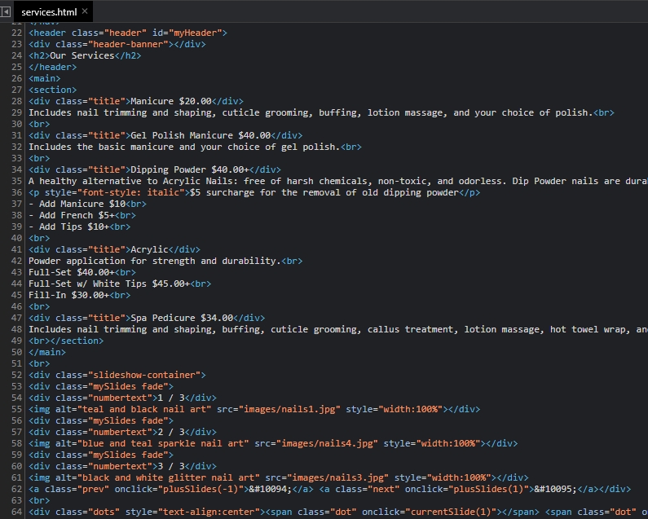

Book an Appointment Page
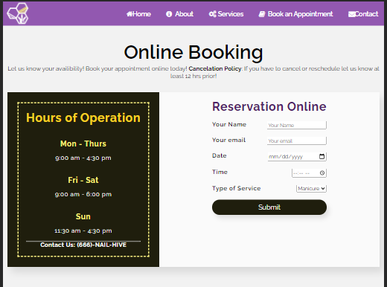
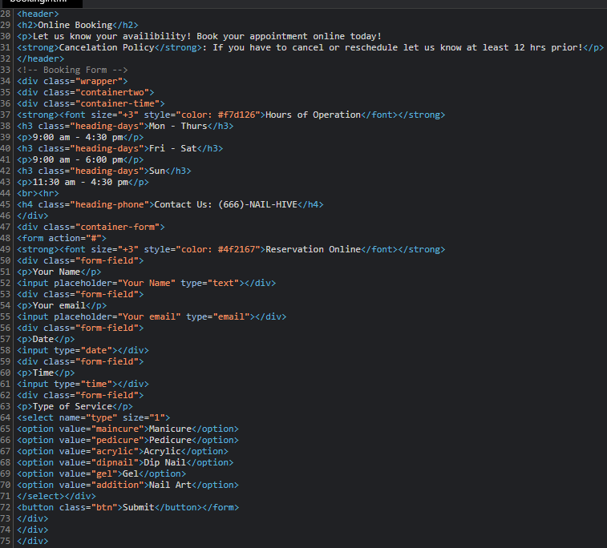

Contact Page
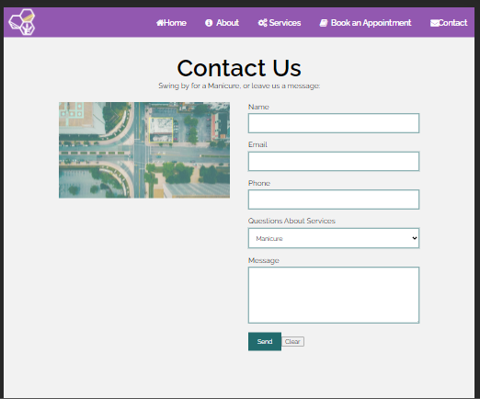
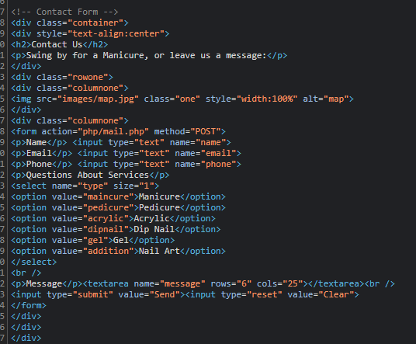

Naming Conventions
- Use names/labels considerations for site users first.
- Titles and descriptions will use clear, simple, descriptive language.
- Aim for SEO (search engine optimization)
- Utilize Keywords
- Avoid abbreviations.
- Avoid special characters and symbols.
- Avoid generic labels.
- Use headings in a proper hierarchy and avoid excessive headings.
- Keywords will be implemented.

File types and extensions
- All the files and folder names will be separated with an underscore “_” and contain no spaces.
- When naming files or folders, it will appear with lowercase letters and numbers (nothing else).
- All file and folder names will be short and straightforward.
- There will be the use of meta tags for keywords and descriptions.
- All images will include the alt tag with keywords that relate to the picture.
- All web files are familiar and recognizable with standard extensions.
File Types | Extensions | Using
Microsoft Word | Editable Documents | .docx, .doc
Portable Document Format (PDF) | Non-Editable Document | .pdf
HTML Documents | Webpage | .html
CSS Documents | Webpage styles | .css
JavaScript Documents | Forms, buttons, etc. | .js
JPG | Pictures/Images | .jpg
PNG | Pictures and Images with a transparent background | .png

Navigation Labels
- The Nail Hive and Logo > index.html
- About > about.html
- Services > services.html
- Book an Appointment > booking.html
- Contact > contact.html

Programming

Document type declaration
<!DOCTYPE HTML>

Languages
- HTML
- CSS
- JavaScript

Development Tools
- Notepad++
- Adobe Dreamweaver
- Brackets
- Microsoft Office
- GoDaddy
- W3C HTML Validation
- W3C CSS Validation
- WAVE Accessibility Tool

Approval

Company | Agency Name ___________The Nail Hive___________
Approved By ___________Rosalind Scott__________
By signing below, the Client agrees that the above description of their consulting project is completed to satisfaction. The Client understands that after approving this phase, any changes relating to the approved portion may require additional development efforts by the Consultant, and additional costs may apply.
Signed:_________Rosalind Scott___________Date: 4/13/2021

Functional Specifications

Summary
This document is the functionality report for The Nail Hive, made by J.A.R.S Web Design. The goal of this website is to be able to navigate the site with ease. It should be user-friendly, modern, and mobile-friendly. The Nail Hive will also be user-friendly and bring new customers and old customers to the new website and the business. There will be diverse web pages on the website to establish and pictures to give good visual attractiveness.

Assumptions
This website will be accessible on any device, tablets, computers, smartphones, etc. Pageable to load in the most used browsers.

Global Elements
Both the Navigation Bar and the Footer are global elements that will remain consistent across all site pages.
The Navigation Bar contains navigation links to other top level, main priority, site pages.
It contains links to the following: Home - About - Services - Book an Appointment - Contact

The Footer contains contact information, hours of operation information, and an additional navigational section for users to access links to secondary site pages and social media links. This footer section is an important aid to site users to access specific and important site information and links.
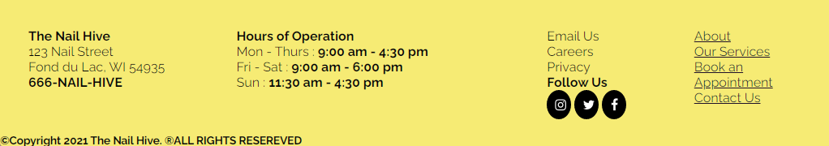
For every page other than the home/landing page, a consistent header will be applied to allow a visual consistency for site users.


Page-Specific Elements

Home Page
Contains a hero image and header to visually catch site visitors’ attention with large overlaid text reading “The Nail Hive ; nail salon & spa”. It also has an outlined action button, “Book Now!”, which will link users to the Book an Appointment page.

An introduction blurb will allow site users to at a glance learn more about the Nail Hive as a business and the overall goals/atmosphere. This section includes a short promotional video example of a nail stamping technique used by the Nail Hive.
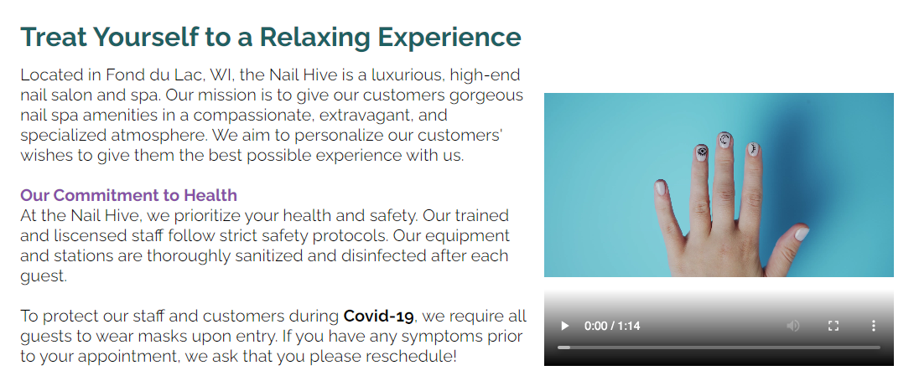
Circle image buttons act as a visual navigation and representation of the Nail Hive’s services to site visitors.
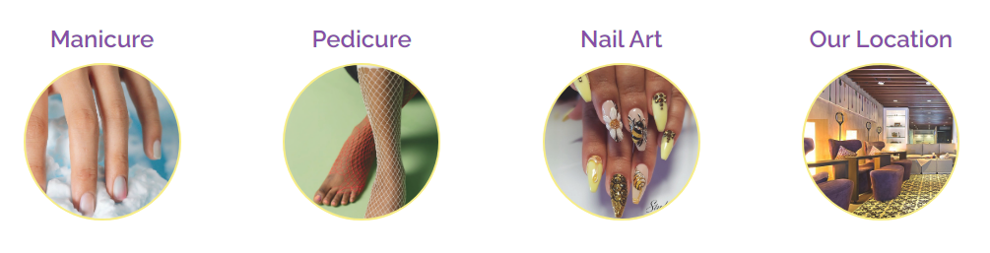
Review of the Month: A chosen quoted review about the Nail Hive to promote business and give potential new customers an idea of what customers have enjoyed about the Nail Hive’s services.
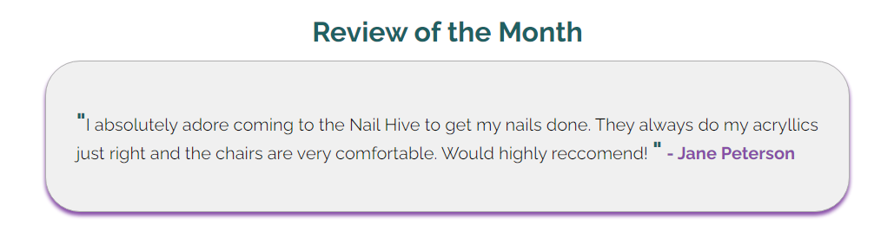

About Page
A short introduction paragraph includes general information about the Nail Hive as a business. This provides site users with a friendly and professional understanding.
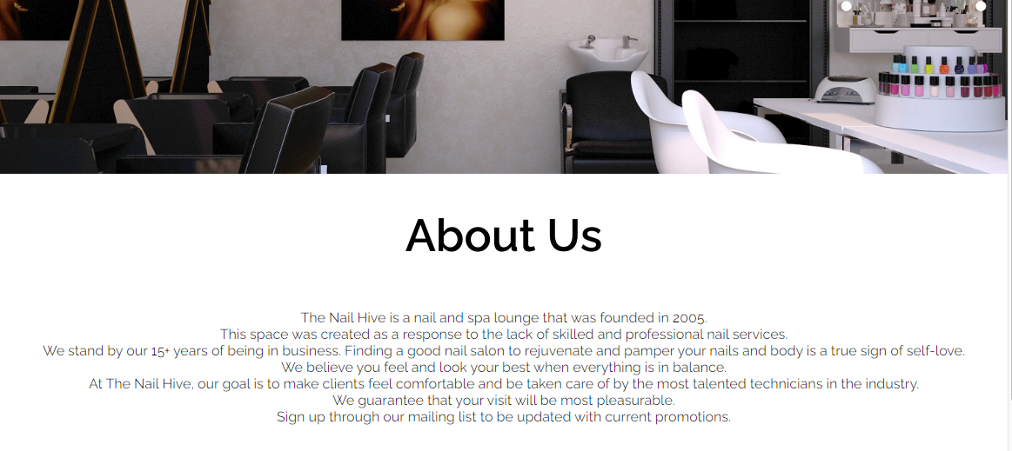
Our Team as a section allows potential customers to connect to and be introduced to our staff and to highlight any skills or specifications. Contact links allow clients to email our staff any questions or inquiries.
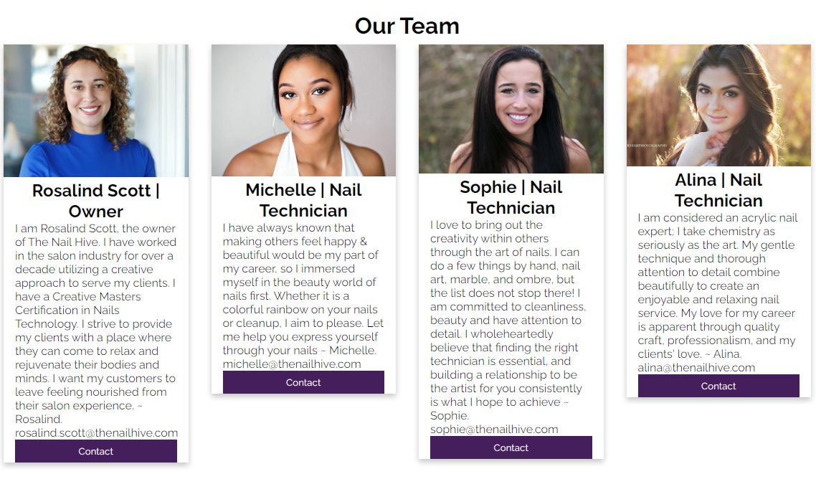

Services Page
Our Services lists and gives detailed descriptions of the services the Nail Hive offers including price information. Prices are easy to locate for user ease.
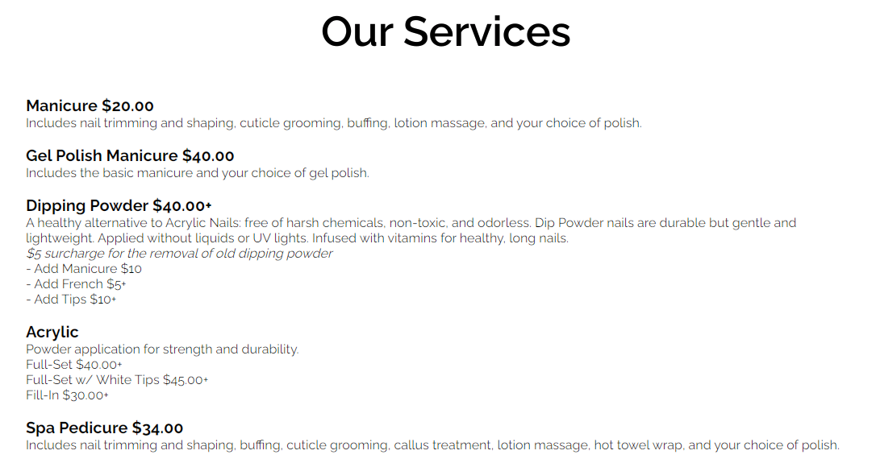
A small gallery of example work highlights the skills and services offered. The gallery arrows allow users to manually flick through images. In the top corner it lists the number of images and the circles at the bottom highlight to show which image is selected from the list.
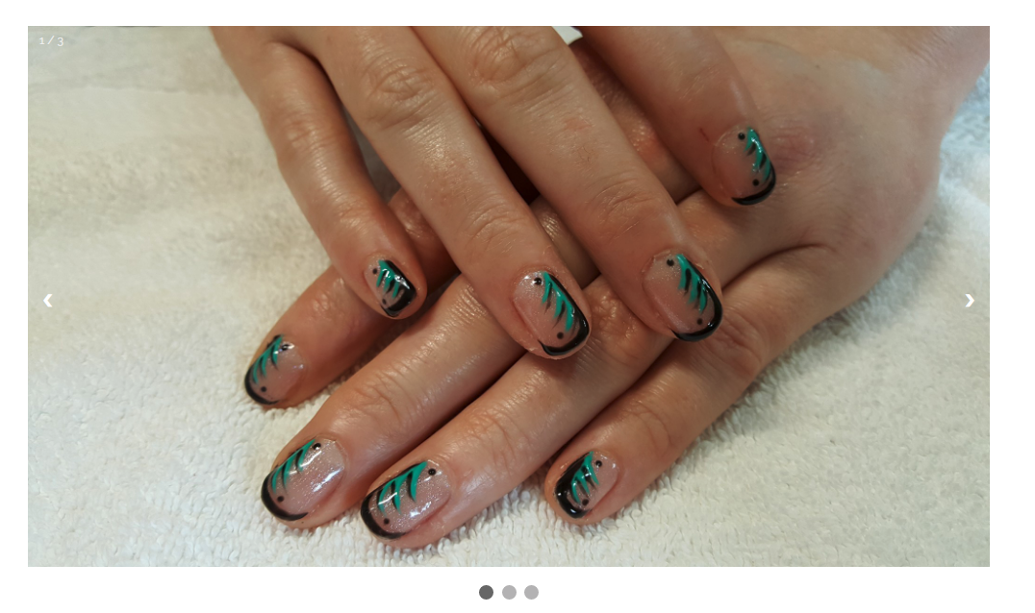

Book an Appointment Page
This page functions as an online form where clients can book an appointment online. It contains form fields for name, email, date, time, and type of service. There is a submit button to submit the form. There is also a side informational panel containing information about the Nail Hive’s hours of operation and a contact number.
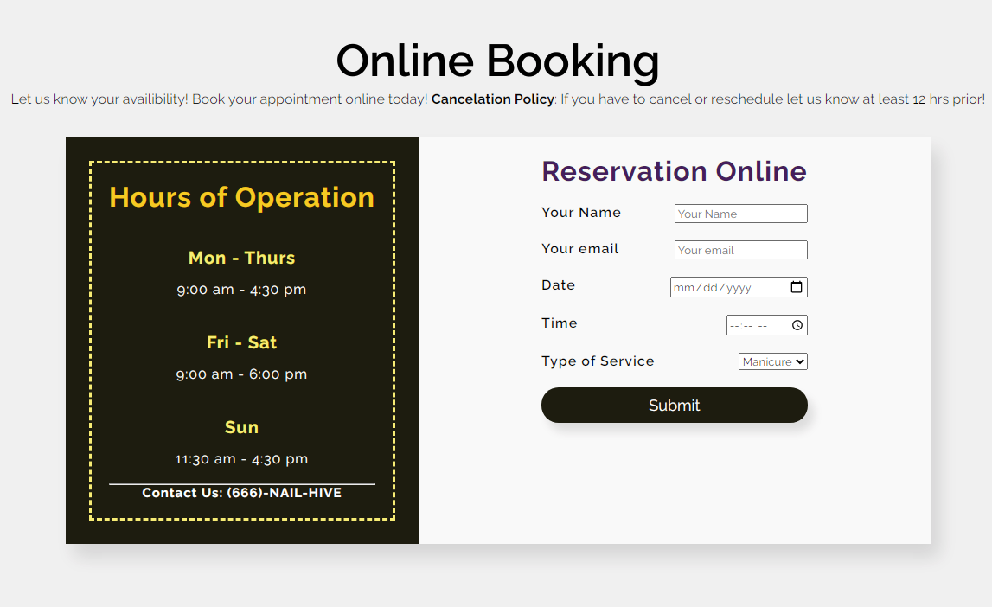
The Date section includes a drop down monthly calendar to allow users to easily select the date/day of the week with one click. It also starts at the current date.
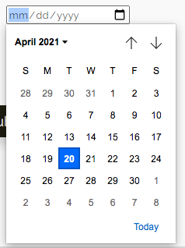
The Time Section includes a scroll through menu to select hour, minute, and am/pm options easily with only a few clicks. It starts at the current time.
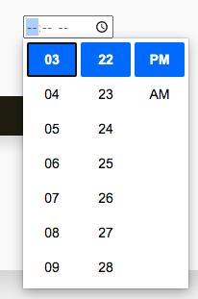
The Type of Service includes a drop down menu to select from a range of service choices: Manicure, Pedicure, Acrylic, Dip Nail, Gel, and Nail Art.

Contact Page
The Contact page functions as a contact form for site visitors to send any other questions or messages to the Nail Hive. It includes a form fields for name, email, phone, message, and a drop down menu to inquire about a specific service. There is a Send button to send the message and a clear button which allows users to reset/clear the form.
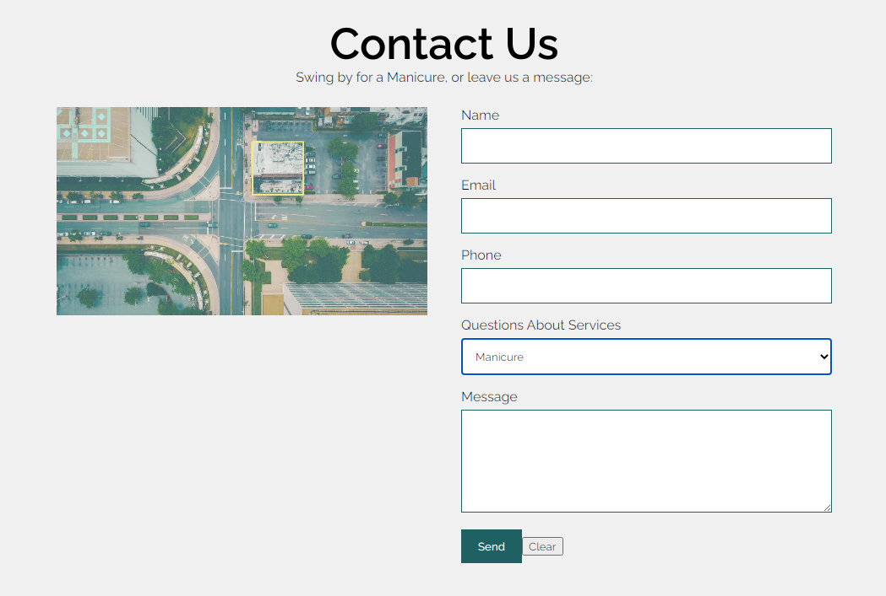

File Structures

Project Folder Name:
- No Spaces, all lower case, simple names

Internal folder structure:
Example
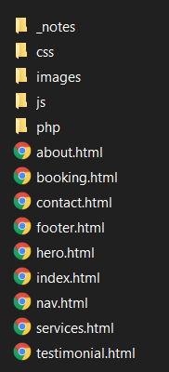
- CSS (different stylesheets)
- Images (png, jpg, etc.)
- Vendor (bootstrap, jQuery)
- Php (php files)
- Js (JavaScript Files)

- Index.html
- About.html
- Service.html
- Booking.html
- Contact.html

Images
Either .jpg or .png files and stored in one file besides the logo, which is in a separate folder.
Example
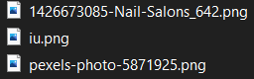

Rules
- Stylesheets go into the CSS folder.
- All images will go into an image folder.
- HTML pages stay in the main folder.
- JavaScript will go into a J.S. folder.
- PHP will go into a PHP folder.

Client Approval

Company | Agency Name ___________The Nail Hive___________
Approved By ___________Rosalind Scott__________
By signing below, the Client agrees that the above description of their consulting project is completed to satisfaction. The Client understands that after approving this phase, any changes relating to the approved portion may require additional development efforts by the Consultant, and additional costs may apply.
Signed:_________Rosalind Scott___________Date: 4/13/2021

