Quality Assurance Plan
Prepared For: The Nail Hive

Contents
Introduction: 3
Testing 3
Participants 3
Test Environments 5
Performed Test Cases 5
Bug Tracking and Fixing Plan 6
Blank Test Case Form 8
Completed Test Cases 9
Blank Bug Report Form 16
Completed Bug Reporting Form 20

Introduction:
J.A.R.S Web Design has designed a Quality Assurance Plan for The Nail Hive website (https://sabrinalarson.com/jars/the_nail_hive/ ). The plan outlines the process that J.A.R.S Web Design will be complete making sure the website & accessibility standards have functioning links & images, is mobile-friendly and has a functioning form. There will be testing completed in various formats.

Testing
The test will be light and informal.

Participants
Quality Assurance Lead / Public Relations Specialist
- Works with Client to finalize major fixes/bugs
- Responsible for overseeing and evaluating bugs.
- Client questions are directed to the QA Lead.
Project Manager
- Oversees internal and external test cases.
- Has final approval with the client over the bugs and their fixes.
Creative Lead
- Assists in bug testing and test cases.
- Approves of any bug fixes that require design changes.
- Fix reported bugs and assist the QA Lead.
Web Production Specialist
- Assists in bug testing and test cases.
- Plans attack on high-risk bugs.
- Revises code to fix bugs.
Client
- Test the final site for bugs before launch.
- Report to the whole team with updates.
- Informs the QA Lead with any questions.
- Signs Final plan idea.

By signing this document, you agree to the Quality Assurance phase, which outlines above.

______Rosalind Scott_____________ _____5/27/21_____________
Signature Date

Test Environments
Test | 1 (Sabrina) | 2 (Ria) | 3 (Ashley) | 4 (Jeanna)
Platform | Windows 10/Samsung 20+ Phone | macOS/ iPhone 11 | Linux/Pixel XL 2 Phone | macOS / iPad /  iPhone 6s
O.S. | Windows 10/Samsung 20+ Phone | Catalina 10.15.3/iOS | Ubuntu 18.04.4/Android 11 | macOs High Sierra 10.13.6 /
Hardware Type | Laptop/ Samsung 20+ Phone | Macbook Pro/ iPhone 11 | Dell G5 15 SE 5505 laptop/Pixel 2 XL Android version 11 | iMac / iPad / iPhone 6s
Browser | Firefox/Opera/Edge/Chrome/Chrome on Samsung 20 + Phone | Safari/Google Chrome 90.0.4430.85 | Firefox version 88.0/Chrome android version 28.0.1500 | Safari version 11.1.2 (desktop)/ Chrome version 99.04430.85 (desktop)
Resolution / Screen Size | 15-inch (1920 x 1080)/Samsung 20+ size 6.7” (1,600 x 720) | 13.3-inch (2560 x 1600)/ iPhone (1792 x 628) size 6.1” | Linux res 1920x1018 size 15.6” / Android res 2880x1440 size 6” | 1920 x 1080 / 11”  1194 x834 / 750 x 1334

Performed Test Cases
- Responsive (Mobile Functionality) across all pages
- Images/Videos across all pages
- Navigation across all pages
- Form Functionality across all pages

Additional (Sample) Test Cases
- Code Validation Testing
- Web Accessibility
- Responsive (Browser Functionality)

Bug Tracking and Fixing Plan
Assumptions
It can be understood that all issues have been fixed by J.A.R.S Web Design and Development before the client’s launch date. J.A.R.S Web Design will be responsible for fixing any problems that may occur in the first six months of the client’s website launch date.
Risk
The tests completed on the client’s web site were performed on commonly used and updated browsers. The website may function and look different on older browsers.
Bug Reporting Tracking Plan
Testers complete the Bug Tracking Form to record any issues/bugs found on the client’s website. Testers then share the information found to the Quality Assurance Lead, who then determines the severity of the problem and works with the Project Manager to establish the priority level for resolving the issue.
Bug Severity Levels
- Low – Basic improvements
- Medium – Easy to resolve problems (typos, grammatical errors)
- High – Minor loss of website function.
- Critical – Major loss of website function
- Catastrophic – Website crashes

Bug Fix Priority Levels
- Priority 1 – Fix bug as soon as possible (highest priority)
- Priority 2 – Fix bug before subsequent testing
- Priority 3 – Fix bug before the final launch date
- Priority 4 – Bugs can be fixed after the launch of the website.
Bugs Not fixed Before Launch Date
If the client’s web site contains low, medium, or high bug severity bug levels, the website will still launch on schedule. If there is a critical or catastrophic bug, all issues must be fixed within one week of the launch date.

By signing below, you signify that you understand and agree with the J.A.R.S Web Design Website & Development’s Bug Tracking and Fixing Plan.

________Rosalind Scott___________ ______5/27/21____________
Signature Date

Blank Test Case Form
The Nail Hive Test Case
Test Case Name:
URL:
Testing Environment:
Tester Name:
Test Date:
Action | Expected Result | Result | Comments

Sample Test Cases
To be completed and filled out by testers.

The Nail Hive Test Case
Test Case Name: | Responsive (Browser) Test
URL: | https://www.sabrinalarson.com/jars/the_nail_hive/
Testing Environment:
Tester Name:
Test Date:
Action | Expected Result | Result | Comments
Page Responsive in intervals up to 400px | Main aspects of all pages resize accordingly
Text resizes in intervals up to 400px | Text realigns and resizes accordingly
Images/videos resized in intervals up to 400px | Images/videos resize and are clear

The Nail Hive Test Case
Test Case Name: | Code Validation Test
URL: | https://www.sabrinalarson.com/jars/the_nail_hive/
Testing Environment:
Tester Name:
Test Date:
Action | Expected Result | Result | Comments
HTML Validation | Code validates across all pages with zero errors
CSS Validation | Code validates across all pages with zero errors

The Nail Hive Test Case
Test Case Name: | Web Accessibility
URL: | https://www.sabrinalarson.com/jars/the_nail_hive/
Testing Environment:
Tester Name:
Test Date:
Action | Expected Result | Result | Comments
Images | All images are visible and contain a descriptive alt attribute
Color Contrast | All text, icon, and input elements meet WCAG 2.0 Level AA contrast standards
Headings | Site has one h1 per page, each page uses h tags in sequence without skipping levels.
Links | All links are descriptive and recognizable. Links that open in a new tab are identified.
Language/Text | All language text used is easy to understand.
WCAG 2.0 Check | Site passes a WCAG 2.0 tool test without any errors or warnings.

Completed Test Cases

The Nail Hive Test Case

Test Case Name: Form Functionality
URL: https://www.sabrinalarson.com/jars/the_nail_hive/
Testing Environment: (Windows 10); Firefox/Opera/Edge/Chrome ; Samsung Galaxy 20+
Tester Name: Sabrina Larson
Test Date: 4/26/21
Action | Expected Result | Result | Comments
Booking Form | Working Book Form | Form does do the date and time, but is not functional | Booking form works, but does not sending anything
Contact Form | Working Contact Form | The form does send an email to me with all the info from the recipient. | Send an email to the user and the reply.
Test Environments | Firefox/Opera/Edge/Chrome ; Samsung Galaxy 20+

The Nail Hive Test Case
Test Case Name: | Responsive (Mobile) Test
URL: | https://www.sabrinalarson.com/jars/the_nail_hive/
Testing Environment: | Platform- Pixel 2 XL  Operation System- Android 11  Browser-Chrome
Tester Name: | Ashley Giedd
Test Date: | 04/26/2021
Action | Expected Result | Result | Comments
Responsive to 400px on all pages | Images/Text resize appropriately | All pages except Booking are appropriately responsive | Check the @media screen attribute in it’s CSS
Text is responsive to 400px on all pages | Text is easy to read at its size and aligned correctly | All pages except Booking are easy to read and aligned | Known issue, please see above
Images/Videos are responsive at 400px | Images/videos resize correctly, easy to see | All pages except Booking are resized and correct | Known issue, please see above

The Nail Hive Test Case
Test Case Name: | Navigation Functionality
URL: | https://www.sabrinalarson.com/jars/the_nail_hive/
Testing Environment: | iMac / iPad 11” Pro / iPhone 6s  Browsers: Safari, Chrome  (see test environment 4 (Jeanna) for additional information)
Tester Name: | Jeanna Brault
Test Date: | 4/26/21
Action | Expected Result | Result | Comments
Navigation Bar (Primary Links) | All links function across all site pages | N | The “Home” link opens in a new tab
Footer Links | All links function across site pages | Y* | *(Social media pages have not been linked yet. Privacy and Careers Pages have not been developed.)
Logo | Returns to the home/landing page | N | Refreshes the current page
Button | Links to “Book an Appointment” | Y | n/a

The Nail Hive Test Case
Test Case Name: | Images/Video Functionality
URL: | https://sabrinalarson.com/jars/the_nail_hive/ (index.html, about.html, services.html, contact.html)
Testing Environment: | Macbook Pro; Safari ; Catalina 10.15.3
Tester Name: | Riandria Gordon
Test Date: | 04/25/21
Action | Expected Result | Result | Comments
Image/Video Quality | Images/video are high quality | Y
Image/Video Optimization | Images or Video load quickly  Images/video are optimized for the web | N | Video on the index.html page buffers or doesn't load at all.
Responsive Images/Video | Images/video mobile friendly  Images/Video have alt text | Y  Y
Image/Video Display | Images/video follow CSS rules | Y

The Nail Hive Test Case
Test Case Name: | Images/Video Mobile
URL: | https://sabrinalarson.com/jars/the_nail_hive/ (index.html, about.html, services.html, contact.html)
Testing Environment: | iPhone 11; iOS; Safari
Tester Name: | Riandria Gordon
Test Date: | 04-25-21
Action | Expected Result | Result | Comments
Images/Video Quality | Images/video are high quality | Y
Image/Video Optimization | Images or Video loads quickly  Images/video are optimized for the web | N | Video on the index.html page buffers or doesn't load at all.
Responsive Images/Video | Images/video mobile friendly  Images/Video have alt text | Y  Y
Image/Video Display | Images/video follow CSS rules | Y

Blank Bug Report Form
Bug Reporting Form
Log # |  | Priority
Tester Name |  | Severity
Test Date |  | Date Started
Browser |  | Date Completed
Error Type
URL of Page with Bug
1
2
3
Description of Bug

Screenshot of Error
Severity of Bug
Low – Basic improvements
Medium – Easy to resolve problems (typos, grammatical errors)
High – Minor loss of website function
Critical – Major loss of website function
Catastrophic – Website crashes
Bug Priority Levels
Priority 1 – Fix bug as soon as possible (highest priority)
Priority 2 – Fix bug before next testing
Priority 3 – Fix bug before final launch date
Priority 4 – Bug can be fixed after launch of website
Budget Impact
Description | Hours | Due Date

Was Bug Fixed?
- Completed 100%
- Fixed, but still needs work.
- Unresolved
Approval
Client Signature

Project Manager Signature

Completed Bug Reporting Forms

Form 1
Bug Reporting Form
Log # | Video on homepage | Priority | 2
Tester Name | Riandria Gordon | Severity | High
Test Date | 04/25/21 | Date Started | 04/25/21
Browser | Safari | Date Completed | in progress
Error Type
Video is buffering on the homepage or does not load at all.
URL of Page with Bug
1 https://sabrinalarson.com/jars/the_nail_hive/index.html
2
3
Description of Bug
video needs to be compressed to a reasonable media size file without losing quality.

Screenshot of Error
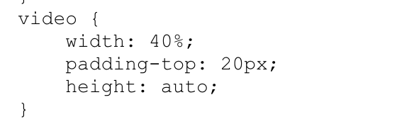
Severity of Bug
Low – Basic improvements
Medium – Easy to resolve problems (typos, grammatical errors)
High – Minor loss of website function
Critical – Major loss of website function
Catastrophic – Website crashes
Bug Priority Levels
Priority 1 – Fix bug as soon as possible (highest priority)
Priority 2 – Fix bug before next testing
Priority 3 – Fix bug before final launch date
Priority 4 – Bug can be fixed after launch of website
Budget Impact
Description | Hours | Due Date
identifying/fixing the issue | 1 | 04/25
Was Bug Fixed?
- Completed 100%
- Fixed, but still needs work.
- Unresolved
Approval
Client Signature

Project Manager Signature
Jeanna Brault 4/27/21

Form 2
Bug Reporting Form
Log # | Accessibility Issues | Priority | 2
Tester Name | Sabrina Larson | Severity | High
Test Date | 4/25/21 | Date Started | 4/25/21
Browser | Microsoft Edge 90.0.0818.46 (64 bit) | Date Completed | In progress
Error Type
Links must have discernible text: Element has not title attribute
URL of Page with Bug
1 https://www.sabrinalarson.com/jars/the_nail_hive/
2
3
Description of Bug
Compliance Data & Impact
- Ensure that all link names are accessible. It may be possible that the inner link text is not visible to a screen reader, that there are duplicate link labels, or that the link is not focusable.

- Ensure all links can receive programmatic focus; for example, avoid device-specific events (for example, onmouseover)

- https://dequeuniversity.com/rules/axe/4.1/link-name?application=axeAPI

Screenshot of Error
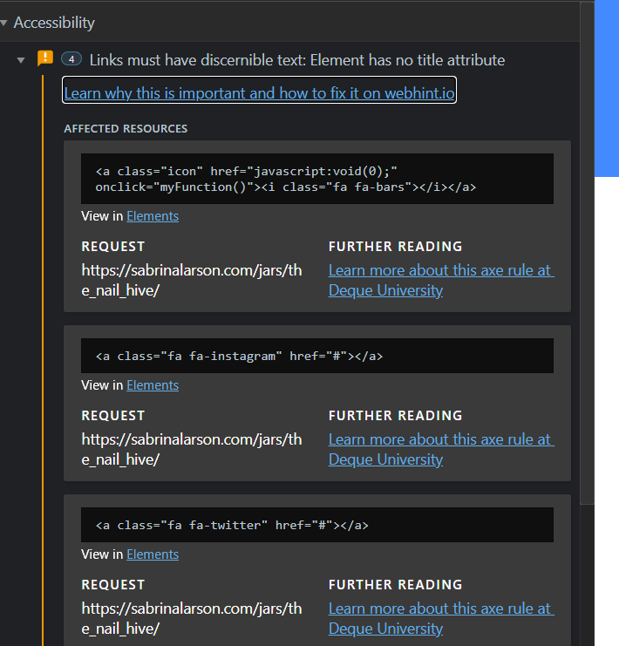
Severity of Bug
Low – Basic improvements
Medium – Easy to resolve problems (typos, grammatical errors)
High – Minor loss of website function
Critical – Major loss of website function
Catastrophic – Website crashes
Bug Priority Levels
Priority 1 – Fix bug as soon as possible (highest priority)
Priority 2 – Fix bug before next testing
Priority 3 – Fix bug before final launch date
Priority 4 – Bug can be fixed after launch of website
Budget Impact
Description | Hours | Due Date
identifying/fixing the issue | 1

Was Bug Fixed?
- Completed 100%
- Fixed, but still needs work.
- Unresolved
Approval
Client Signature

Project Manager Signature
Jeanna Brault 4/27/21

Form 3
Bug Reporting Form
Log # | Runtime Errors/ Type Error | Priority | 3
Tester Name | Sabrina Larson | Severity | High
Test Date | 4/25/21 | Date Started | 4/25/21
Browser | Opera Browser | Date Completed
Error Type
Unchecked runtime.lastError: Invalid color name.
Error handling response:TypeError: Cannot destructure property ‘h” of ‘undefine’ as it is undefined
URL of Page with Bug
1 https://www.sabrinalarson.com/jars/the_nail_hive/
2
3
Description of Bug
Invalid Color Name and JavaScript Error

Screenshot of Error
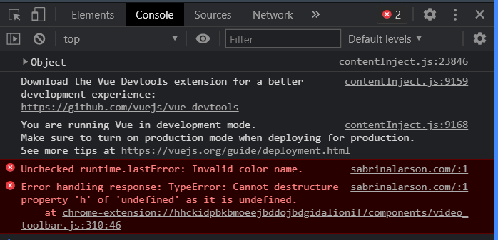
Severity of Bug
Low – Basic improvements
Medium – Easy to resolve problems (typos, grammatical errors)
High – Minor loss of website function
Critical – Major loss of website function
Catastrophic – Website crashes
Bug Priority Levels
Priority 1 – Fix bug as soon as possible (highest priority)
Priority 2 – Fix bug before next testing
Priority 3 – Fix bug before final launch date
Priority 4 – Bug can be fixed after launch of website
Budget Impact
Description | Hours | Due Date
identifying/fixing the issue | 1

Was Bug Fixed?
- Completed 100%
- Fixed, but still needs work.
- Unresolved
Approval
Client Signature

Project Manager Signature

Form 4
Bug Reporting Form
Log # | Layout Forced/Parsing Value Error | Priority | 3
Tester Name | Sabrina Larson | Severity | High
Test Date | 4/25/21 | Date Started | 4/25/21
Browser | Firefox (Ver. 88, 64-bit0 | Date Completed | 4/27/21
Error Type
Layout Forced
Parsing Error with homestyle.css
URL of Page with Bug
1 https://sabrinalarson.com/jars/the_nail_hive/
2
3
Description of Bug
Layout is being force before the page is fully loaded. This cause the stylesheets not to load and may cause a flash of unstyled content. There is also a parsing error for the background-origin. Is the in the homestyles.css.

Screenshot of Error
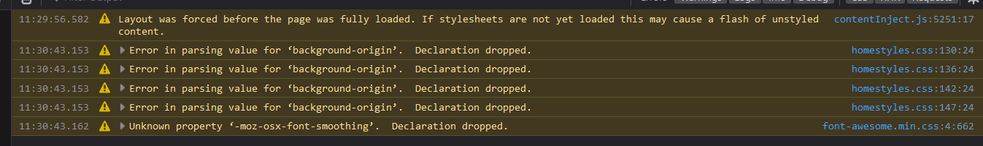
Severity of Bug
Low – Basic improvements
Medium – Easy to resolve problems (typos, grammatical errors)
High – Minor loss of website function
Critical – Major loss of website function
Catastrophic – Website crashes
Bug Priority Levels
Priority 1 – Fix bug as soon as possible (highest priority)
Priority 2 – Fix bug before next testing
Priority 3 – Fix bug before final launch date
Priority 4 – Bug can be fixed after launch of website
Budget Impact
Description | Hours | Due Date
identifying/fixing the issue | 1

Was Bug Fixed?
- Completed 100%
- Fixed, but still needs work.
- Unresolved
Approval
Client Signature

Project Manager Signature

Form 5
Bug Reporting Form
Log # | NU HTML Checker | Priority | Medium
Tester Name | Sabrina Larson | Severity | 3
Test Date | 4/25/21 | Date Started | 4/25/21
Browser | Chrome | Date Completed | 4/25/21
Error Type
No Space between attributes
End tag Header seen.
Unclosed element
Stray end tag
URL of Page with Bug
1 https://www.sabrinalarson.com/jars/the_nail_hive/
2
3
Description of Bug
Error No space between attributes.
Error End tag header seen, but there were open elements.
Error Unclosed element <div>
Error Stray end tag <div>

Screenshot of Error
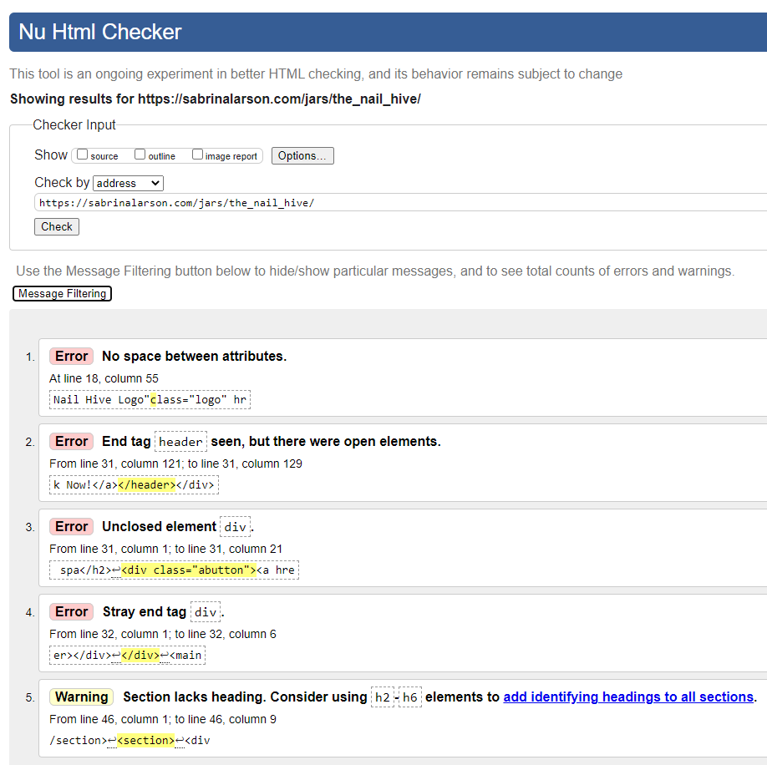
Severity of Bug
Low – Basic improvements
Medium – Easy to resolve problems (typos, grammatical errors)
High – Minor loss of website function
Critical – Major loss of website function
Catastrophic – Website crashes
Bug Priority Levels
Priority 1 – Fix bug as soon as possible (highest priority)
Priority 2 – Fix bug before next testing
Priority 3 – Fix bug before final launch date
Priority 4 – Bug can be fixed after launch of website
Budget Impact
Description | Hours | Due Date
identifying/fixing the issue | 1

Was Bug Fixed?
- Completed 100%
- Fixed, but still needs work.
- Unresolved
Approval
Client Signature

Project Manager Signature

Form 6
Bug Reporting Form
Log # | W3C CSS Validator | Priority | Medium
Tester Name | Sabrina Larson | Severity | 3
Test Date | 4/25/21 | Date Started | 4/25/21
Browser | Chrome | Date Completed
Error Type
Center is not a background-origin
URL of Page with Bug
1 https://www.sabrinalarson.com/jars/the_nail_hive/
2
3
Description of Bug
Center is not a background-origin value center.
#circle1 - #circle4

Screenshot of Error
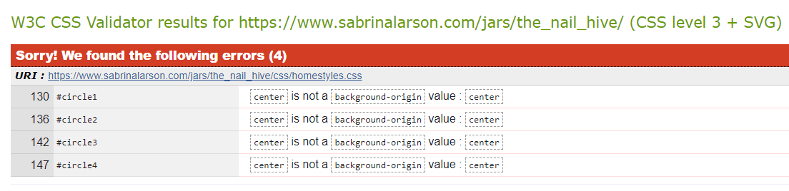
Severity of Bug
Low – Basic improvements
Medium – Easy to resolve problems (typos, grammatical errors)
High – Minor loss of website function
Critical – Major loss of website function
Catastrophic – Website crashes
Bug Priority Levels
Priority 1 – Fix bug as soon as possible (highest priority)
Priority 2 – Fix bug before next testing
Priority 3 – Fix bug before final launch date
Priority 4 – Bug can be fixed after launch of website
Budget Impact
Description | Hours | Due Date
identifying/fixing the issue | 1

Was Bug Fixed?
- Completed 100%
- Fixed, but still needs work.
- Unresolved
Approval
Client Signature

Project Manager Signature

Form 7
Bug Reporting Form
Log # | W3C Link Checker | Priority | High
Tester Name | Sabrina Larson | Severity | 3
Test Date | 4/25/21 | Date Started | 4/25/21
Browser | Chrome | Date Completed
Error Type
Broken URI fragments
JavaScript Void
URL of Page with Bug
1 https://www.sabrinalarson.com/jars/the_nail_hive/
2
3
Description of Bug
Some of the links to this resource point to broken URI fragments (such as index.html#fragment).
You should change this link: people using a browser without JavaScript support will not be able to follow this link.

Screenshot of Error
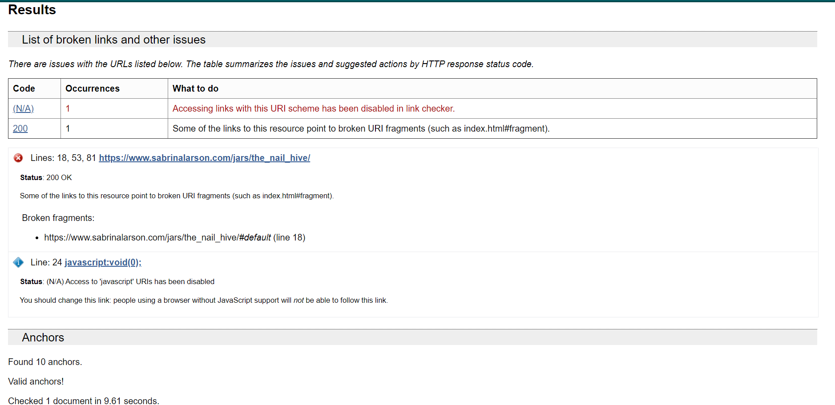
Severity of Bug
Low – Basic improvements
Medium – Easy to resolve problems (typos, grammatical errors)
High – Minor loss of website function
Critical – Major loss of website function
Catastrophic – Website crashes
Bug Priority Levels
Priority 1 – Fix bug as soon as possible (highest priority)
Priority 2 – Fix bug before next testing
Priority 3 – Fix bug before final launch date
Priority 4 – Bug can be fixed after launch of website
Budget Impact
Description | Hours | Due Date
identifying/fixing the issue | 1

Was Bug Fixed?
- Completed 100%
- Fixed, but still needs work.
- Unresolved
Approval
Client Signature

Project Manager Signature

