Site Map Visual for The Nail Hive:
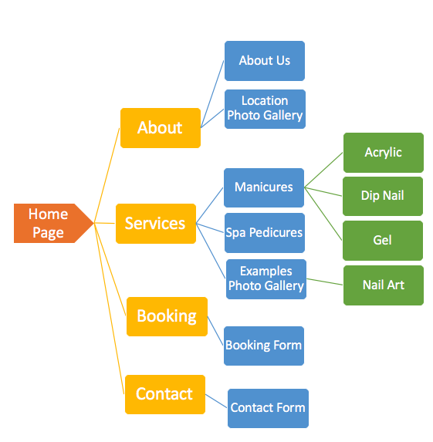
Site Map Key:
▪ Home Page ▪ Site Pages ▪ Content ▪ Secondary Content

By signing this document, you approve of the site visual structure as detailed above:
X______________________________________________
Customer Print Name
X______________________________________________ __________

