Visual Design Approval Document
The following color palette and website layout have been chosen by: ___The Nail Hive___
https://coolors.co/9258b0-4f2167-f7ee7f-f7d126-ffffff-388697-226b6d
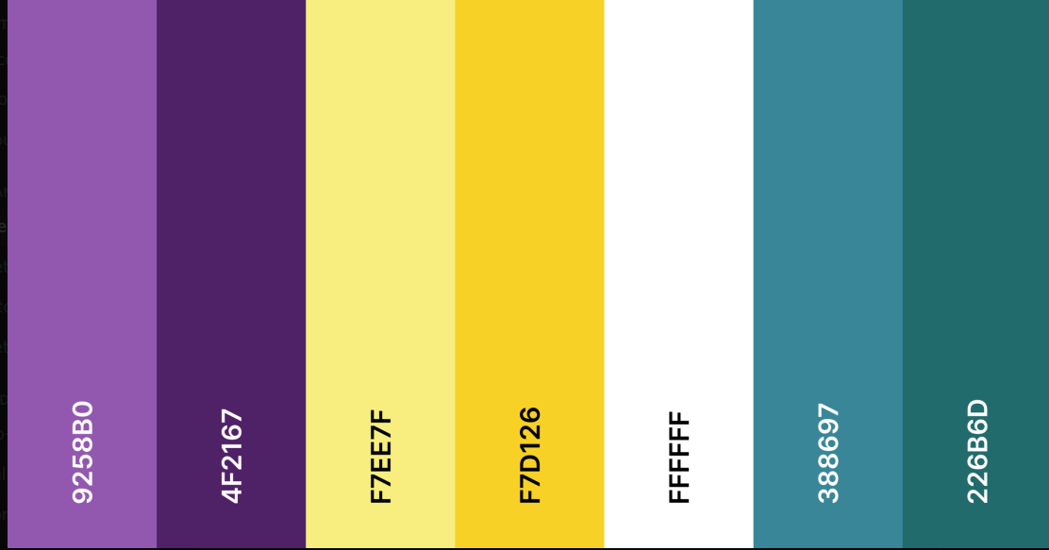
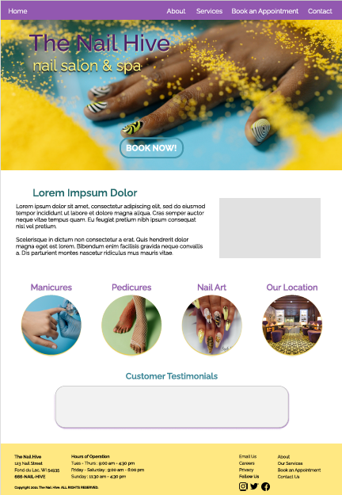
I, as a client of J.A.R.S Web Design, have selected the above color palette and design for my website. I understand that further revisions will affect the budget and schedule of the website’s development.
Client signature : _______Rosalind Scott______ Date : ____4/13/20____

